How to Stake the Oasis Rose Token
Oasis Protocol Foundation
Follow
May 5 · 9 min read
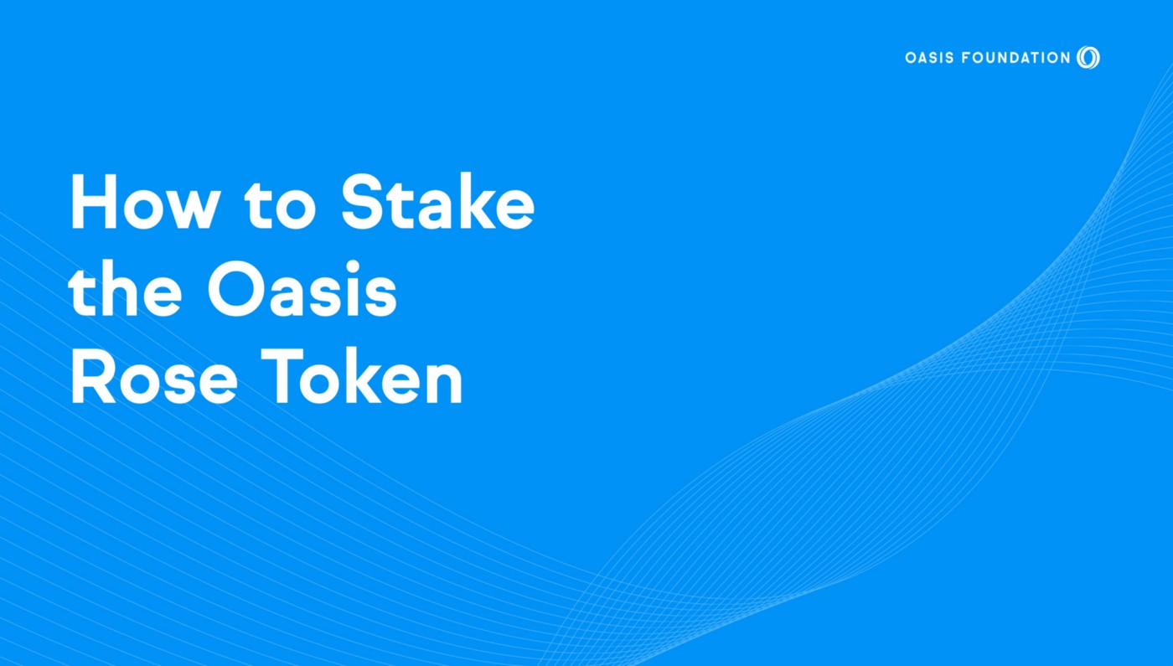
Staking your crypto is a great way to earn rewards for contributing to the network, and the ROSE token provides up to a 20% annualized staking rewards for “staking” your crypto on the network! But what exactly is staking, and how does it work?
The Oasis Network is a Layer 1, Proof-of-Stake platform that enables the tokenization of data to give ownership back to individuals. This guide steps you through the entire staking process so you know what staking is, how it works, and most importantly how to be rewarded for contributing to the security of the network.
Here’s an overview of what this guide covers.
- How Staking Works
- How to Stake your ROSE Tokens
- The Benefits Of Staking
- ROSE Staking FAQs
If you’re new to staking then be sure to read the whole way through so you have a complete understanding of the power of staking and how you can benefit from it. However, if you’re already familiar with the inner workings of PoS, staking, delegation, and validators then feel free to skip to the section that’s most relevant to you using the links.
Let’s jump right in!

What Exactly Is Staking and How Does It Work?
The simplest way to look at staking is that it’s the act of locking up (“staking”) your cryptocurrency to receive rewards.
All blockchains require that transactions be validated, and Proof of Stake (PoS) is a consensus mechanism that allows blockchain networks to achieve distributed consensus in an energy-efficient manner. Most people have heard of Proof of Work (PoW) because of Bitcoin, but PoS differs in that rather than miners receiving rewards for “proving they’ve done the work” (Proof of Work), with PoS participants effectively “prove they’ve staked their crypto” (Proof of Stake) to the network and receive rewards as a result.
Mechanisms like PoW and PoS both have the same goal of reaching consensus in their respective blockchains, although the general sentiment in the cryptosphere is that PoS allows for a much more efficient use of energy and enables a higher level of scalability. In fact, this is one of the big reasons cited for Ethereum upgrading to ETH 2.0.

The Benefits of Staking
Now that you understand the fundamentals of staking, let’s dive into some of its key benefits!
Earn Rewards
Staking allows you to earn rewards for contributing to the safety and security of the network as described below.
You Help Secure the Network
Because blockchain is permissionless, theoretically anyone could arbitrarily create multiple wallets, join the network and then suddenly have control of the majority of the network and over new block proposals.
To gain control of the network in PoS any one entity would have to buy a majority of the network. But when you lock up your stake, you help make it either more expensive for anyone entity to gain control of the network.
Control Over Your Crypto
Security is a big issue when it comes to staking, and you can often choose whether you want to “cold stake” your crypto, which means staking on a wallet that’s not connected to the internet. This is something you can do on the Oasis Network, so let’s get into some staking examples.

How to Stake Your Rose Tokens: A Step By Step Guide
There are a number of ways to stake your ROSE tokens. In this section, we’ll cover a few popular ways, including options with a hardware wallet as well as mobile.
Before doing the below steps, you’ll of course need ROSE tokens, which you can earn as rewards or find on exchanges like Binance, Kucoin, and others listed on Coingecko.
Staking with RockX Wallet for Oasis Using Ledger
A reliable way to stake and delegate your ROSE is using RockX.
Step 1: Go to RockX Wallet for Oasis Network.
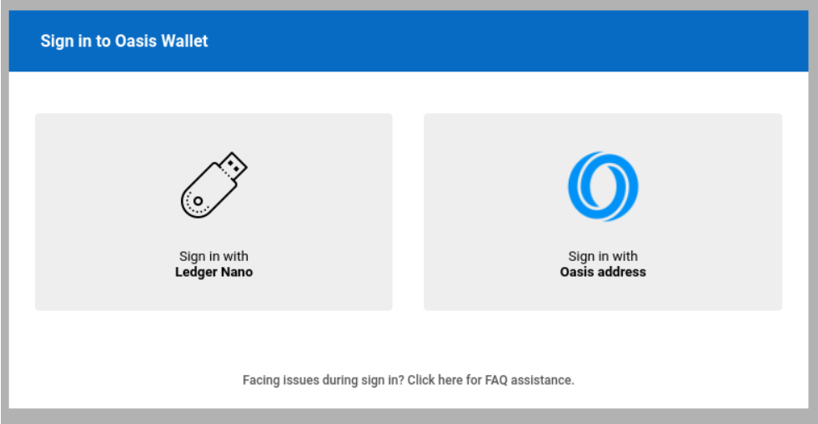
Step 2: Connect your Ledger and follow the instructions.
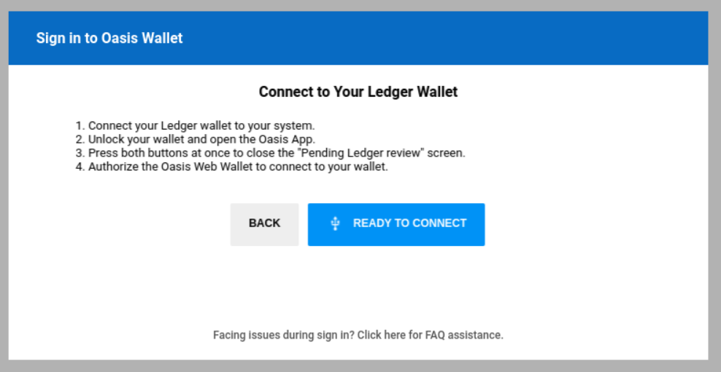
Step 3: Once you are connected, select the ‘STAKING’ tab.
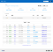
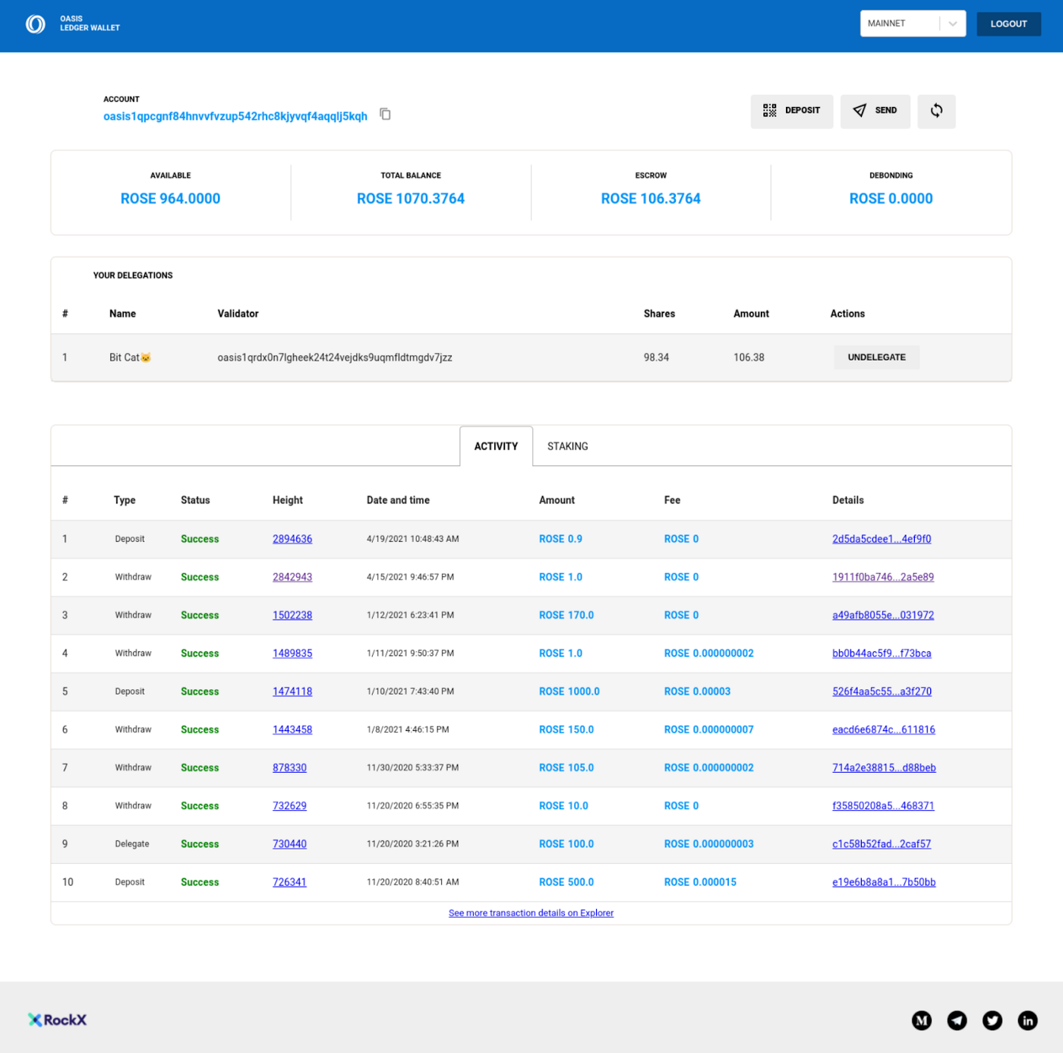
Step 4: Select the validator you want to delegate your tokens to by selecting ‘DELEGATE’.
The validators are sorted by their staking power. You can also see what commission they take on the staking rewards you earn, as well as how many people already delegate tokens to them.
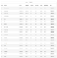
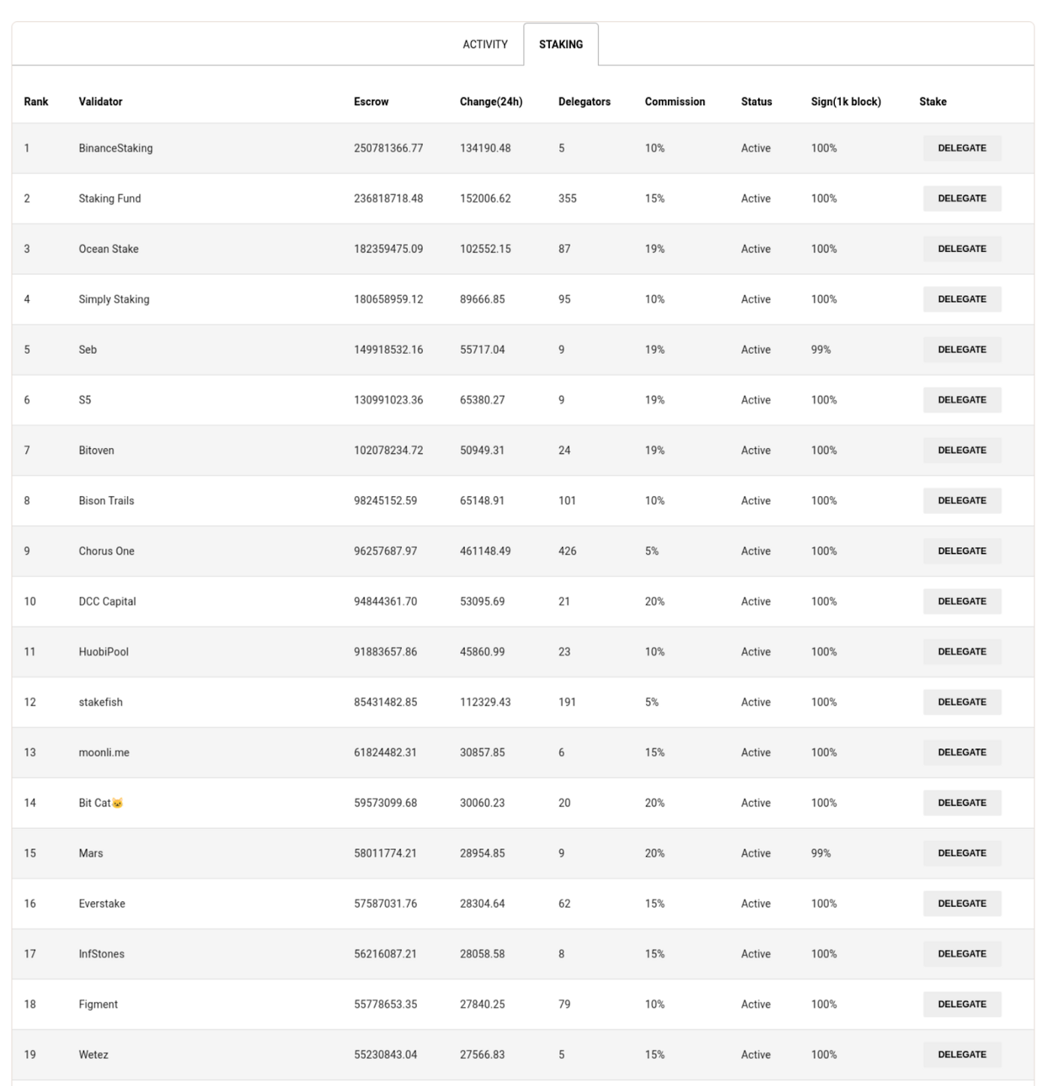
Step 5: Select ‘DELEGATE’.
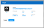
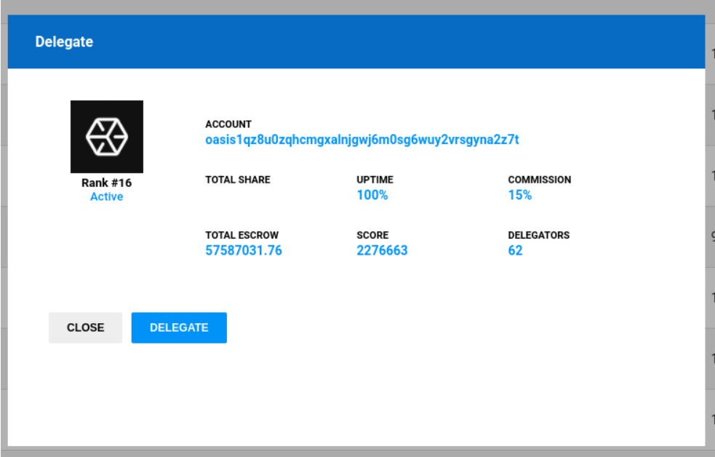
Step 6: Choose the delegation amount and Gas price
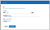
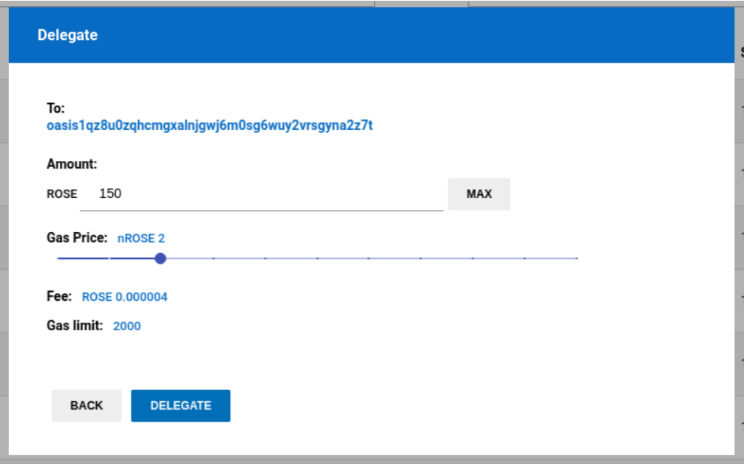
Step 7: Sign the transaction by selecting the ‘SIGN AND SUBMIT’ button.
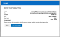
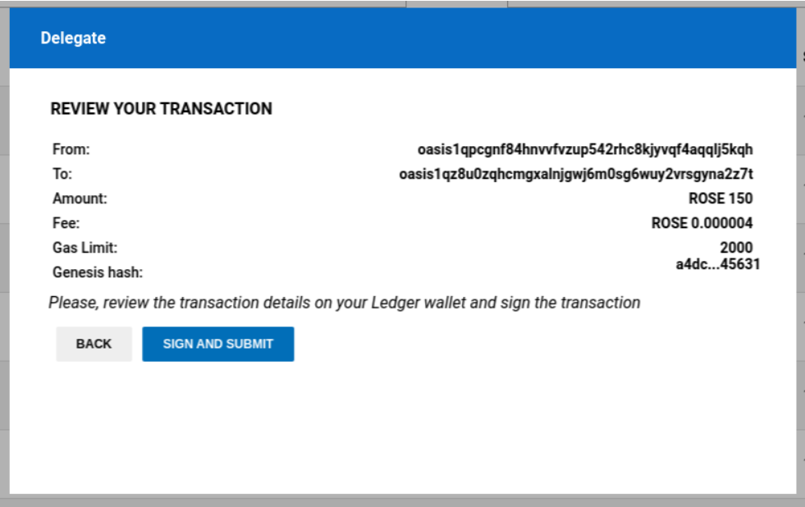
You’re now staking your ROSE tokens, and you should see a screen that looks similar to the one below.
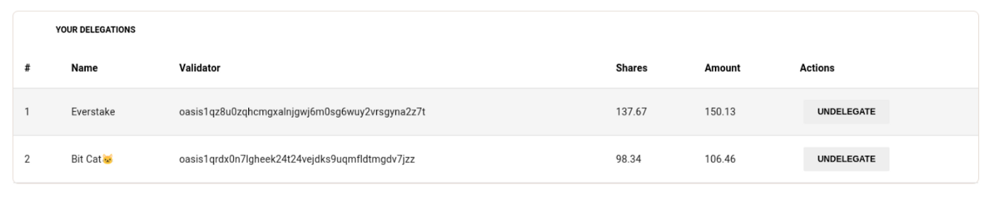
Staking With Bitpie (Mobile Wallet)
Bitpie is the first mobile wallet for ROSE tokens on the Oasis Network and it’s available on both iOS and Android.
Here’s how to stake with your mobile device.
Step 1: Download Bitpie wallet and Choose the ROSE wallet system! (Android & iOS*)
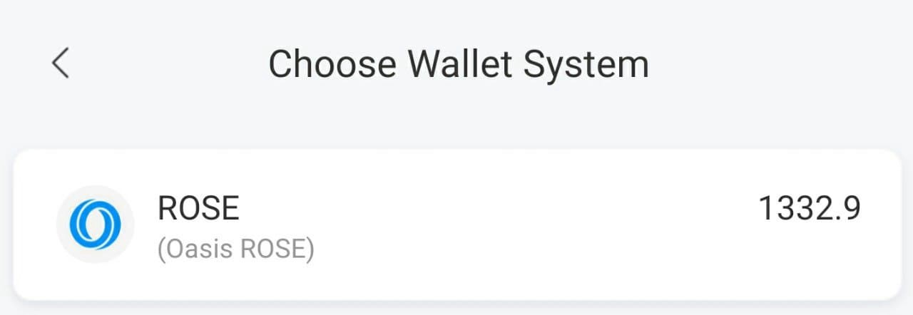
Step 2: You can see your ROSE dashboard and your ROSE wallet address. To see the deposit address click “Receive” & make your deposit to your wallet. To stake your ROSE tokens, click “Escrow” after the deposit.
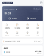
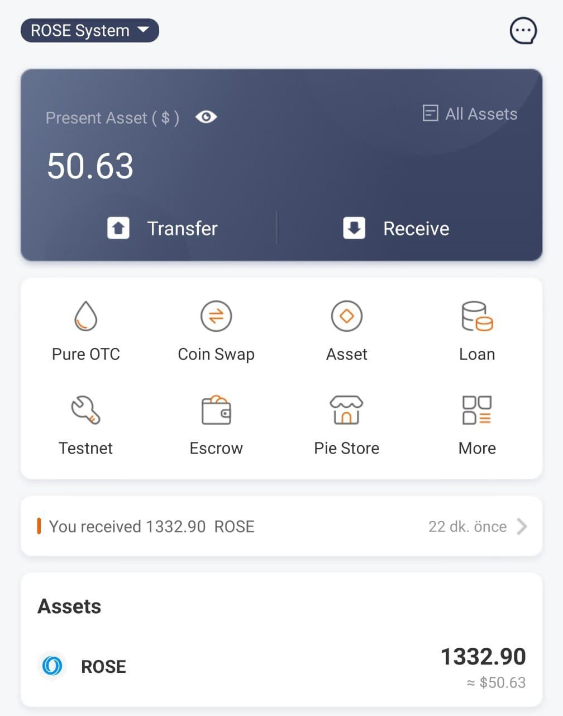
Step 3: You can see all validators in the “Escrow” tab. Please pick one and tab on it. You can see all validators on Oasis Scan also.
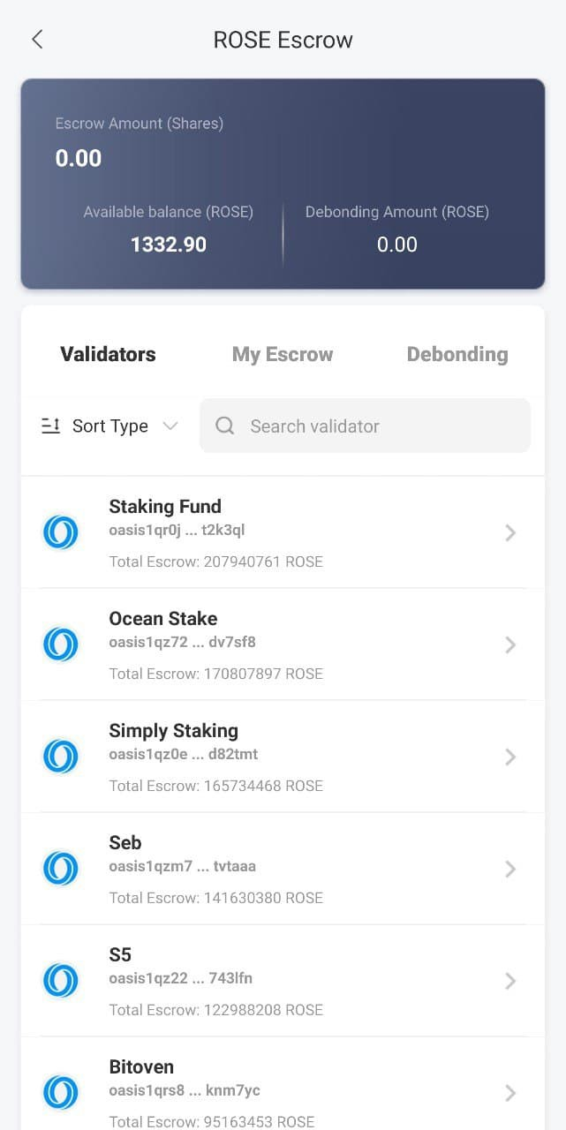
Step 4: Check out the details of the validator you selected and write down how many ROSE you will stake and submit.
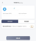
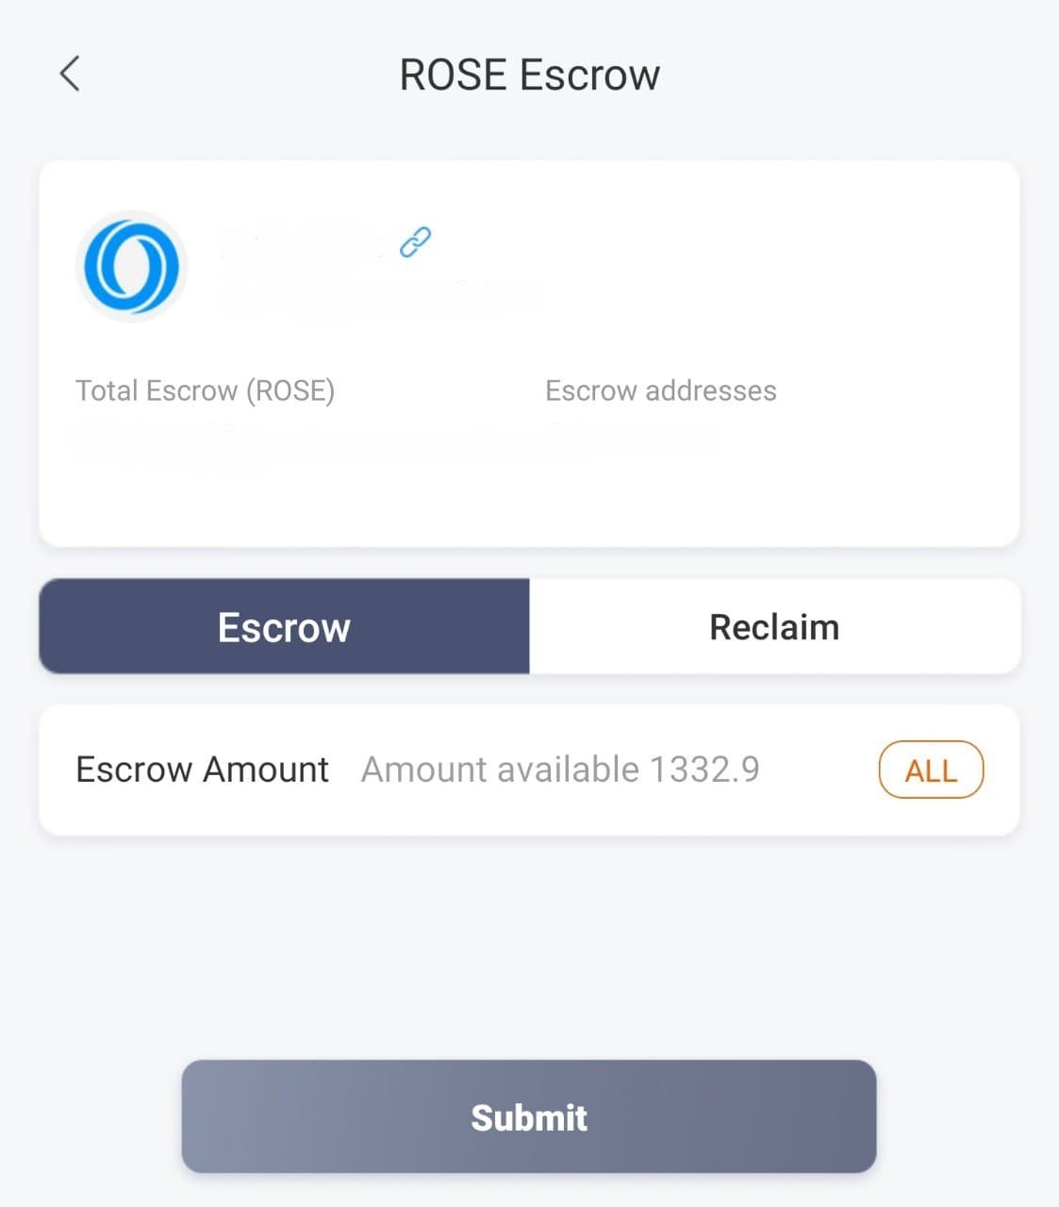
Step 5: Bitpie will ask for your PIN code or biometric verification for the transaction. Enter your PIN code & proceed.
Congrats!! Your ROSE tokens have been sent to the validator address and staking has begun.
Pro Tip: You can see your staked tokens in “my escrow” tab.
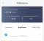
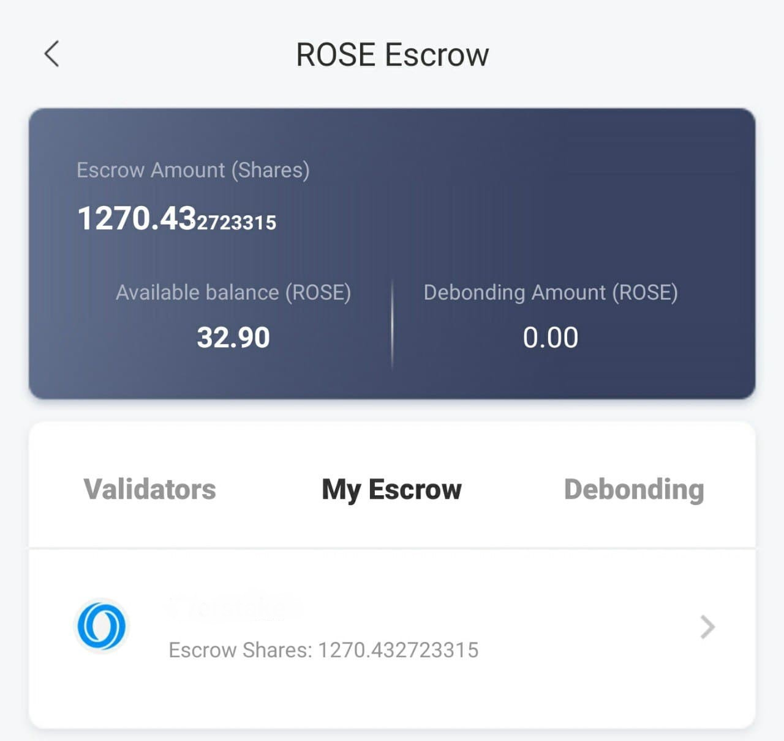
Staking with Anthem (by Chorus One) Using Ledger
Step 1: Head to Chorus One’s Anthem and use your Ledger hardware device to log in. Connect to the Oasis network.
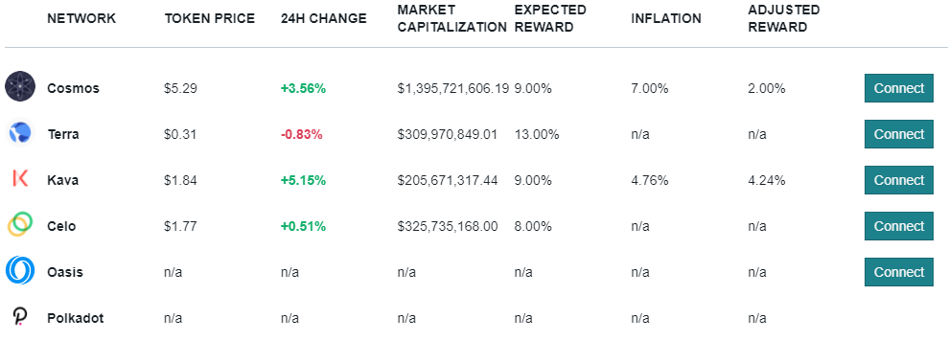
Step 2: Verify your available balance, and then click the ‘Stake’ button.
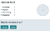
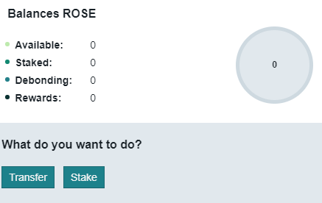
Step 3: Select ‘Choose Validator’ and search for your desired validator
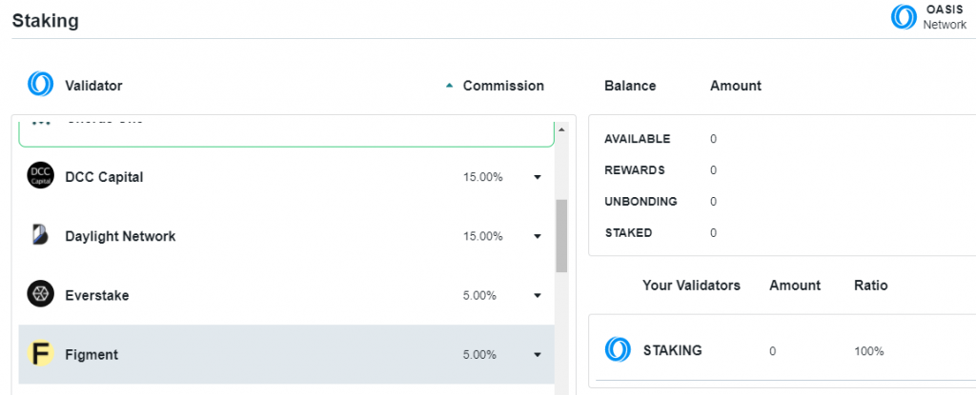
Step 4: Enter the number of ROSE tokens you plan to stake and delegate. Note that you should keep at least 5 ROSE for transaction fees.
Step 5: Click the ‘Generate My Transaction’ button and finalize the delegation with your Ledger device.
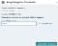
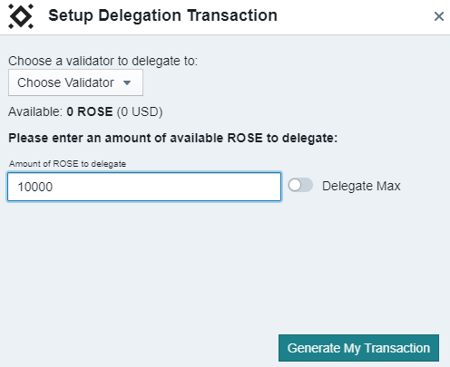
More Options for Staking Your Rose Tokens
Staking with your Ledger hardware wallet and Bitpie are just a couple of ways to stake your ROSE tokens. You can also stake through Binance, where availability is on a first come first serve basis and staking durations can be varied.
If you’d like to explore even more options go here.

A Network and Team Your Can Trust
Since the launch of the Oasis Network, we have amassed an incredible community of supporters, developers, as well as major backers like Binance Labs, Pantera, a16z and many others.
By staking on the Oasis Network not only do you earn great rewards, but you are helping to secure a network and ecosystem that’s looking to change the world.
The Oasis Network is built with three key principles in mind:
Privacy-First Design — End-to-end confidentiality and true data ownership will be supported by the Oasis Network. Compute techniques, like Intel’s SGX secure enclave, will be leveraged to ensure that data is not exposed on the network. The protocol can also support other privacy preserving technology such as homomorphic encryption and zero-knowledge proofs.
Resilient, Flexible Architecture — The Oasis Network is designed to support a broad range of use cases without having to go through hard-forks or large network updates. This will ensure that it can retain its utility in the long term.
Real-World Performance — The Oasis Network separates computation from consensus. This will allow the network to handle more complex computations while avoiding computational backlog.
Headed by a World Class Team — Headed by our award winning Founder, Dawn Song, Oasis is an international team made up of researchers, security experts, and privacy advocates — all working together to build a platform for a responsible data economy.

ROSE Staking FAQs
How much does Oasis pay in staking rewards?
Currently you can earn 20% rewards on an annualized rate by staking your ROSE tokens.
How Often Are Rewards Paid Out?
ROSE rewards are received on each epoch transition which is approximately every hour.
Are there lockup periods when I stake my ROSE?
Yes, the unbonding process takes 14 days to complete. During this time you will not earn rewards. When the process is complete, you can transfer your ROSE tokens.
Where can I find validators?
All validators can be found at https://www.oasisscan.com/validators
I’d like to become a Validator. Where do I start?
If you’d like to be a Validator, please view this comprehensive guide that goes over things like taking part in our incentivized Testnet, benefits, costs and everything involved to get started.
Can I choose how I receive my staking rewards?
Rewards are always in ROSE. Also please note that awarded tokens are automatically restaked, so if you want to unstake them, the unbonding of staked tokens takes 14 days.
What wallets can I use for staking and delegation?
In addition to using the Oasis CLI, there are a number of wallets, Ledger GUIs and Custodians support staking and delegation on the Oasis Network. Those include:
- RockX Wallet for Oasis Network (Ledger GUI)
- Bitpie (mobile wallet)
- Chorus One Anthem (Ledger GUI)
- Anchorage (custodian)
- Finoa (custodian)
- More options
Do I maintain custody of my ROSE tokens? Who or what controls my staked ROSE tokens?
You can maintain self-custody of your ROSE tokens, ideally using a Ledger hardware wallet. Instructions for using your Ledger wallet with Oasis can be found here.
The Oasis Network takes control of your ROSE tokens while they are staked. If you unbond your tokens, this process will take 14 days before the protocol returns your tokens to you.
Where can l learn more about Binance staking?
As with most tokens, staking your ROSE on Binance is subject to availability. You can get more info on how to stake your ROSE through Binance here.
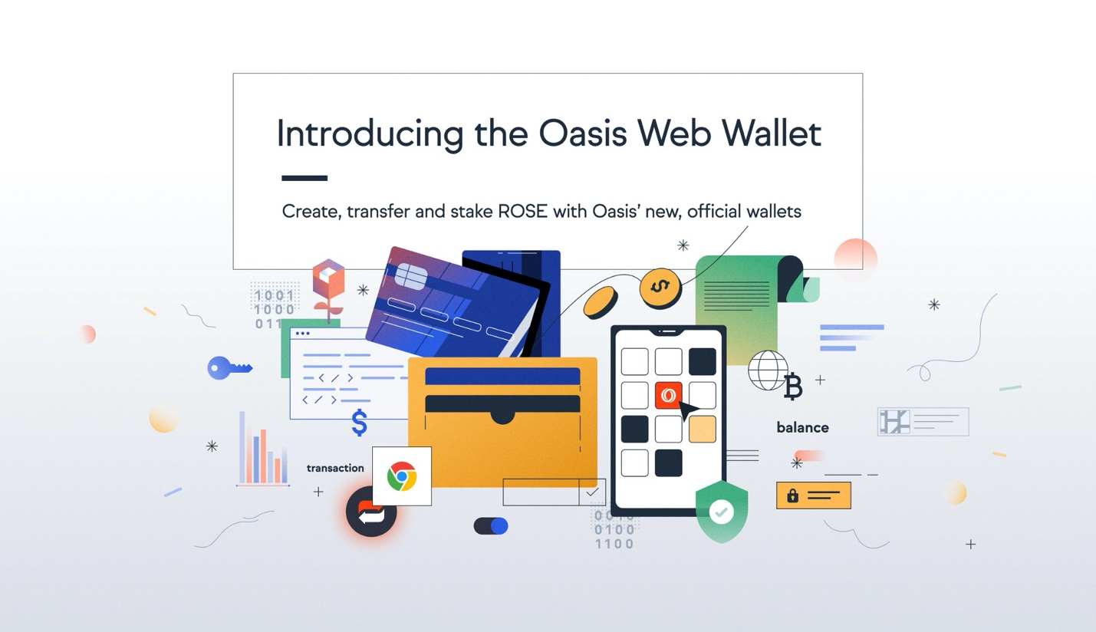

The starter’s guide to the Oasis ROSE wallet
Jack Booth
Follow
Sep 22 · 6 min read
We all have to start somewhere, and if you’re looking to start your journey into the ROSE token. There’s no better place than this article to get you set up with a wallet, sending and receiving ROSE and learning how to stake to earn yield on your tokens.
The most requested platform by the Oasis Network community has been a safe place to store and stake their ROSE tokens.
Introducing the official Oasis ROSE wallets!
As of today, we are launching the web wallet to be your front page for everything ROSE related and the browser extension for quick and easy access to your ROSE when you need it.
This guide will serve as an introduction to the wallets and their features. It will help you to:
- Set up a wallet
- Fund your account
- Import a wallet or link your Ledger hardware wallet
- Send and receive ROSE
- Stake your ROSE tokens
- And reclaim your staked tokens
For a quick run through of the both wallets, we’ve created a walkthrough video for both the web wallet and the browser extension.

Set up a wallet
You can find
- The web wallet at wallet.oasisprotocol.org
- And the browser extension in the chrome web store
Both wallets have very similar set up processes, with highly secure authentication via a mnemonic phrase (24 words for the web wallet, 12 for the extension).
Click to create a wallet and you’ll be shown your mnemonic phrase (like below). You should copy this down somewhere especially safe, preferably offline where it can’t be hacked from your local files. If you lose it you will lose access to your wallet so this is very important.
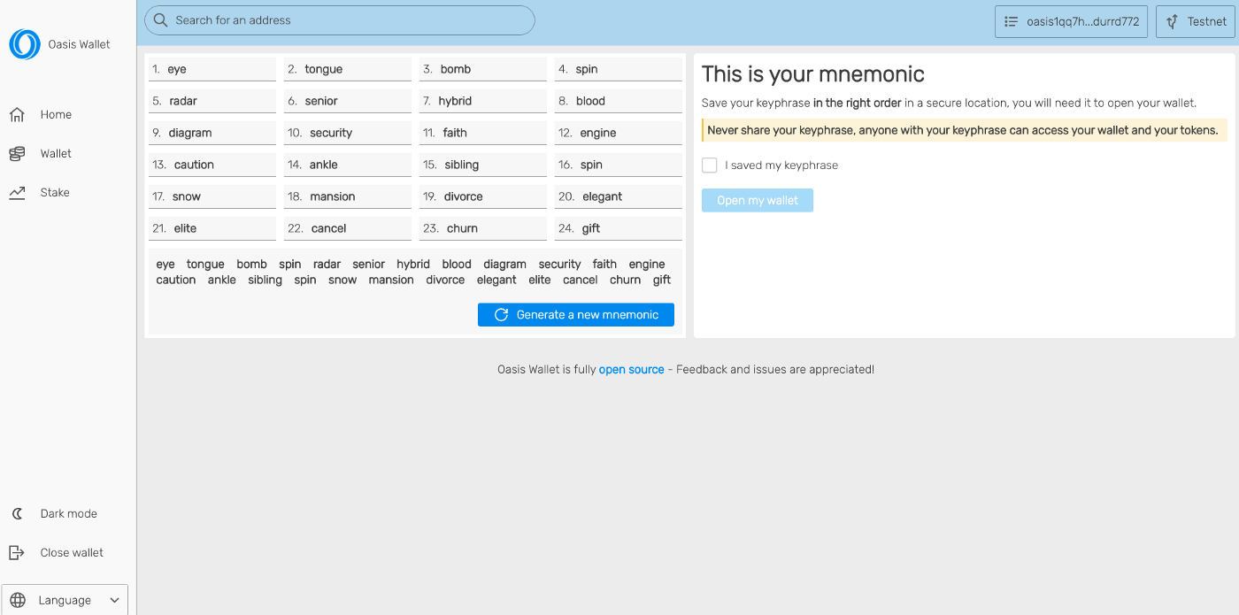
Once you’ve saved your phrase, confirm you’ve done so and it will ask you to fill in the blanks
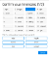
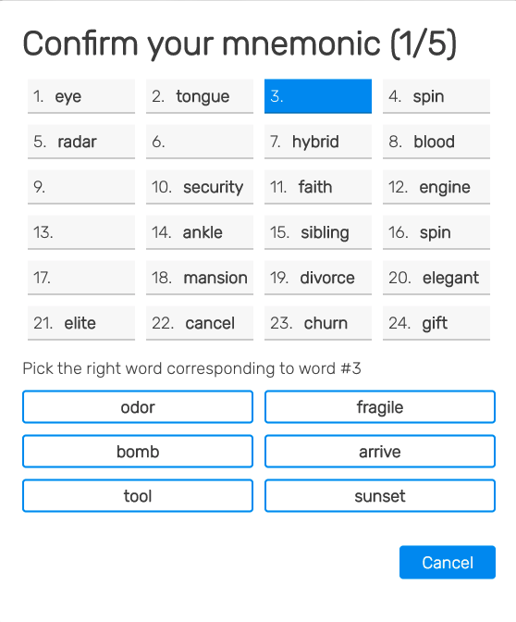
Then you’re in! You’ll see the homepage of your wallet with the total balance of the account, how much you have available, how much you have staked and how much you have waiting to be released from staking under “Debonding”.
Obviously in our new account we’re not going to have any ROSE yet so next, lets fund our account!

Funding your account
There will be plenty of “brose” reading, who have been stacking ROSE tokens any and every way they can. For the few here who are just starting out though, you can buy ROSE at many of the larger exchanges including Binance and KuCoin — Check out more places to buy ROSE on CoinMarketCap here.
Once you have ROSE it’s very easy to transfer it to your ROSE wallet — Just copy and paste your wallet address (shown highlighted below) and withdraw to your new wallet.
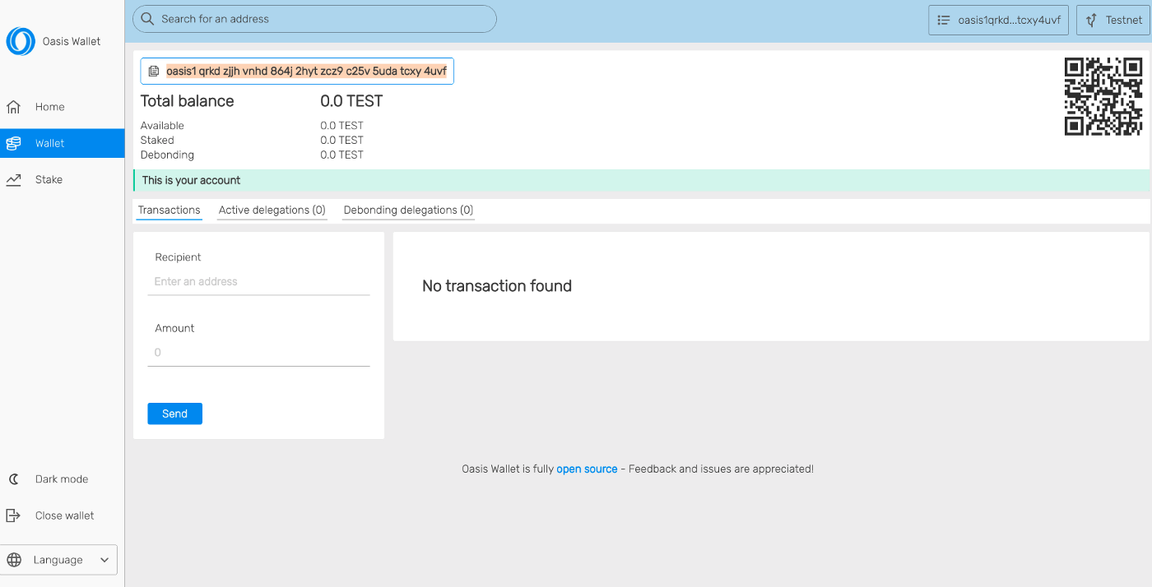

Import a wallet or link your Ledger hardware wallet
If you’re wanting to import an existing wallet or link to your Ledger.
Head back to the home screen and click open wallet:
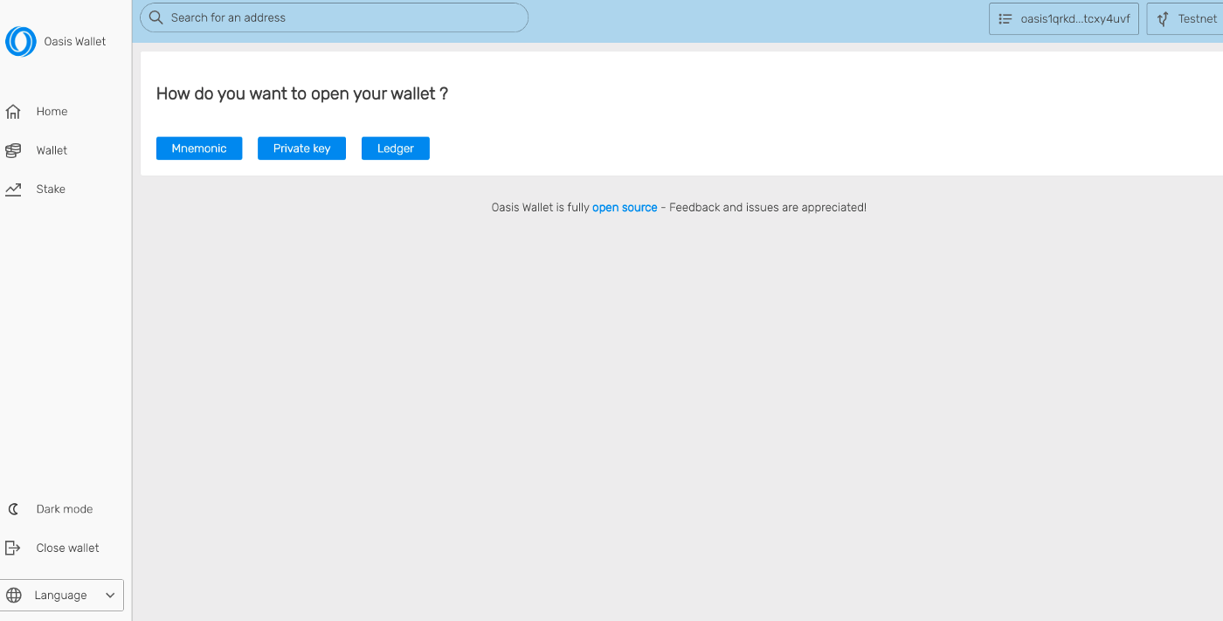
You get 3 options to open your existing wallet:
- Mnemonic — use your saved Mnemonic phrase from earlier
- Private Key — Input your private key
- Ledger — use your USB connected Ledger device
Using a Ledger hardware wallet with the web wallet or browser extension is the most secure way to interact with the Oasis network; as your funds remain on your ledger and can be disconnected from the internet at anytime.

Send and receive ROSE
We’ve gone through receiving ROSE but sending ROSE couldn’t be faster, easier or cheaper. It takes roughly 6 seconds for ROSE to move from one wallet to another — much faster than many other L1 blockchains and at a fraction of the cost.
To send ROSE:
- Open up your wallet
- Enter an address under “Recipient”
- Enter the amount you’d like to send
- Click Send
- Confirm your transaction details are correct
- Done!
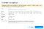
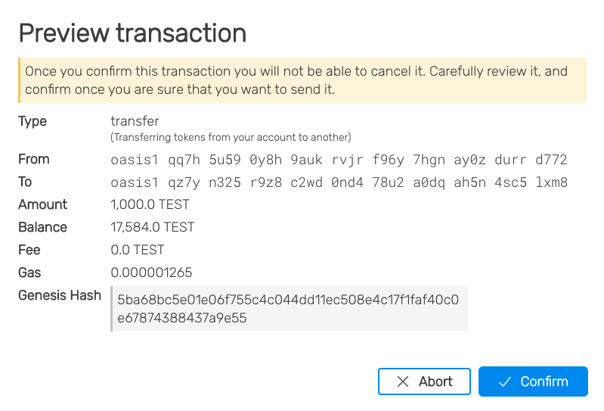
Once you’ve successfully sent a transaction you’ll get a confirmation message like the one below.
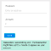
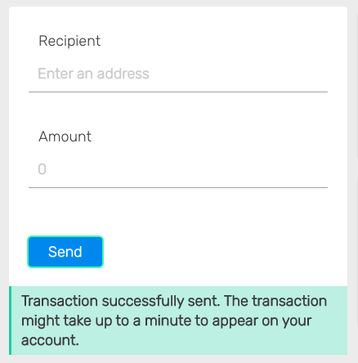
You should also see the transaction details in your transactions history.
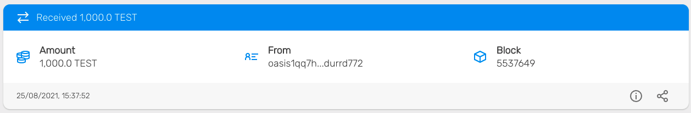

Stake your ROSE tokens
The most exciting feature of our new wallets is the ability to directly stake your funds with network validators and earn a slice of that validator’s staking rewards — based on the amount you stake.
Head to the Stake section of the app to see all the active network validators, the total amount delegated to them, and under “Fee” — the % fee they take from your rewards should you delegate funds to them.
Pro Tip: You can calculate your expected staking rewards overtime here.
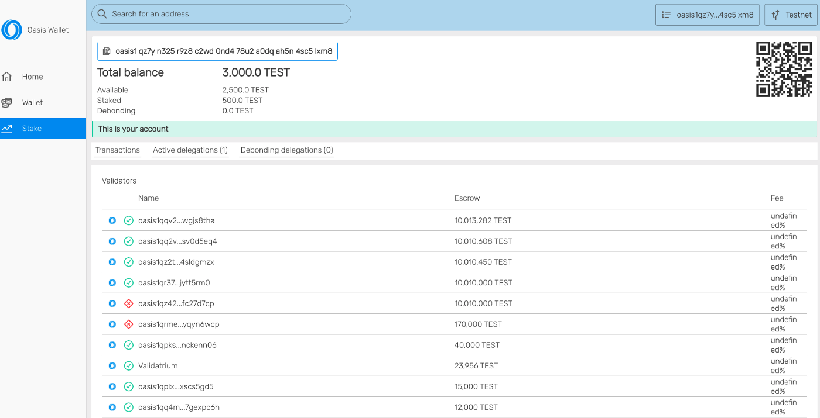
By clicking on any of the validators you will reveal their:
- Rank amongst validators based on total amount staked to them
- The total amount staked
- The % yield that staking your ROSE will generate
- The bounds of where that yield should fluctuate between
- The status of the validator, either active or inactive
It is here that you can then delegate your ROSE to a validator to earn a % of your tokens back as rewards for securing the network. The rewards decrease over time from Mainnet launch, read more about the rewards schedule here.
To delegate your ROSE you simply input the amount you want to stake and click delegate.
Bear in mind that once your funds are staked you will not have instant access to them. Currently it is ~14 days from debonding funds to those funds being available again in your wallet.
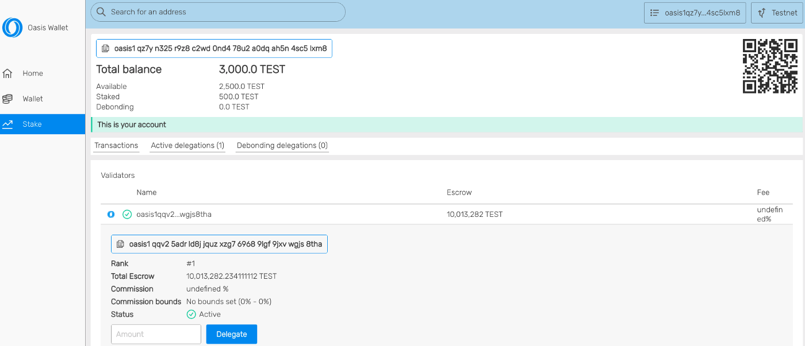

And reclaim your staked tokens
If it’s that time and you’re ready to reclaim some of your staked ROSE. Head to your “active delegations” tab and you will see all the ROSE you have staked.
To reclaim (or debond) you’ll just have to:
- Click the delegation you want to withdraw from,
- Enter the amount you want to reclaim
- Review the transaction details and click to confirm
- That’s it — your fund will now begin to be debonded
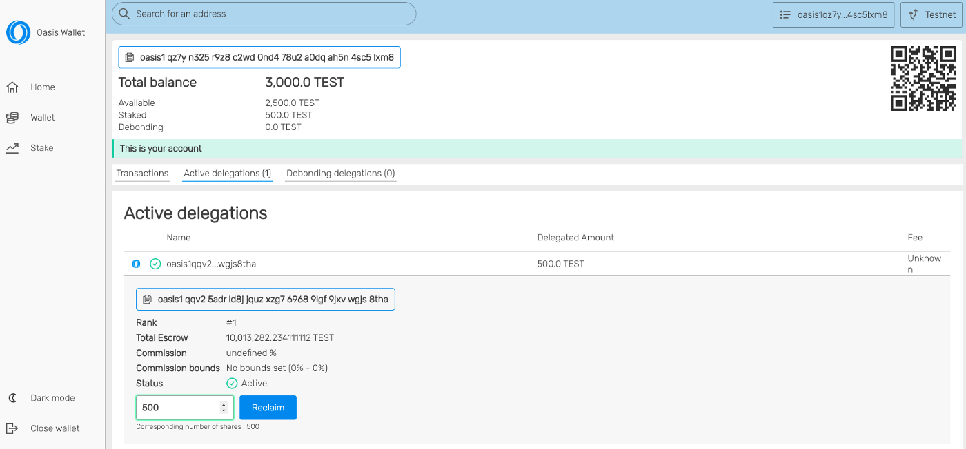
You’ll now see that debonding transaction within the “debonding delegations” tab along with the expected “Epoch” those funds will be released.

Conclusion
There you have it. A quick introduction and walkthrough into the new Oasis ROSE wallet. As always, you can continue to ask any further questions in the community on
- Slack,
- Discord
- or Telegram.
You can also see the walkthrough videos for both
- The web wallet
- and the browser extension

