Sleep, Health, and Performance
WellnessFX practitioner Dr. Ruchir Patel knows the value of a good night’s sleep. After practicing internal medicine for several years, Dr. Patel began specializing in sleep disorders and after serving as the medical director in an Arizona sleep clinic, started thinking about opening his own practice.
“The most challenging part of getting started was the decision to do it,” Dr. Patel said about venturing out on his own. Once he made the decision, there was no going back. After six months of construction, Dr. Patel opened the doors to the Insomnia and Sleep Institute of Arizona this February. When we spoke to him, he’d already generated 150 patients in four weeks, with more than 30 overnight stays in his six-bed sleep lab.
The sleep lab serves as a diagnostic tool to help identify various sleep disorders, from periodic limb movement disorder (PLMD) to sleepwalking, sleeptalking, and night terrors. All of these things can disrupt sleep, leaving people groggy and tired throughout the day, or worse.
As a WellnessFX practitioner, there are many connections for Dr. Patel between his years as an internist, his work as a sleep specialist, and his WellnessFX consults.
People suffering from chronic headaches to diabetes to heart disease can be and perhaps, should be, referred to a sleep clinic, as the underlying causes of common diseases are often associated with or connected to poor sleep quality or sleep disorders.
What Sleep has to do With Your Heart
Just recently, Dr. Patel performed a WellnessFX consult with someone who had high lipid panels. “He had a family history of heart attacks and wasn’t taking anything for his high cholesterol,” Dr. Patel said. Turns out the gentleman also had a snoring problem and frequently felt tired throughout the day. He was ultimately diagnosed with sleep apnea, which has connections to high blood pressure and other heart problems.
According to the American Association of Oral and Maxillofacial Surgeons, obstructive sleep apnea is characterized by significant and prolonged interruptions of breathing during the night. Not only may these cessations of breathing cause a decrease in blood oxygen levels, they can also cause cardiac arrhythmias (irregularities in the heart’s normal beating pattern), high blood pressure, and may even cause sudden death. The disorder has also been linked to significant lung and heart problems over time, including increased blood pressure. For those with underlying heart disease, multiple episodes of low blood oxygen can also lead to a cardiac event and may be associated with increased risk of atrial fibrillation, congestive heart failure, and other vascular diseases.
Poor Sleep Quality Can Make You Fat
You know you feel better when you get a good night’s sleep – more alert, higher energy stores, maybe even less hungry? Maybe you’ve noticed a spike in your hunger on days when you’ve skimped on sleep. Your intuition is right – sleep deprived people lose up to 60% less weight during diets when compared to folks who get a healthy amount of sleep.
In this paper, published in Annals of Internal Medicine, researchers found that your metabolism is directly affected by how much sleep you get (or don’t get) by disrupting the way fat cells respond to insulin. Sleep deprivation can cause increased insulin resistance in human fat cells, which can lead to metabolic syndrome.
Other hormones are affected by lack of sleep, namely ghrelin and leptin. Ghrelin is the hormone that tells you when to eat and leptin is the hormone that tells you to stop eating. Sleep deprivation triggers more ghrelin and gives you less leptin, resulting in weight gain.
A healthy amount of sleep for most people is about seven to eight hours a night. Make sure you’re maximizing your health by getting the sleep you need.
As a board certified Internal Medicine and Sleep Medicine physician, Dr. Ruchir Patel has the unique role of being able to provide guidance, education, and counseling regarding all aspects of Internal Medicine but also various aspects of Sleep Medicine. The combination of the two specialties is a unique blend of medicine; Dr. Patel helps patients improve daytime functionality and lifestyle in addition to improving sleep. He believes that without one truly understanding the principles of his or her condition, the potential negative consequences of said conditions, and the benefits of proper therapy a physician cannot be successful at truly treating a patient.

“Carbs Are Killing You”
credit: Instagram @ deutschefrau
The Dilemma
In 1984 the National Heart, Lung, and Blood Institute set out to do a noble thing: fight heart disease, obesity, and all the complications that come with it. They launched a massive campaign to promote low-fat diets. Saturated fat consumption certainly went down, but obesity and diabetes levels went up.
The Study
This raised the question: is it really fat consumption that makes us fat? Researchers from Stanford University attempted to answer just that. The study was simple: one group ate all the fat and protein they wanted, but were restricted to 20-50 grams of carbohydrates per day while the other group was put on a calorie-restricted low-fat diet where carbs made up 55-60 percent of all calories. Both groups lost weight, but the low-carb group saw nearly twice the benefits in weight loss, triglyceride levels, and blood pressure.
The Science
According to the infographic, which is based off of ‘Why We Get Fat‘ by Gary Taubes, the science behind why this may be is quite simple. While it is certainly true that fat gain is a result of more fat being stored in fat cells, we have to look at: why does they body store more fat in the first place? As it turns out, insulin is the body’s primary regulator of fat metabolism. When insulin levels go up, we store fat. When it falls, we use fat for fuels.
And guess what drives insulin? That’s right: carbohydrates.
Even then, it’s not so cut and dry. The easier the body can digest the carbs, the more they will affect insulin levels. Examples of easily digestible carbs are starches, liquid carbs, and foods made of refined flour. A great example of a complex, hard-to-digest carbohydrate source is the sweet potato, which we have talked about extensively here, here, and here.
Be sure to look over the interesting inforgraphic below from Massive Health to learn more about exactly what carbs are doing to your body. The key seems to be insulin, which can be tracked, monitored, and managed through WellnessFX Performance package and a WellnessFX practitioner.
What do you think of low-carb versus low-fat diets? Weight in below!

Celiac Disease, Exercise to Sleep, Omega-3s for a Healthy Baby, and More!
credit: iStock @Nick_Thompson
National Sleep Foundation Poll Finds Exercise Key To Good Sleep
“Exercise is great for sleep. For the millions of people who want better sleep, exercise may help.” – David Cloud, CEO of the National Sleep Foundation (NSF)
Have you ever told someone how you ‘slept like a baby’ after a tough workout, or a long day of physical exertion? Well, it turns out you don’t have to climb Mount Kilamonjaro to get a good night’s rest. The results of the National Sleep Foundation’s 2013 Sleep in America® poll show just how beneficial exercise can be to a good night’s sleep:
- Exercisers say they sleep better – Among people who sleep roughly the same amount each night, exercisers reported better sleep than non-exercisers. “If you are inactive, adding a 10 minute walk every day could improve your likelihood of a good night’s sleep,” says Max Hirshkowitz, PhD, poll task force chair.
- Vigorous exercisers report the best sleep – Vigorous exercisers are almost twice as likely as non-exercisers to report “I had a good night’s sleep.” More than two-thirds of vigorous exercisers say they rarely have sleep problems such as waking up too early and difficulty falling asleep, while one-half of non-exercisers experienced these problems.
- Non-exercisers are the sleepiest and have the highest risk for sleep apnea – Participants were evaluated on how ‘sleepy’ they were using a standard excessive sleepiness clinical screening measure. The poll found that non-exercisers had a high sleepiness level about twice as often as exercisers. Here’s an interesting finding: non-exercisers reported having trouble staying awake while driving nearly three times the rate of those who exercise. Non exercisers were more than two times as likely to have symptoms of sleep apnea (a serious medical condition in which a person stops breathing during sleep) than vigorous exercisers.
- Less time sitting is associated with better sleep and health – How much data have we seen lately showing how much sitting is ruining our lives? This study also found that people who sit for less than eight hours a day are twice as more likely to say they have “very good” sleep quality than those who sit for eight hours or more. The same comparison is seen in overall health: non-sitters were twice as likely to report having ‘excellent health’.
- Exercise at any time of day appears to be good for sleep – But when is the best time to exercise? As far away from bedtime as possible, right? Not exactly. According to the study, those who report exercising close to bedtime and earlier in the day do not demonstrate a difference in self-reported sleep quality. For most people, exercise at any time seems to be better for sleep than no exercise at all.
“Exercise is beneficial to sleep. It’s time to revise global recommendations for improving sleep and put exercise—any time—at the top of our list for healthy sleep habits.” – Dr. Barbara Phillips, poll task force member.
Read the full article here.
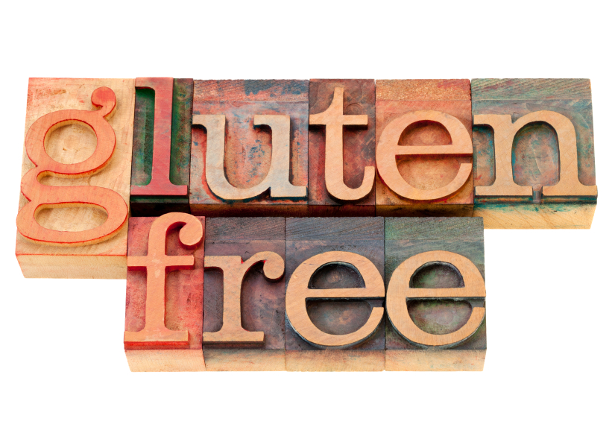
credit: iStock @marekuliasz
What Really Causes Celiac Disease?
Are we entering into a period where people start paying more attention to the role microbes and bacteria have in our health? This is an interesting piece on new studies and thoughts about what the more recent rise of celiac disease and gluten intolerance might stem from.
Highlights:
- Celiac disease is an autoimmune disorder where gluten proteins in wheat, barley and rye cause the body to turn on itself and attack the small intestine. Complications range from diarrhea and anemia to osteoporosis and, in extreme cases, lymphoma.
- Roughly 30 percent of people with European ancestry carry genes for celiac disease, but more than 95 percent of the carriers tolerate gluten just fine. So what else needs to be in place to cause intolerance?
- Scientists use the presence of certain self-directed antibodies to predict celiac disease. They have analyzed serum stored since the mid-20th century and compared it to serum from Americans today. Today’s serum is more than four times as likely to carry those antibodies.
Primary Prevention of Cardiovascular Disease with a Mediterranean Diet
If you could cut your risk of dying from heart disease by 30%, would you do it? A recent study published in The New England Journal of Medicine suggests that switching to a Mediterranean diet can do just that. For those of you unfamiliar with the foods associated with this diet, it consists of: a high intake of olive oil, fruit, nuts, vegetables, and cereals; a moderate intake of fish and poultry; a low intake of dairy products, red meat, processed meats, and sweets; and wine in moderation, consumed with meals.
The study focused on endpoints: how many people actually had heart attacks and strokes, or died as a result of heart-related ailments? Here are the main take-aways from the study:
- Scientists randomly assigned 7,447 people in Spain who were overweight, were smokers, or had diabetes or other risk factors for heart disease to follow the Mediterranean diet or a low-fat one.
- Most participants didn’t stick strictly to the ‘low-fat’ diet, so that became more of the traditional modern diet, with its regular consumption of red meat, sodas and commercial baked goods.
- The researchers were careful to clarify that while the diet clearly reduced heart disease for those at high risk for it, more research is needed to establish its benefits for people at low risk.
- Among persons at high cardiovascular risk, a Mediterranean diet supplemented with extra-virgin olive oil or nuts reduced the incidence of major cardiovascular events.
Omega-3s Make For A Healthier Pregnancy
There are numerous benefits to omega-3 fatty acids, including reduced risk of heart disease and managing inflammation. Apparently, omega-3s are the gift that keeps on giving! A recent double-blind study published in The American Journal of Clinical Nutrition found that pregnant women who took daily supplements of DHA, a type of omega-3 fatty acid, had longer gestations, bigger babies and fewer early preterm births.
Here are the highlights:
- 154 healthy women were assigned to take 600 milligrams of DHA during the last half of pregnancy; 147 took a placebo.
- Babies of mothers who took supplements were almost a half pound heavier. They were slightly longer with larger head circumferences.
- Almost 5 percent of mothers who took the placebo gave birth at 34 weeks’ or less. For those who took DHA, this went down to only 0.6 percent.
- The placebo group’s statistics aligned with low birth weight and short gestation period rates in the general population, while the omega-3 takers had dramatic reductions.
In Five Years, America Spends Forty-One Percent More On Diabetes
“The cost of diabetes is rising at a rate higher than overall medical costs with more than one in 10 health care dollars in the country being spent directly on diabetes and its complications, and more than one in five health care dollars in the U.S. going to the care of people with diagnosed diabetes.” – Robert Ratner, MD, Chief Scientific & Medical Officer, American Diabetes Association.
Despite more and more Americans becoming ‘health-conscious’ and adopting this workout fad or that latest diet craze, it seems like diabetes isn’t going anywhere. The American Diabetes Association recently released new research estimating the total costs of diagnosed diabetes have risen to $245 billion in 2012 from $174 billion in 2007. That’s an increase of 41%! The study includes a detailed breakdown of costs along gender, racial and ethnic lines, and costs on a state-by-state basis.
The complete study will be published in the The American Diabetes Association‘s April issue of Diabetes Care. Until then, find out more about the study here.

Latest in Health News: Gluten-Free, Detecting a Stroke, Health Care Spending, and More!
credit: NYTimes.com @Lou Beach
Gluten-Free, Whether You Need It or Not
There’s been a lot of talk recently about gluten, wheat, and the potential benefits of nixing them from your diet. We even featured our own article around the good and bad of grain consumption. But is it just another fad diet? Will it fade into the darkness like so many before it? Or is there actually something to it?
For people who have celiac disease, avoiding gluten is a no-brainer. With this disease, ingesting gluten causes the immune system to attack the walls of the intestine, leading to vomiting, chronic diarrhea or constipation. Most people who have celiac disease don’t know it. What’s even more scary is that more and more people seem to be contracting the disease, according to comparisons to blood samples taken from a century ago.
For most people without celiac disease, it seems that gluten ingestion doesn’t cause any problems. Some, however, report health benefits after giving up on gluten, including alleviation of symptoms associated with irritable bowel syndrome and arthritis. Experts remain skeptical about how directly related gluten ingestion is to such results.
A recent study, however, claims to prove that gluten sensitivity (that is, experiencing adverse effects from gluten even if you don’t have celiac disease) exists. People who suffered from irritable bowel syndrome, did not have celiac and were on a gluten-free diet were given bread and muffins to eat for up to six weeks. One group had gluten-free, the other regular. Those in the gluten group reported feeling significantly worse.
Dr. Stefano Guandalini, medical director of the University of Chicago’s Celiac Disease Center, holds that gluten sensitivity is very rare among our population. “Less than 1 percent,” he says. However, he recognizes that any such number at this point is speculation. More research needs to be done.
Health Care Spending In America, In Two Graphs
We all know healthcare costs have been rising by the decade. No surprise there. But where is all the money going? Are we spending the same percentage now on hospitals, for example, that we were in 1970? Perhaps more importantly, where is the money coming from?
This article from NPR News first looks at the trends in health care spending and then breaks down reasons for some of the possible changes over the decades. Here’s how funds are dispersed, then and now:
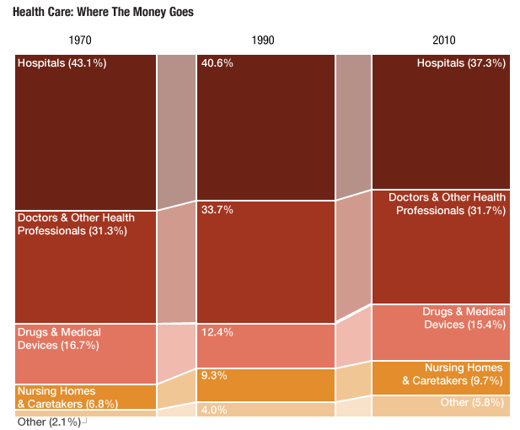
Source: Centers for Medicare and Medicaid Services
Credit: Lam Thuy Vo / NPR
As you can see, not much has changed. We still spend the most on hospitals and medical professionals. In contrast, there have been major shifts in where all the money is coming from:
Source: Centers for Medicare and Medicaid Services
Credit: Lam Thuy Vo / NPR
The largest shift is out-of-pocket going from a third of the money source to approximately an eighth. Analysts think this is due to health insurance plans becoming more comprehensive in their coverage.
credit: iStock @JuSun
The Effects Of Diabetes On Male Fertility
There is a long list of well-known reasons why one should do everything in his or her power to prevent the onset of diabetes. Recent studies are making that list longer by showing that the chronic illness can have even broader effects, especially for males.
Diabetes is either a deficiency of insulin or an insensitivity of insulin, both of which result in elevated blood glucose levels. As a reminder, the blood is responsible for shuttling nutrients to all the cells of the body; cells get the bad along with the good. When the sperm in the testes is exposed to excess sugar, chances of defects leading to infertility rise.
It might sound like you’re in the clear as long as you don’t have diabetes, but not so fast. We must remember the main effect of diabetes: high blood glucose levels. Thus, even if you’re not diabetic, you could still be putting your fertility at risk simply by maintaining glucose levels that are higher than normal. Research has shown a direct link between blood sugar levels and sperm quality: more blood sugar means more malformed or dead sperm in semen. Total sperm count also suffers under high glucose levels.
These two correlations have additive effects. If an individual has less overall sperm and a higher percentage of that sperm is defective, infertility skyrockets. Check out the full article to learn more.
What Happens During A Stroke
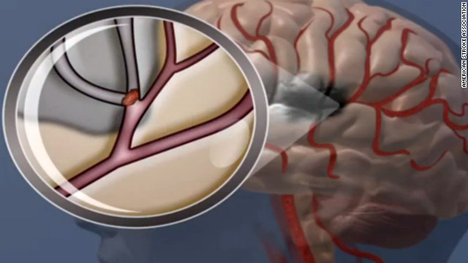
CNN put together a concise overview of what a stroke is, the risk factors, and how to notice it in its early stages. Here are some key take-aways:
- Use the F.A.S.T. acronym to identify symptoms: If you see Face drooping, Arm weakness or Speech difficulty, it’s Time to call 911.
- Other symptoms include sudden numbness in the legs, sudden confusion or trouble seeing, sudden dizziness or loss of balance, or a sudden severe headache.
High blood pressure is the leading cause of stroke, according to the American Stroke Association. Smoking can also play a role.

What is YOUR action plan?
credit: Instagram @marinaaav
What does it take to lose 85 pounds? One of our newest members is on a quest to find out! Recomp Hacks is a personal fitness journal with weekly reviews of diet, exercise, and commentary on general progress. Recently the author had a blood draw and consult with WellnessFX; he’s now using his results to bring himself closer to his goal.
His numbers turned out quite well. Specifically, there were no visible problems with cholesterol levels even though he expected them to be slightly higher. His Vitamin D levels were a little low, and his ALT (a biomarker for the liver) turned out a bit high.
The consult with his practitioner addressed these issues. Recommendations included certain supplements, more sleep, and tracking sleep patterns. Using his new information, here’s the action plan he came up with:
- 8 hours of sleep every night, measured with a Zeo Sleep Manager Pro
- Betaine HCL and Super Enzymes to better absorb foods
- Bio-Kult Probiotic for better digestion
- Liver Detox support
- Vitamin D supplementation
- Low carb whole foods diet based on combination of a few diets: GAPS Diet, The Paleo Solution Diet, Weston A Price / Nourishing Traditions, and the New Atkins / Low Carb Performance
- Exercise 4x/week using MMA and Starting Strength
Pretty cool, huh? We’d love to hear from more of our members: what’s your action plan? Tell us in the comment section below.
Since our new member has been tracking himself for quite a while, he compared his numbers to a separate draw from nearly two years ago. Check it out:
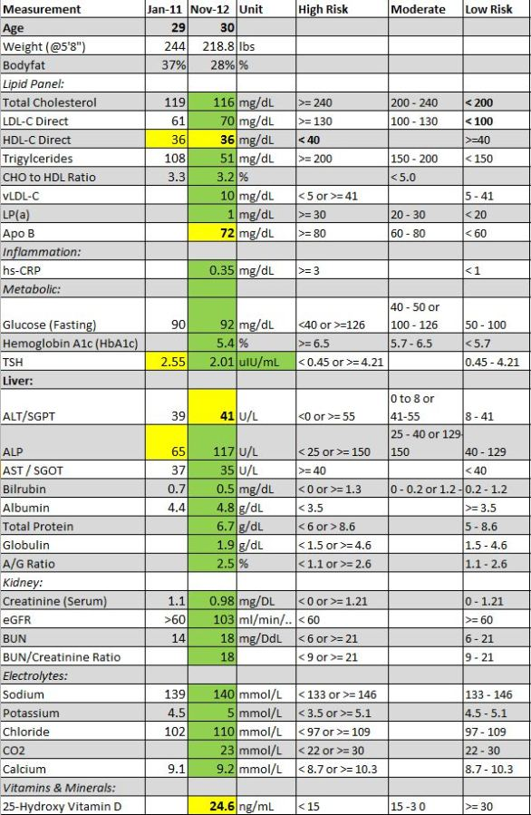

The Scoop on Low-Carb Eating
credit: Instagram @tronks88
There are many proponents of low-carb dieting, much research in support of it, and a slew of people with real results (just do a Google image search). Still, there remains skeptics. And for understandable reasons. Two legitimate questions are often posed against the efficiency of low-carb dieting in weight loss:
- If low-carb eating is so effective, why are so many people in America still overweight?
- How is it possible for cultures who eat high amounts of carbs to stay so lean?
Dr. Peter Attia, who runs a popular blog on health and nutrition, decided to tackle these two questions in separate, detailed articles. They are both worth a read, and offer interesting perspectives and possible answers to these issues.
The root of the answers to both questions is education, or the lack thereof. We, as Americans, just don’t know how to eat. It’s not our faults, really, considering the recommendations by the USDA, AHA, AMA, and ADA, organizations we should be able to trust. Not to mention how hard it is to find healthy options while traveling, or attending social and/or business events where it seems everyone is choosing from the same faulty menu. When it seems you’re the only one who’s aware, it can be hard to stay strict. And if you just don’t know . . . well, then you don’t really have a chance!
Specifically, the reason a lot of Americans are still overweight despite how effective low-carb dieting is supposed to be includes not only misinformation and the faulty system, but how the immediate joy of certain foods can lead astray even those who are knowledgeable and have access to good foods. Dr. Attia goes into detail about these reasonings and even gives helpful analogies from more devastating diseases. But the gist is that we’ve built a culture around high-carb, processed food, one that has become so engrained that people will continue to partake even with knowledge of the detrimental effects.
As for eating habits and body types overseas, Dr. Attia encourages us to look at the foods other cultures consume on a more qualitative level. Sure, people might consume high amounts of rice and bread, for example, but how much of their carbs come from sugar? And we must consider how much people of these cultures eat overall. Even though their entire diet could be composed of carbs, when compared to many Americans, they are still taking in less carbs in total. Because, let’s face it, Americans can EAT. So, in fact, their diets could very well be considered ‘low-carb’ because, by our standards, they are ‘low-everything.’
Dr. Attia also goes into detail about the ratio of Omega-6 and Omega-3 fatty acid intake of American diets versus other cultures, which our CEO and The Bulletproof Executive have also discussed. In short, the lower your 6:3 ratio, the lower your overall inflammation, and the better your outlook on a slew of diseases, including heart disease and diabetes. And, comparably, American diets have a very high ratio. The connection with insulin sensitivity could also be contributing to obesity, regardless of relative carb intake.
There are a lot of benefits to a low-carb diet in terms of preventing and fighting chronic disease and obesity. But it’s not just keeping the carbs low, but looking at the quality of foods and how different levels affect your body. So the next time someone tries to question the value of a low-carb diet, maybe you’ll now have more ammunition to defend your position. Or maybe you disagree? We’d love to hear your thoughts, whether your diet consists mostly of grass-fed beef, whole-grain oats, or peanut-butter jelly sandwiches.

The Dangers of Too Much Calcium
We all know that calcium is good for us. As the mineral found in the greatest concentration in the body, it is crucial for maintaining proper nerve and heart function, blood clotting, and muscle contraction. The dairy industry has made calcium a household name, and many people take supplements to make sure they’re getting the right amounts. Then we learned about the importance of Vitamin D in the absorption of calcium, and we’ve supplemented with that as well.
As with many things, however, calcium is proving to follow the old adage: moderation is key. According to some recent studies, the problem with too much calcium is that it can lead to plaque build-up in arteries, which puts you at a high risk for heart disease. Too much Vitamin D has already been associated with high inflammation levels in the body, and a surprising study found that high supplementation actually leads to more bone fractures. We’ve found some studies that illustrate these risks:
Calcium Plaque Build-up in the Arteries Leads to Coronary Heart Disease in Multi-Ethnic Groups
The Multi-Ethnic Study of Atherosclerosis (MESA) did a study with nearly seven thousand men and women who had no prior heart disease. They followed them for three and a half years and found that a presence of calcium-plaque in the arteries meant an increase in heart attack risk and death.
Calcium Supplements Linked to Significantly Increased Heart Attack Risk, Study Suggests
Earlier this year, ScienceDaily.com pointed out that calcium supplements are often recommended to elderly people and women who have gone through menopause. This may be alarming, due to information from a study conducted by the European Prospective Investigation into Cancer and Nutrition (EPIC) in Heidelberg. The study followed 24,000 participants over 11 years. They found that while higher calcium from natural sources was okay, those who took calcium supplements were 86% more likely to have a heart attack.
Scientists followed up the study with possible explanations. They said that calcium from food is usually ingested in small amounts throughout the day, while supplements cause calcium levels in the blood to soar above the normal range. This sudden spike and ‘flooding’ of calcium might be to blame.
Who Will Tell the People? It Isn’t Cholesterol!
This informative article talks about the fairly recent finding that cholesterol-lowering drugs don’t have positive effects in nearly three quarters of the people who take them. Why is this? The answer actually might have come more than 20 years ago, in 1991. Dr. Stephen Seely wrote that cholesterol only makes up 3% of arterial plaque and calcium is 50%. He claimed that in countries where the daily calcium intake is moderate, heart disease is almost nonexistent. In contrast, in countries with high intake, like the USA, heart disease is the leading cause of death.
This Popular Supplement Can Spike Your Heart Attack Risk by 30%…
This article has a good overview on the rise of calcium supplementation, different research studies, and “The Calcium Lie.” It concludes that plant-based sources of calcium are best for your health.
Warning on high-dose vitamin D
Australian researchers found a correlation with high Vitamin D supplementation and bone fractures in older women. The study focused on 2,256 women 70 years and older. They want to do more studies to further explore these surprising findings.
So what does this mean?
It seems that more research is needed to definitively say how much is too much or how much is too little when it comes to calcium supplementation, and the exact effects. But, moderation IS key and the only way to know if you’re bombarding your body with calcium is to get tested. And don’t forget to let us know the results!

Greatist’s Complete Guide To Calories

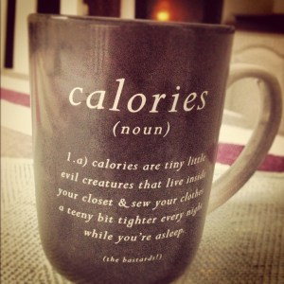
credit: Instagram @tinanicolexx
Did you know that you burn calories while sleeping? Or that one pound of fat equals 3,500 calories? How about the amount of calories in one gram of alcohol? There’s a lot to know about this commonly used measurement for the energy our bodies use for fuel. Where to get them, how fast your body uses them for your specific needs, and how to manipulate them for your health goals.
Greatist recently put together an interesting infographic on the topic. There’s a lot of information here which represents varying viewpoints.
Some highlights include:
- Of the macronutrients, carbs and proteins have 4 calories per gram, while fat has 9 calories per gram
- Fats are essential in cell, nerve tissue, and hormone production
- Proteins are essential for growth, tissue repair, immune function, preserving lean muscle, and producing essential hormones and enzymes
- You can easily calculate how many calories your body needs per day to maintain weight by knowing you age, weight, activity level, and height. Check out the infographic below for the formula!
- To lose one pound of bodyfat per week, aim to take in 500 calories less per day than you’re using
- Some useful mobile apps for tracking caloric intake include: MyFitnessPal, MyPlate Calorie Tracker, and Lose It!
Check out the infographic below and let us know what you think. Agree with certain parts? Disagree? We’d like to know your thoughts!

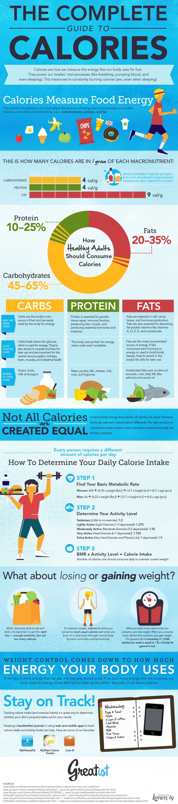
“10 Good Reasons to Like WellnessFX”
credit: Facebook
“If you love data, technology and are interested in a personalized and systems based approach to your health . . .”
Recently Tarquin, one of our new customers in Arizona, wrote about his experience with WellnessFX Baseline. It seems it was extremely positive! We’re constantly working to bring you the best for your preventive care goals, and hearing this feedback is very helpful. We thought we’d share Tarquin’s thoughts with our loyal readers:
10 Good Reasons to Like WellnessFX – Taken from The WellnessFX Experience
- WellnessFX is partnered with LabCorp, a medical laboratory testing company which conducts many of the drawings for our customers. Tarquin only had good things to say: “LabCorp gets a 10/10 for the cleanliness of the facility, brightness of the waiting room, honoring of the appointment.”
- We try to make it easy for you (the customer) to have what you need to smoothly transition from sign-up to blood draw to consultation. “It’s a good feeling to know someone cares about resolution,” Tarquin said about his experience.
- How many times have you had to wait for what seems like forever to get simple tests back from your doctor? That whole ‘uncertainty’ phase of waiting doesn’t feel good, does it? “I had my blood drawn on a Friday morning,” Tarquin said. “[I] received notification of the results having been reviewed by a practitioner and being published online at noon on Monday.”
- We test a lot of biomarkers. While some are familiar (glucose, sodium, cholesterol), most might leave you scratching your head. If you’ve been following our blog, you know we continue to make the knowledge surrounding these biomarkers accessible to our readers. We try to do the same with our product. According to Tarquin, “The team has found a way to present the results in a simple format (either summary or table) with descriptions allowing you to understand both the ranges and the marker itself.“
- WellnessFX Baseline provides insight on cardiovascular health, inflammation levels, metabolic and hormone balance, liver and kidney health, electrolytes and overall health, all at a reasonable price. “This is on average twice the predictive biomarker diagnostics a doctor will order for an annual physical, includes a consultation with a doctor in the program of your choice, an action plan and the hosting of your results.”
- Earlier this year WellnessFX launched a mobile app which helps you build, manage and track your personal health goals. Tarquin had this to say about it: “The iPhone app is a gateway to a wealth of information on supplements and conditions.”
- “I was pleased to be able to select from a choice of practitioners,” Tarquin said. “I had 4 options available, complete with bio’s offering a range of specialization including homeopathic, cardiovascular and general practitioners.”
- We know it can be hard to keep track of appointments in the midst of a busy lifestyle. Our platform offers notifications after scheduling blood draws, posting of lab results, confirmation of consultation, and a reminder prior to consultation. For Tarquin, “this attention to detail really helps the experience and prevents you from having to change apps or click around to find the required information.”
- When it’s time for your consult, you don’t have to worry about exchanging numbers. As our Arizona customer pointed out, “a conferencing line is assigned for your consultation which both you and your doctor dial into.”
- WellnessFX is focused on preventive medicine through helping to improve our customers’ health naturally. This means you’ll hear recommendations on certain foods to bring down inflammation, for example, as opposed to medication or supplements. To sum it up, Tarquin’s view: “WellnessFX is part of a new wave of medicine which is focussed on optimizing wellness systematically as opposed to treating sickness and symptoms.”

Why Butter Is Good For You

credit: lentilbreakdown.blogspot.com
In the 50s and 60s the American government went on a campaign against dietary fats. Representatives of the American Heart Association appeared on national television to inform the general public that the consumption of butter, lard, eggs, and beef leads to coronary heart disease.
The man responsible for this movement was Ancel Keys, an American scientist who dedicated his life to studying the effects of diet on health. He conducted the Seven Countries Study, which followed more than 10,000 men spread out over the United States, Northern Europe, Southern Europe, and Japan. Over 40 years, the study found that the risk and rates of heart attack and stroke was related to the level of total serum cholesterol. Dr. Keys concluded that saturated fats (like those found in butter) were responsible for these results. Sounds good, right? But there’s just one thing . . .
Ancel Keys got it all wrong – and you’re paying the price
That’s the bold statement the Bulletproof Executive and upcoming author of the Better Baby Book, Dave Asprey, made on his most recent campaign in educating the masses about the nutritional benefits of butter. Some of you may have wrinkled your noses when, in his talks with WellnessFX CEO Jim Kean, Dave mentioned using butter as a snack for his kids. It wasn’t a fluke. Dave is a strong proponent of organic butter from grass-fed animals. Here are some of the benefits of butter:
- Butter is essentially animal fat with only minor traces of dairy proteins and sugars remaining. As Dave and Jim also discussed, grass-fed animals have a higher level of healthy fatty acids in their tissues than non grass-fed animals. Consuming these fats can help you achieve your own healthy levels and ultimately decrease inflammation, which is associated with risk of cancer, dementia, cardiovascular disease, and many other chronic diseases.
- Vitamin K2 is thought to reduce, prevent, or even counteract arterial plaque. It also helps the body use calcium correctly and effectively. Guess where Vitamin K2 is found? That’s right: butter.
- Conjugated Linoleic Acid (CLA), a trans fat, is found in butter. This probably sets off alarms, as trans fat is usually considered bad. And it is. But that’s artificially made trans fat. CLA is made naturally in grass-fed cows and has been linked to superior heart health, suppression of tumors, and assistance in fat loss for the obese.
So if you’ve cut out butter from your life for health reasons, maybe it’s time to reconsider. Check out the full infographic below and don’t forget to head over to The Bulletproof Executive’s site for more tips on achieving a state of high performance.
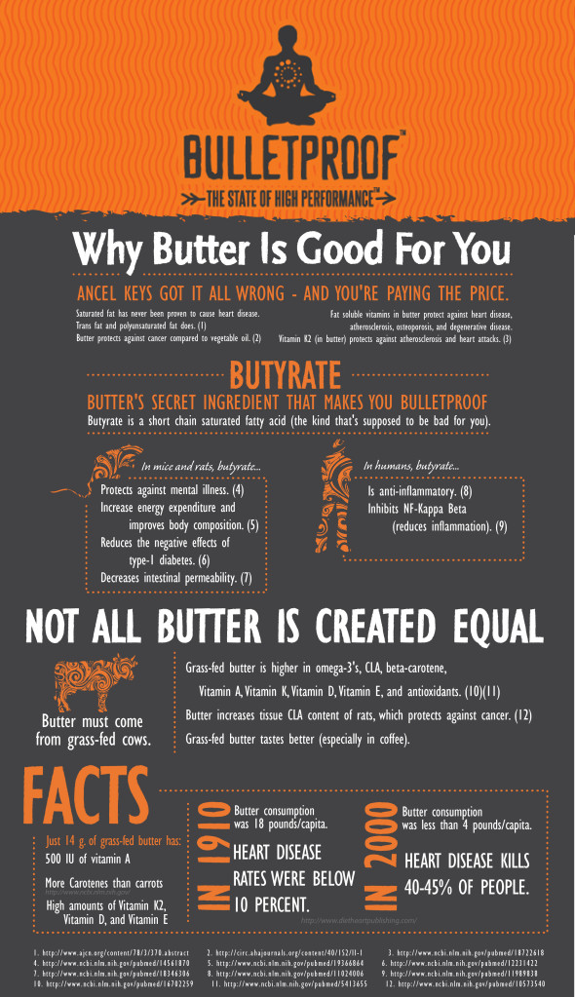
The Grains Debate – How Good For You Are They, Really?
Photo Credit: @status9 via Flickr

Edible grains comprise the majority of global cultivated crops and provide the greatest percentage of consumed calories worldwide, in the form of corn, rice, wild rice, wheat, barley, rye, kamut, spelt, millet, oats, triticale, buckwheat, quinoa, teff, and amaranth. Grains, however, are currently in the middle of a public relations nightmare. As an increasing number of people report incredible health improvements from the adoption of gluten-free or Paleo diets, the family of foods known as “cereals” is rapidly losing its status as a health food group. In fact, now, some would even refer to them as flat-out toxic.
But going completely grain-free isn’t easy, and the verdict still isn’t completely out on whether eliminating all grains is the best way to go. Our guest writer, Kathleen Bundy, combines her educated opinions with some of the main points expressed in various places to provide a comprehensive overview. Here are the bad and good of grains, and a response for each.
Whole grains do have health benefits for some people. They are a good source of fiber, provide a small amount of protein, and are rich in some vitamins and minerals.
You can, however, meet all of your nutrient needs on a grain-free diet, if necessary. For example, consider this: lamb liver contains nearly 10 times as much folate as the same amount of whole wheat flour, and the same amount of yardlong beans has 6-7 times as much. Cooked collard greens contain almost twice as much dietary fiber than cooked brown rice. Green peas has nearly three times as much and raw fireweed has six times as much (all according to Nourished Kitchen). Remember, eliminating or reducing grains from your diet makes room for more vegetables, which of course, is healthy for everyone.
Humans have been cultivating grains agriculturally for about 10,000 years. Certainly, we’ve grown used to them by now?
From an evolutionary perspective, this is a relative drop in the bucket. The hypothesis that grains are not fit for human consumption, then, is based on the premise that humans are not evolved to consume grains in the high concentrations that they are found in our diet today and that our digestive capacity has not evolved at the same rate as our diet has advanced over time. Notably, the diet that our ancestors thrived on for the majority of our species’ advancement was based on the hunter-gatherer pattern and included very little cereal grasses.
“When improperly prepared, grains can inhibit vitamin and mineral absorption. Grains contain substances like phytic acid which binds up minerals and prevents proper absorption. Essentially, though your diet might be rich in iron, calcium and other vital nutrients if you eat improperly prepared grain, you’re not fully absorbing nutrients from the foods you eat.” – Nourished Kitchen
Purchase organic and minimally processed grain products whenever possible. Keep portions reasonable and do not exceed the equivalent of three cups daily. You can also try soaking, sprouting, and fermenting grains to make them easier to digest. These techniques have been used for millennia and increase the availability of nutrients in grains. Sprouted buckwheat granola and sourdough bread are great examples.
Gluten is the name of the protein storage portion of edible grains. Most grains contain some form of gluten, but it is the “gliadin” portion of a certain class of grains that is toxic to people with celiac disease or “gluten-intolerance.” Wheat, rye, barley, spelt, kamut, and triticale are grains in this class. Oats may also be contaminated with gluten due to shared harvesting and storage equipment. “Current research estimates that about 1% of the population suffers from celiac disease, an auto-immune condition related to the ingestion of gluten-containing grains like wheat and barley; however, some researchers on celiac disease and gluten intolerance estimate that 30% to 40% of people of European descent are gluten-intolerant to some degree.” – Nourished Kitchen
Not all grains contain gluten, however. Some gluten-free grains include: amaranth, buckwheat, corn, millet, montina (Indian rice grass), oats, quinoa, rice, sorghum, teff, and wild rice.
For athletes, the consumption of whole grains offer a good energy source to fuel training. For some regimens it’s recommended that 60% of calories come from carbohydrates.
Grains are not the only sources of carbohydrates in our diets, though. Other sources of carbs include: beans and legumes, fruits, sugars and sweeteners, milk and dairy products, and starchy vegetables, such as potatoes, peas, squash, and corn. Personally, I steer most of my patients towards eating primarily non-grain sources of carbohydrate in whatever amount is appropriate for them. Check out “The Paleo Diet for Athletes,” written by Loren Cordain, Ph.D., and Joe Friel to see how you can make a grain-free diet work for your lifestyle.
As concentrated carbohydrates, grains may raise blood sugar and promote an insulin response. They may also contain compounds which can impair digestion, absorb nutrients, or damage the digestive tract. Lectins, though naturally occurring in grains, can impair (or damage) the intestinal lining and lead to digestive problems or food sensitivities. Phytate may bind to nutrients and make a portion of them unabsorbable by the body. Some people with inflammatory bowel diseases such as Crohn’s or colitis experience significant symptom improvement on a grain-free diet as a high starch intake may promote the growth of less-than friendly bacteria.
When taken in moderation, lectin and phylates may not be as bad as we think. Lectin is present in all foods at varying levels. Most of the lectin we eat becomes harmless when cooked. Some lectins, however, are not as affected by heat, and can be active when we eat them. This is the kind of lectin usually found in grains, though foods like carrots, apples, and bananas contain them as well. When some lectins enter our body, they can have positive effects. Lectins can break down the membranes of cancer cells, fungi, bacteria, and viruses. Lectins become an issue when they are consumed in large amounts. With too much lectin, the damage it can do to cancer and virus cells begins to pool over to your intestinal cells (according to OutLawFitness).
Similarly, phylate isn’t generally a worry with a well-balanced diet. Although they do keep a portion minerals from being absorbed, most people consume enough of what they need from their diets to make up for the small amount wasted (according to Dr. Andrew Weil).
Diets high in whole grains have been shown to significantly lower the risk of developing heart disease and stroke, increase IVF success in men, protect you from high blood pressure, improve insulin sensitivity by lowering insulin levels, significantly reduce heart failure risk, reduce risk for blood vessel disease and cancer, reduces the risk of type 2 diabetes, and help to lose and maintain weight.
While those health benefits are hard to ignore, it should be noted that while diets high in whole grains have been shown to have positive effects, there is probably many other health related behaviors and nutrition habits common to people that also eat more whole grains. Also, some of those results may be based on people who had a poor diet/lifestyle to begin with and when they started eating more whole grains and likely otherwise improving their diet, they had less health problems and lower risk of disease. In short, grains may not necessarily be responsible for the health benefits.
Also, the detrimental affects of grains must also be taken into consideration. The more hybridized or processed the grain, the greater the inflammatory potential. Whole grains are the least inflammatory of the grains, but they can still cause inflammation and immune reactivity. When immune cells mount a response against a foreign invader, the end result is inflammation. And since some groups of amino acids (proteins) in grains mirror that of body tissue, immune recognition of those proteins can cause your immune system to react to your own body. This can lead to autoimmune disease like Hashimoto’s thyroiditis and rheumatoid arthritis. Grains can also lead to tooth decay. Anthropologists often use the incidence of tooth decay as evidence of an agricultural society because record of pre-agricultural ancestors show little to no tooth decay (according to Nourished Kitchen).
To summarize, as gluten intolerance becomes a more prevalent problem, many people are finding relief by going gluten-free. Others are going entirely grain-free and experiencing significant benefits. However, a grain-free diet is not always easy, convenient, nor right for every individual. Consuming some grains may be right for some people, but remember to always focus on quality and processing techniques, and to eat smaller portions of grains. Eat more vegetables and non-grain sources of carbohydrates whenever you can to optimize your health.

Misunderstanding Cholesterol: How to Control Levels for a Healthy Body

credit: Instagram @kayleighmac92
Cholesterol has a bad rep. In 2009, nearly 600,000 Americans died of heart disease, more than the deaths from all cancers combined. And there’s no getting around it: high cholesterol is a major risk factor for heart disease. But what if we told you that a certain type of cholesterol is actually trying to help you? In many cases, cholesterol isn’t the culprit. It’s just responding to other underlying issues in the body.
In a recent article on her blog, Food Diary of a Dietitian, Kathleen Bundy sets out to clear cholesterol’s name. She explains the chemical’s important roles in human health, including its place in every single cell membrane in your body. Most Americans are at least aware of the negative connotations associated with the phrase ‘high cholesterol.’ As Kathleen explains, however, if your cholesterol is too low you could be a risk for various deficiencies, imbalances, and mental problems. She’ll introduce you to the two main types of cholesterol, their effects on your health, and how to make sure you are taking in the right amounts for a happy, healthy heart.

5 Critical Supplements for Women’s Health
in

Credit: Flickr Creative Commons, KMo Foto
In our quest to optimize our performance, we often need to understand what our baseline should be. Even the healthiest ones among us stand to benefit from diagnosing our current nutrition and improving it through supplements. We turned to one of our favorite pharmacists, Dr. Ross Pelton, for his recommendations on the top nutritional supplements every woman should take.
5 Critical Supplements for Women’s Health
1. A Daily Multivitamin/mineral supplement
A daily multivitamin/mineral supplement should be the foundation of everyone’s supplement program – a high potency, broad spectrum vitamin/mineral supplement. I do not mean a 1-a-day vitamin supplement. A 1-a-day supplement contains doses of nutrients that are equal to or similar to the RDA, which stands for the Recommended Daily Allowance. I think the RDA stands for the Really Dumb Allowance. I have thousands of studies in my data bases which report that doses of nutrients substantially higher than the RDA provide significant health benefits. I am not going to recommend a specific brand. I simply want to present the concept of a higher potency supplement. If you need advice, ask someone who works in a health food or vitamin store, or a knowledgeable health care professional. Taking your supplements in divided doses twice daily is much more beneficial than just taking them once a day.
2. Folic Acid
Folic Acid is an incredibly important nutrient for women. A deficiency of folic acid increases the risks for:
- Anemia, which results in fatigue and lack of energy
- Plaque buildup in the arteries which can cause strokes and/or heart attacks
- Hysterectomies
- Birth defects such as spina bifida, cleft lip and cleft pallet
- Breast cancer, uterine cancer and colon cancer
One reason I stress folic acid for women is because oral contraceptives deplete folic acid from a woman’s body. Hence, women who take birth control pills are much more likely to become folic acid deficient. I also urge women to have a blood test to assess their folic acid requirements.
3. Iron
Iron is especially important for premenopausal menstruating women. Every month when a woman has her period she loses some blood. A deficiency of iron causes anemia (tired ness, weakness & low energy) as well as a weakened immune system. However, iron is a double-edged sword. Too much iron can be harmful. This is why I always suggest that women have a lab test to have their iron levels checked. Do not take supplemental iron unless a lab test confirms that your iron levels are low.
4. Vitamin D
Vitamin D is one of the most commonly deficient nutrients in America. For decades it was thought that vitamin D’s primary function was to facilitate calcium absorption and reduce risks to osteoporosis. In the past decade, research into vitamin D’s activity and function has exploded. Scientists now realize that virtually every cell in our body contains vitamin D receptors and vitamin D controls thousands of genes. Some of vitamin D’s most important functions are now known to be regulation of genes that control many things, especially our immune system, and several different ways of protecting against cancer.
Vitamin D does itself is hard to measure. Therefore, vitamin D levels are determined by measuring a compound called 25-hydroxy vitamin D, or 25-OH D. Most labs state that levels of 25-OH D above 30 are optimal. I strongly disagree. I follow the world’s leading vitamin D researchers and their opinion is that optimal vitamin D levels should be between 50 to 60 ng/ml. I suggest that adults take 4,000 to 5,000 IU/day. The RDA for vitamin D is 600 IU/day, which is ridiculously low. VitaminD is a fat-soluble nutrient, and we do not absorb fat-soluble nutrients very efficiently. Taking vitamin D at your largest meal of the day, which is likely to contain some fat-containing foods will enhance the absorption of vitamin D.
5. Omega-3 Fish Oils
Omega-3 Fish Oils are non-negotiable…I recommend them for everyone. We need to talk about both omega-3 and omega-6 fats, because their ratio and their relationship to each other is a critical health issue. Our body cannot make these fats, so they must be obtained from the foods we eat.
It is important to understand that these fats are counter-regulatory. For example, some of the functions of omega-3 fats include lowering blood pressure, thinning the blood, reducing cancer risks and strengthening the immune system. Omega-6 fats do the opposite; increase blood pressure, stimulate blood clotting, increase cancer risks, and suppress the immune system. What is critical is the amount and the ratio between these two classes of fats. Experts suggest we our dietary ratio of omega-3 to omega-6 should be somewhere between 1 to 2 and 1 to 4. Unfortunately, many Americans consume a ratio of 1 to 20 or 1 to 30. Americans consume FAR too much of the omega-6 fats and far too little of the omega-3 fats. The overconsumption of omega-6 and underconsumption of omega-3 fats greatly increases risks to a wide variety of health problems.
I suggest that people take one or two omega-3 fish oil capsules twice daily. Quality is extremely important in this class of supplements. I only recommend the Nordic Natural brand as they have been independently shown the highest quality product on the market worldwide.
Nutritional supplements are not a substitute for a food. Supplements should be considered along with a healthy diet, exercise and other lifestyle attributes

Discovering And Optimizing Your Personal System Biology
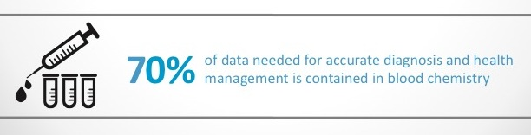
If the 20th century was one of reductionism, the 21st century is all about system biology. Knowing the function of individual parts is important, but so is looking at the body holistically. Every piece affects the other in complex ways.
Think of the body as a factory. DNA, the architect, draws up daily instructions (RNA) to build protein. The body can only use what it’s supplied for this process. Give a factory bad supplies and it will make a bad product. You are what you eat, as the saying goes.
At Krav Maga Worldwide Training Center in West LA, WellnessFX CEO Jim Kean discusses the changing face of healthcare in the 21st century, the difference between ‘health’ and ‘wellness,’ and the need for advancement in system biology as a means of prevention.
[youtube=http://www.youtube.com/watch?v=7MeRXrbvNS4&feature=youtu.be]
Main Take-Aways
- Every process in the body leaves some kind of ‘footprint.’ These markers can give insight to physical states, both past and present.
- “You can’t change what you don’t measure.” Technological advancements are increasing the amount of measurable information in the body. And the cost of these measurements? Downward spiral.
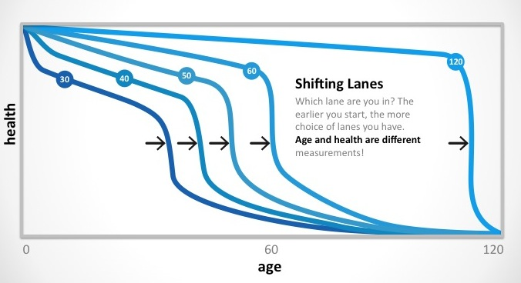
- Medical science has moved the chains on the age of death, but what’s the quality of life during the extra years we’ve tacked on? As shown by the above graph, our goal should be to push back both morbidity and disease as far as we can.
- 90% of the diagnostics tests done at the doctor’s aren’t seen by patients.
- One out of every ten American adults has a thyorid issue. By tweaking his thyroid, Jim upped his athletic performance by 5% in a year’s time.
- Limiting measurement easily causes oversight. For example, good cholesterol numbers don’t give enough information on sub-fractions like ApoB, a powerful indicator for cardiovascular health. Real life consequences of this oversight are seen in emergency rooms across America.
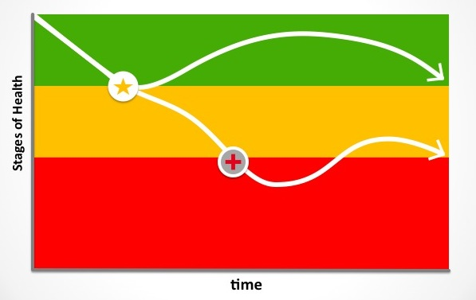
What It All Comes Down To
The original definition of health was the ‘absence of pathology.’ If you’re not sick, you’re healthy. But is waking up in the emergency room really the way you want to find out that something needs to change? Set up a warning system that alerts long before serious problems arise. Your body will thank you for it.

Nutritional Supplements: The Right Dose, The Right Kind
I want to address the importance of taking the right kind of nutritional supplement(s) and how to determine what the optimal dose of a supplement is for you. It is not a one-size-fits-all situation. When working with the WellnessFX platform, a trained pharmacist such as myself can review your personal history and laboratory test results to determine what is the best dose and type of supplement for you. In my practice and with the beta WellnessFX users, I often notice a few typical cases of health shortcomings that can easily be remedied through nutritional supplements.
1) Drug-Induced Nutrient Depletions: Many people take prescription drugs without realizing that most drugs cause nutrient depletions. It is important to know which nutrients are being depleted by your drug(s) so you can supplement with levels of the depleted nutrients to overcome the drug’s nutrient depletion effects. One of the most common examples is for women taking birth control pills. Oral contraceptives deplete many nutrients, which increase women’s risk of depression, sleep problems, heart disease, weakened immune system, and so on.
2) Abnormal Lab Test Markers: Let’s say one (or several) your laboratory test values comes back indicating HIGH RISK. Maybe its elevated cholesterol, or homocysteine, or blood glucose. In any of these cases, there are natural therapies (nutritional and/or herbal) that can be used therapeutically to improve and/or correct the situation. The trick is knowing what dose and what form of the specific supplement is best.
3) Biochemical Individuality: One of the most genetic variations is in the gene that converts the B-vitamin folic acid into its active form is used in the body. If you are one of the approximately 20% of Americans who have this genetic abnormality, you have a MUCH greater risk of heart disease and various forms of cancer. If you are a women, possessing this genetic abnormality, you have a greater risk of giving birth to an infant with birth defects. No symptoms usually manifest for years, until a major health crisis happens. The WellnessFX platform and team help identify genetic uniquenesses and advise clients as to which form and dosage level is required to help overcome these types of problems. In this example, a person with the gene variation for the folic acid-converting enzyme will be advised to take the active from of folic acid, which is called 5-methyl folate. This is critical for these clients, because the genetic variation means they can not utilize the folic acid in foods, nor can the effectively use the common folic acid nutritional supplement.
Understanding your personal health profile is critical to developing an appropriate supplement regimen. With the comprehensive practitioner care and advanced diagnostics of the WellnessFX platform, I can review an individual’s health history and laboratory test results to design a nutritional supplement program that is individualized to fit their unique biochemical and metabolic needs. This is true personalized health care…and a breakthrough to provide pro-active health advice.

Healthy Eating from an Eastern Medicine View
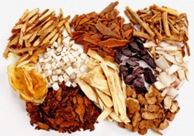
When we think about healthy eating, it is not only what you eat but also how you eat. Practitioners of Traditional Chinese Medicine (TCM) emphasize the regularity of meal times as important to maintaining health. Irregular eating patterns, such as eating late at night, skipping meals, and over- or under-eating can negatively impact the digestive system, leading to symptoms such as acid reflux, gas, and abdominal pain. Moreover, emotional stress or excessive mental activity during mealtimes, e.g. working lunches, watching tv, reading email, etc, could interfere with proper absorption of the nutrients in your food. This relationship between the mind and digestive system parallels that of the Brain-Gut Axis in western medicine.
According to TCM principles, food should be eaten at an unhurried pace, in small bites, and with little distraction. This is also the concept behind the Buddhist practice of “mindful eating,” which has attracted interest among health experts and consumers as a method to curb binge eating.
Yet there’s more than personal stress and distractions that could affect your eating habits and nourishment. According to TCM, even factors outside of your control such as seasons, temperature, and humidity may affect your appetite and weaken digestive systems. TCM recognizes that choosing the right kinds of food is what brings balance to an individual between their natural cycles and surroundings. To find the balance that works best for you, start by getting a deeper insight into the state of your health!
Currently a student and clinic intern at American College of Traditional Chinese Medicine (ACTCM) in San Francisco, Teresa Lau believes that health should not be viewed as merely a lack of disease, but rather, a positive state of physical, mental, and social well-being. Teresa’s vision is to combine her clinical training in Traditional Chinese Medicine (TCM) with her background in Public Health to not only heal clients through acupuncture treatments and herbal remedies, but to also educate everyone on TCM perspectives of health and well-being in order to empower them with the knowledge and tools to make positive lifestyle, diet, and behavioral changes.

High Protein, Low Carb or High Fat, Low Carb?
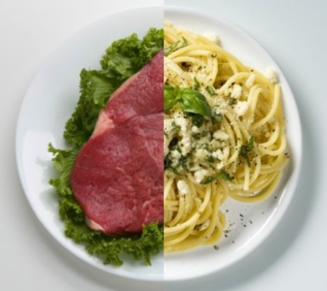
credit: Ben Greenfield Fitness
By now, you’ve probably heard about low-carb eating, and may have even adopted the lifestyle yourself. If you’re a little new to the whole low-carb thing, it’s not just about weight loss. Health benefits can include reduced risk of diabetes, increased HDL (good cholesterol), improved insulin sensitivity, decreased blood pressure, and it is also thought to reduce the risk of certain types of cancer. Sounds good, huh? But cutting carbs is only the first step.
It might be easy for an individual to decide on a low-carb diet based on their specific goals, but there are still two macronutrients left. So how to fill in the gap? Recently one of Ben Greenfield‘s listeners asked just that: Which is better, low-carb/high-protein or low-carb/high-fat?
Ben Greenfield is a leading source worldwide for people to learn how to use the most efficient techniques possible to transform their bodies, achieve their physical goals and, to put it simply, become superhuman. He hosts a regular podcast on his website, Ben Greenfield Fitness, and we definitely think they’re all worth a listen. In Episode #202 below, he starts talking about high protein versus high fat at about 1hr4min. He also discusses hip dysplasia, how to deal with a baker’s cyst, how carbs are listed on packaged food, trouble sleeping after evening workouts, what type of milk is best, HUUB websuits, over-the-counter testosterone creams, Muscle Activation Technique work, and ENG3. Give it a listen:

Ben talks about the importance and benefits of achieving a ketogenic state through a low-carb, high-fat diet. Ketosis may sound like a scary term. However, it simply indicates the presence of ketones in the body, which are produced from the breakdown of fatty acids. It means your body is using mainly fats as fuel and, depending on your goals, this can be a good thing.
Here are some of the take-away’s from Ben’s talk on high protein versus high fat diets.
- The ammonia smell some people experience in their breath is caused by the breakdown of proteins as primary fuel by the body. This can indicate either the breakdown of skeletal muscle tissue (i.e., reduction of lean body mass) or too much dietary protein.
- In a ketogenic state the body uses primarily fats or ketone bodies as fuel as opposed to actual protein. This process produces acetone, which can be present in the breath and urine. However, this has a fruity smell, much different than that of ammonia.
- When adopting a low-carb diet, it’s recommended to aim for 60-70% calories from fat, 15-35% from protein and 5-15% from carbs. Making your protein 60-70% (essentially an Atkin’s diet) leaves very little room for fats, and thus is not recommended.
- Prolonged high-protein diets are possibly unhealthy for your kidney or your liver.
Benefits of being in a state of ketosis include: accelerated fat loss, reduced risk of diabetes, better mental focus, reduced risk and potential treatment of Alzheimer’s disease and cancer, improved cardiovascular health, and better preservation of lean body mass (which becomes very important when trying to lose weight).

Traveling? 15 Ways to Pack Your Workouts and Stay On Track
Credit: Flickr Creative Commons, Niels Linneberg
It’s travel season and you want to maintain a health-conscious lifestyle. But how, when you’re so used to your gym back home, or your schedule is out of whack?
You don’t have to be a product of the environment – just because you’re traveling doesn’t mean you can’t keep moving. Don’t throw in the towel! Instead:
Challenge yourself: “For the next three trips longer than three days, I will commit to bringing along fitness equipment that will help keep me on track.”
15 Suggestions to Get You Started
First, how are you traveling and how much space do you have? Check to see which of the three categories below fit your traveling schedule.

On a road trip with trunk space or in a vanpool? Toss these pieces into the back and bust out when you get to your destination or even at rest stops along the way:
- Free weights: Pack some dumbbells and you can try this dumbbell workout. If you pack a single kettlebell, it can provide an entire workout.
- Push-up bars: You can purchase some from bodysolid.com or your local sporting goods store…or you can make a set yourself.
- Medicine ball: There are at least 25 difference exercises you can try, according to Greatist.com
- Pull-up bar: This one is easy to put up and take down.

If you have a little space available, as in a suitcase or a carry on, this list is for you because if you’re taking a plane, train, or bus, lugging around 40 extra pounds worth of dumbbells may not be feasible (for the record, we don’t recommend it), you can try:
- Water dumbbells: Aqua dumbbells will pack easy and expand to 32 lbs. of weight
- Balance discs: These ones from Natural Fitness pack virtually flat, even when inflated. Whether you take it on the road or use it at home, incorporating it into moves body weight moves, like push-ups, crunches, or one-legged squats, will improve balance, strength, and stability.
- Gliding discs: These pack flat and instantly create a smooth surface on carpet or wood.
- Yoga mat: Manduka makes a yoga mat specifically for travel – the eKO SuperLite is light and folds up. (although, even if you don’t have a mat, you can still do some yoga)
- Resistance bands: Find the level of resistance you need, toss them in your suitcase, and try these exercises.
- Jump rope: You can try this 15-minute jump rope workout, and when you’re done, just roll it back up and fit inside your shoes so it takes up even less space.
- Inflatable exercise ball: You can try gaiam.com or any sporting goods store. Easy to expand and then collapse when you’re ready to hit the road again.
- Yoga socks & gloves: You can skip the mat all together and just bring these.

- So you have minimal space. As in, barely anything. So….no space at all. We get it! Chunky sweaters take up a lot of space. You can still use your:
- Body weight: The body’s mass itself is a great source of resistance. Great bodyweight exercises include hand-stand push-ups, push-ups, pull-ups, air squats, one-legged squats, V-ups, and burpees. For an infographic on a full no-gym bodyweight workout, try this one.
- Activity tracker: If you want to stay on track, data can help you do that (and reach your health goals.) Track your steps with Moves or even quantify and map your run by downloading RunKeeper; Both mobile apps are free.
- Mobile apps: There are many mobile apps that can aid you in your fitness activity, no matter where you are. GAIN fitness has programs that range from basketball, yoga, crossfit and strength training – you tell it how much time you have and what resources are available, and it will suggest a full workout with a warm up, cool down, and detailed instructions. If you just need a timer to help with circuits, HIIT or Tabatas, there is the Seconds app.
Simple Steps to Wellness: Want More?
This blog is part of our Simple Steps to Wellness series.
We believe that incorporating small, feasible changes over shorter periods of change can help you experience the motivation and confidence that comes from seeing your personal goals fulfilled. Remember, you don’t need to wait until January 1, 20XX to get started – you can start today. You can incorporate healthy habits into your life with more ease than you may think.

