SELECTED INTANGIBLE AND TANGIBLE ASSETS VALUATION
Exhibit A4 – Selection of Appropriate Discount Rate
We estimated a discount rate based on a market participant’s perspective of
NeoPhotonics Russia’s weighted average cost of capital (“WACC”). The WACC is an estimate
of the rate of return on investment required by all investors of capital. The WACC is computed
by calculating the cost of debt and cost of equity. The costs of equity and debt were developed
based on market-derived data and factors relevant to the economy, the industry, and the
Company as of the Valuation Date. Certain data inputs were derived from the observed data of
selected guideline companies. These costs were then weighted in terms of a typical industry
capital structure to arrive at an estimated WACC.The WACC is determined as follows:
FORMULA 2. WACC
WACC = (Wd)(Kd) + (We)(Ke)
Where:
Wd
Kd
We
Ke
–
–
–
–
Share of debt to total capital
After-tax cost of debt
Share of equity to total capital
Cost of equity
Cost of Equity
The cost of equity (Ke), or required return on equity, was estimated using the capital asset pricing
model (“CAPM”). The CAPM may be used to relate the returns equity investors require to the
risk-free return as approximated by government securities. The additional returns or risk premium
required by the market in general can be adjusted by the factor beta, to account for relative risks
for specific industries. The CAPM utilizes the following formula to arrive at an appropriate cost of
equity rate.
FORMULA 3. DISCOUNT RATE CALCULATION
R = R + CRP+ β × R − R + SP
efmf
Where:
Re
Rf
CRP
β
Rm-Rf
SP
–
–
–
–
–
–
Required rate of return;
Risk-free rate;
Country Risk Premium;
Beta, a measure of the relationship between industry risk and the aggregate market;
The expected return of the market in excess of the risk free rate;
Size Premium.
(
)
Risk-free Rate (Rf)
A proxy of a risk free-rate Rf for investments was considered to be the 10-Year U.S. Treasury
Securities. As of June 30, 2014 they were yielding 2.53%26.
Country Risk Premium (CRP)
Country risk premium for Russian investments was estimated using the market pricing of 10-year
Russia Credit Default Swaps (CDS). As of the valuation date the market price of this contract
amounted to 2.25%27.
Beta
Estimation of the beta coefficient relates to a specific industry’s risk compared to the average
market risk. Essentially, it is a mathematical calculation of the historical reaction of the stock price
of representative companies in an industry, to the changes in the aggregate prices of the stocks
in the market as a whole.
The beta coefficient of 1.14 was indicated by the data provided by Aswath Damodaran 28 for
Telecom Equipment industry.
26
Bloomberg
Bloomberg
http://people.stern.nyu.edu/adamodar/
Valuation Report # 4218
Page 53
27
28
LLC “Amercian Appraisal”
Leading \ Thinking \ Performing

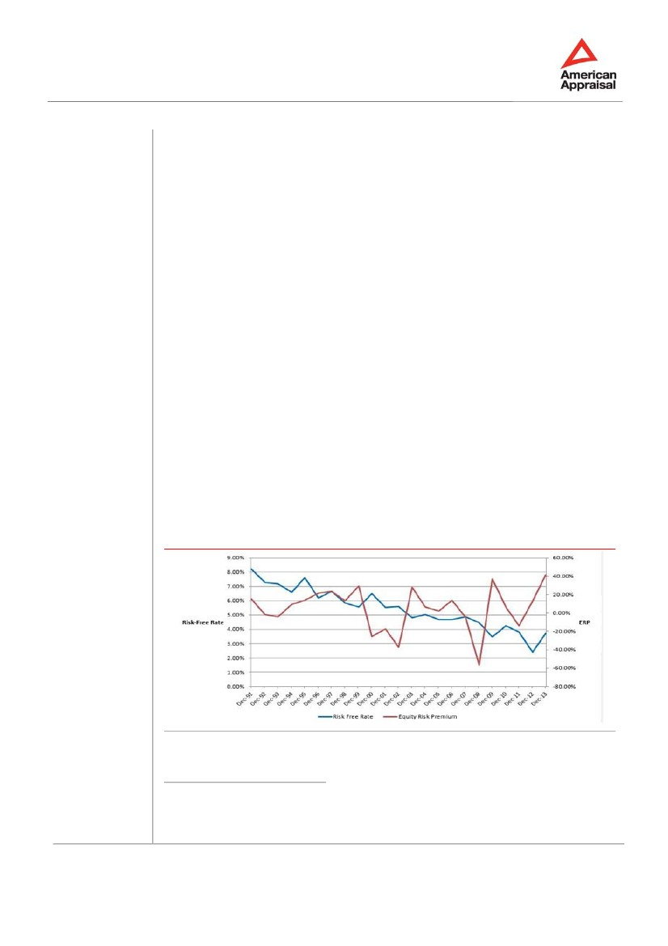
SELECTED INTANGIBLE AND TANGIBLE ASSETS VALUATION
Exhibit A4 – Selection of Appropriate Discount Rate
Equity Risk Premium
The equity risk premium (“ERP”) is the extra return over the expected yield on risk-free
securities that investors expect to receive from an investment in a diversified portfolio of
common stocks. It can also be thought to measure what investors demand over and
above the risk-free rate for investing in equities as a class or the market price for taking on
average equity risk.
There is no one universally accepted standard for estimating ERP. The methods
used in estimating it can be broadly categorized into one of the two approaches:
the Realized Return, or ex post approach, and the Forward-looking Return, or ex-ante
approach29.
The realized return approach is based on the expectation that history will repeat itself and
such a premium return will again be realized (on average) in the future. Historical market
realized equity premiums since 1926 as reported by Ibbotson Associates’ SBBI Yearbook are
often considered as proxy of ERP.
While one can observe premiums realized over time by referring to historical data,
such calculated premiums serve only as estimates for the expected ERP. Moreover
giving considerations to long-run historical arithmetic average realized returns, many recent
researches conclude that the post-1925 historical arithmetic average of one-year
realized premiums as reported in the SBBI Yearbook results in an expected ERP estimates that
is too high. In most recent update to the study of Roger Ibbotson and Peng Chen reported
in the SBBI Yearbook, Ibbotson Associates determine that the long-term ERP that
could have been expected given the underlying economics was approximately
6.1% on an arithmetic basis for 1926-2011 compared to actual risk premium of 6.6%30.
Research has shown that ERP is cyclical during the business cycle. When the economy is near
or in recession (and reflected in the relatively low prices of stocks), the conditional ERP is more
likely to be at the higher end of the range. When the economy improves (with expectations of
improvement reflected in higher stock prices), the conditional ERP is more likely at the lower end
of the range31.
Comparison of historical risk-free rate and ERP is provided in the chart below.
CHART 9. RISK-FREE RATE VS ERP
Source: American Appraisal
29
30
31
Roger J. Grabowski, “Equity Risk Premium: What is the Current Evidence?” Business Valuatin Digest, 2005
Ibbotson SBBI 2012 Valuation Yerbook
Shannon Pratt and Roger Grabowski, Cost of Capital: Applications and Examples, fourth edition (New York:
John Wiley & Sons, 2010), pages 115, 137
Valuation Report # 4218
Page 54
LLC “Amercian Appraisal”
Leading \ Thinking \ Performing

SELECTED INTANGIBLE AND TANGIBLE ASSETS VALUATION
Exhibit A4 – Selection of Appropriate Discount Rate
In recent years the historical basis of ERP was challenged on the back of the interest rates of
the risk-free asset dynamics. All around globe the US Treasury bonds were considered
as asset, which properties are almost matching the concept of risk-free asset. Therefore,
the US Treasury bonds were used as risk-free asset for the purposes of the relevant
calculation.
In recent years, US risk-free rates have reached levels near historic lows due to the
perceived low risk of US treasuries relative to the sovereign debt of other developed
nations. Additionally, the Federal Reserve and other Central Banks around the world have
undertaken quantitative easing and other efforts to lower interest rates in response to economic
conditions. As a result, the capital asset pricing model (“CAPM”), which utilizes the ERP to
calculate a cost of equity, has implied a below-average cost of equity when the market may have
exhibited higher risk.
American Appraisal32 researched and analyzed various economic and market factors in order to
determine where the current ERP should fall within a range of historical ERP. Analysis was
performed based on historical ERP for two terms 1993 – 2013 and 2003 – 2013.
Research revealed that CBOE volatility index (VIX), Damodaran’s Implied Premium, and
Moody’s Aaa corporate credit spreads demonstrated medium to strong negative correlation with
the historical ERP premiums. In particular the following results were arrived at:
TABLE 13.
Parameter
CBOE Volatility Index (VIX)
Damodaran’s Implied Premium
Moody’s Aaa 20 years corporate credit spreads
CORRELATION OF SUBJECT PARAMETERS AND ERP
1993 – 2013
-0.59
-0.30
-
2003 – 2013
-0.74
-0.49
-0.55
Source: http://www.american-appraisal.com/US/Library/Articles/Equity-Risk-Premium-Quarterly-7.htm
In addition the following economic indicators determining current status of the USA economy
were analyzed. Among the selected factors are these featuring economic cycle and
comprising Consumer sentiment trends, as tracked by the University of Michigan and
USA Real GDP.
With consideration of the above, ERP premium recommended by American Appraisal for the
purposes of calculations in combination with risk-free rate amounted to 6.0%.
32
http://www.american-appraisal.com/US/Library/Articles/Equity-Risk-Premium-Quarterly-7.htm
Valuation Report # 4218
Page 55
LLC “Amercian Appraisal”
Leading \ Thinking \ Performing

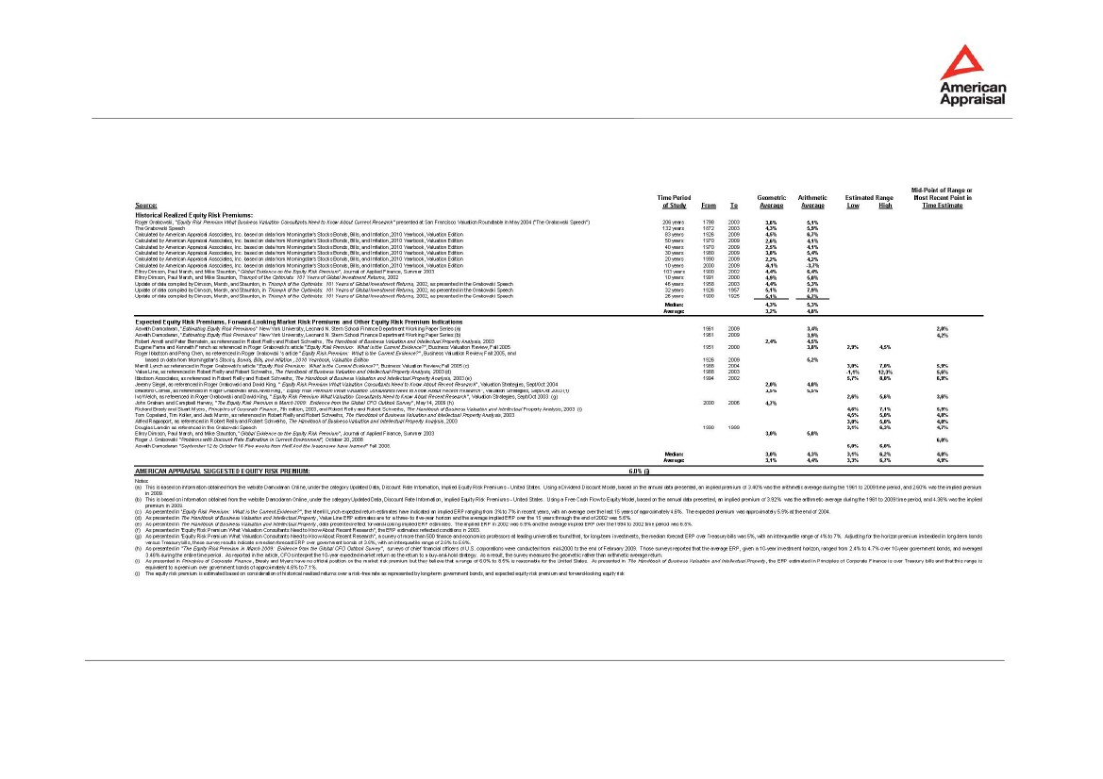
SELECTED INTANGIBLE AND TANGIBLE ASSETS VALUATION
Exhibit A4 – Selection of Appropriate Discount Rate
TABLE 14.
EQUITY RISK PREMIUM (“ERP”) STUDY)
LLC “Amercian Appraisal”
Leading \ Thinking \ Performing
Valuation Report # 4218
Page 56

SELECTED INTANGIBLE AND TANGIBLE ASSETS VALUATION
Exhibit A4 – Selection of Appropriate Discount Rate
Size Premium (SP)
The size premium reflects the risks specific to the company due to its size. This premium is also
known as the return in excess of CAPM or “beta-adjusted size premium”. The size premium is
considered as empirically observed correction to the CAPM.
Based on the data provided in "Morningstar, Inc.’s” SBBI (Valuation Edition 2013 Yearbook) size
premium (SP) of 3.81% (corresponding to Micro-Cap group of companies) was used for the
subject valuation.
Based on the above analysis the post-tax cost of equity in U.S. Dollars amounted
to 15.4%.
Cost of Debt
The before-tax cost of debt of 6.8% was selected based on the average interest rate for long-
term USD-denominated loans in Russia as of June, 2014 as indicated by Central Bank of Russia33.
Using the nominal corporate income tax rate of 20%, the after-tax cost of debt was concluded to
be 5.5%.
Capital Structure
Industry leverage of 10.8% as measured by the ratio of net debt to equity was indicated by the
data provided by Aswath Damodara34. This corresponds to the capital structure of 90% equity
and 10% debt, which was assumed in our analaysis.
WACC Conclusion
Based on the preceding analysis of each of the components, the concluded post-tax WACC was
calculated as follows:
Post- tax WACC
post -tax WACC
post-tax WACC
=
=
=
(Wd)(Kd) + (We)(Ke)
10%* 5.46%+ 90% * 15.43%
14.46%
The post- tax discount rate was concluded to be 14.46%.
33
34
http://www.cbr.ru/statistics/print.aspx?file=b_sector/rates_cr-no-d_14.htm&pid=procstavnew&sid=ITM_30164
http://people.stern.nyu.edu/adamodar/
Valuation Report # 4218
Page 57
LLC “Amercian Appraisal”
Leading \ Thinking \ Performing

SELECTED INTANGIBLE AND TANGIBLE ASSETS VALUATION
Exhibit B
Selected Tangible Assets Valuation
LLC “Amercian Appraisal”
Leading \ Thinking \ Performing
Valuation Report # 4218
Page 58

SELECTED INTANGIBLE AND TANGIBLE ASSETS VALUATION
Exhibit B – Illustrative Valuation Example
The exhibit provides illustrative valuation example for separate types of assets.
TABLE 15.
Asset
MACHINERY AND EQUIPMENT
LIGHTWAVE POWER
SENSOR (MODULE)
Machinery and equipment
4
July 2008
CNY 52 700
ASSEMBLY & TESTING
HORIZONTAL FURNACE
Plasma Enhanced
Chemical Vapor
Deposition (PECVD)
Machinery and equipment
1
Not in books
n/a
OPTICAL WAFER
PROCESSING
Market approach
Specialized asset
Novellus
concept 1 dielectric
Seller/s price (used
equipment)
$690,000
MV = VVS ×D
--
1.47
--
Accounting group
Quantity (Q)
Date in
Original Purchase Cost
Department
Valuation procedures:
Applied valuation procedure
Reasoning of valuation
approach selection
Producer
Model
Value Source (VS)
Value of the value source
(VVS)
Calculation formula:
Price index to valuation
date35,I
Delivery and Installation
Index (D)
Estimated cost new (CRN)*,
USD:
CORLP calculation:
Normal life (NL), years
Remaining life (RL), years
Calculation formula:
CORLP*, USD
Adjustment for functional
obsolescence:
CORLD*, USD
Adjustment for economic
obsolescence:
MV, USD
* Rounded
Machinery and equipment
1
Not in books
n/a
OPTICAL WAFER
PROCESSING
Cost approach
Specialized asset
Tystar
mini tytan 4600
Manufaturer’s Price
$380,000
СRN/COR = VVS × D
--
1.12
$423,800
Cost approach
Specialized asset
Agilent
81635A
Original Purchase Cost
$7,686
СRN/COR = VVS × I×D×Q
1.00
1.47
$45,200
--
--
10
4
10
10
COPLP = CRN × ⎜ 1 −
--
--
--
--
$1,014,990
⎛
⎝
NL − RL ⎞
NL
⎟
⎠
$423,800
0
$423,800
0
$423,800
$18,080
0
$18,080
0
$18,080
35
FM Global, http://www.fmglobal.com/
Valuation Report # 4218
Page 59
LLC “Amercian Appraisal”
Leading \ Thinking \ Performing

SELECTED INTANGIBLE AND TANGIBLE ASSETS VALUATION
Exhibit C
References Including Documents with Qualitative and
Quantitative Characteristics of the Property Appraised
LLC “Amercian Appraisal”
Leading \ Thinking \ Performing
Valuation Report # 4218
Page 60

SELECTED INTANGIBLE AND TANGIBLE ASSETS VALUATION
Exhibit С – References
Documents36 used by the Valuer as defining qualitative and quantitative characteristics of the
property appraised are provided below.
#
1.1
1.2
1.3
1.4
Name
List of subject tangible and intangible assets
NeoPhotonics Russia project overview and business plan
Financial statements of NeoPhotonics Corporation
Overview of Technopolis Moscow site offering
Applicable standards are provided below.
#
2.1
Name
Federal Law “Regulation of the Appraisal Activity in the Russian Federation” #135-FZ (amendments to
the law dated December 21, 2001; March 21 and November 14, 2002; January 10 and February 27,
2003; August 22, 2004; January 5 and July 27, 2006; February 5 and July 13, 2007, June 30, 2008)
The Federal Valuation Standards #1-#3 approved by the Russian Ministry for Economic Development
and Trade, Statements #256#254 respectively as of July 20, 2007
International Valuation Standards 2013 (IVS)
Decree of the Russian Ministry for Economic Development and Trade #303 “On confirmation of the
statute on procedures for expert examination of securities valuation report; on requirements and
procedures for selection of self-regulating organization of valuers, carrying out expert examination as of
September 29, 2006
Valuation Standards Code (VS 2010) of the Russian Society of Appraisers (RSA)
Russian accounting standards
International financial reporting standards
Business Valuation Standards of the American Society of Appraisers, June 1988
2.2
2.3
2.4
2.5
2.6
2.7
2.8
Bibliography is provided below.
#
3.1
3.2
3.3
3.4
3.5
3.6
3.7
3.8
Name
Roger J. Grabowski, “Equity Risk Premium: What is the Current Evidence?” 2005
Aswath Damodaran, Investment Valuation, 3rd edition. Alpina Business Book, 2006
James R. Hitchner, “Financial Valuation: Applications and Models”, John Wiley & Sons, 2003
Shannon P. Pratt, Robert F. Reilly and Robert P. Schweihs, “Valuing a Business: The Analysis and
Appraisal of Closely Held Companies”, 4th edition. McGraw-Hill, 2000
Shannon P. Pratt, Robert F. Reilly and Robert P. Schweihs, “Valuing Small Businesses and Professional
Practices”, 3rd edition. McGraw-Hill, 1998
American Society of Appraisers. Valuation of machinery and equipment, 2000
Infinera Corp. White papers of Photonic Integration Technology, 2011 and beyond
CISCO Visual Networking Index, 2014
Other sources of information are provided below.
#
4.1
4.2
Name
The official exchange rates of foreign currencies against the Russian Ruble set by the Central Bank of
the Russian Federation on selected date www.cbr.ru
Statistic data, provided by Federal State Statistics Service of the Russian Federation: www.gks.ru
36
Documents provided by the Client. As agreed with the Client, copies of documents are provided in Exhibit F
and in electronic files on CD, that is an integral part of the Report
Valuation Report # 4218
Page 61
LLC “Amercian Appraisal”
Leading \ Thinking \ Performing

SELECTED INTANGIBLE AND TANGIBLE ASSETS VALUATION
Exhibit D

Information about the Client and the Valuer
LLC “Amercian Appraisal”
Leading \ Thinking \ Performing
Valuation Report # 4218
Page 62

SELECTED INTANGIBLE AND TANGIBLE ASSETS VALUATION
Exhibit D1 – Information about the Client and the Valuer
Information about
the Client
Information about
the Valuer
Legal form and legal entity full name: NeoPhotonics Corporation
Location: 2911 Zanker Road, San Jose, CA 95134
Full name: Rumyantsev Alexander Yurievich
Membership in the Self-Regulated Organization (SRO) of Appraisers:
Member of self-regulated organization of valuers (Non-commercial
partnership Specialists and Valuers Community (SMAO) #0001 dated June
28, 2007, in the uniform state register of self-regulated organizations)
recorded in the registry of appraisers, registration #3559.
A copy of appraiser membership certificate is provided in Exhibit D4.
Professional education:
Plekhanov Russian Academy of Economics. Financial Valuation Certificate
PP # I №110453 dated July 30, 2010
Personal liability insurance data:
Policy of Valuer’s Liability Compulsory Insurance #433-068218/14, issued
by Ingosstrakh insurance company on September 15, 2014, effective from
September 25, 2014 till September 24, 2015
Work experience as an appraiser: since 2006
Valuer Location: Moscow, Russian Federation
Legal Address and
Other Pertinent
Information about
Valuation Company
employing the
Valuer
Limited liability company American Appraisal
Location: 1st Khvostov per., 11A Moscow 119180 Russian Federation
INN 9909014021
KPP 773851001
Main State Registration Number 5077746451085
OGRN date of issue: April 2, 2007
LLC “Amercian Appraisal”
Leading \ Thinking \ Performing
Valuation Report # 4218
Page 63

SELECTED INTANGIBLE AND TANGIBLE ASSETS VALUATION
Exhibit D2 – Certificate of Appraiser
I certify that, to the best of my knowledge and belief:
The statements of fact contained in this Report are true and correct.
The reported analyses, opinions, and conclusions are limited only by the reported assumptions
and limiting conditions, and represents the impartial and unbiased professional analyses,
opinions, and conclusions of LLC “American Appraisal”.
LLC “American Appraisal”, and I personally have no present or prospective interest in or bias
with respect to the property that is the subject of this Report and have no personal interest or
bias with respect to the parties involved.
The engagement of LLC “American Appraisal”, and myself personally in this assignment and
compensation for LLC “American Appraisal”, are not contingent on the development or reporting
of a predetermined value or direction in value that favors the cause of the client, the amount of
the value opinion, the attainment of a stipulated result, or the occurrence of a subsequent event
directly related to the intended use of this appraisal.
The analyses, opinions, and conclusions were developed, and this Report has been prepared,
in conformity with the International Valuation Standards (IVS) and Russian Federal Valuation
Standards #1-#3.
Members of my appraisal staff have made an inspection of the real and personal property that is
the subject of this Report.
In addition to those signing this Report the following people provided significant assistance
including investigation and research, as well as Report preparation – Alexander Lopatnikov,
Sergey Tsurinov, and Alexei Ovsiannikov.
Valuer
_____________________________
Alexander Rumyantsev
LLC “Amercian Appraisal”
Leading \ Thinking \ Performing
Valuation Report # 4218
Page 64

SELECTED INTANGIBLE AND TANGIBLE ASSETS VALUATION
Exhibit D3 – Project Team
List of specialists participating in the project with their qualifications is provided below.
Specialist
Alexander
Lopatnikov
Participation
Selected intangible
assets valuation
TABLE 16. PROJECT TEAM
Qualification
Plekhanov Russian Academy of Economics. Valuation.
Certificate of professional development # 164-7C, 2007.
London Business School Advanced Corporate Finance.
Executive Programme.
Plekhanov Russian Academy of Economics. Financial Valuation
Certificate PP # 409169.
The D. V. Efremov Scientific Research Institute of Electro Physical
Apparatus, Saint Petersburg. Post-graduate studies.
Moscow Engineering Physics Institute. Theoretical and Experimental
Physics.
Sergey
Tsurinov
Selected tangible
assets valuation
Leningrad Shipbuilding Institute. Qualification: ship constructor
Inter-industry Institute of Professional Development and
Management and Specialists Retraining.
Plekhanov Russian Academy of Economics.
Program "Valuation Activity".
Valuation Certificate of professional development # 175-7C, 2007.
Inter-industry Institute of Professional Development and
Management and Specialists Retraining.
Plekhanov Russian Academy of Economics. Professional valuation
and expert review of property and ownership rights. Business
enterprise (business) valuation. Business Enterprise (Business)
Valuation Certificate of professional development PP# 411100.
Courses in accounting
Leningrad State University, Automation Design Faculty,
Qualification: Software Engineer
Alexei
Ovsiannikov
Selected tangible
assets valuation
Plekhanov Russian Academy of Economics. Valuation. Certificate of
professional development # 165-7C, 2007.
Plekhanov Russian Academy of Economics. Financial Valuation
Certificate PP # 409170.
Moscow State Aviation Institute, Department of Business and
Management.
Moscow State University, Department of Economics.
B.A. Economics.
Moscow State University, Accounting Training Center:
International accounting training courses (GAAP).
LLC “Amercian Appraisal”
Leading \ Thinking \ Performing
Valuation Report # 4218
Page 65

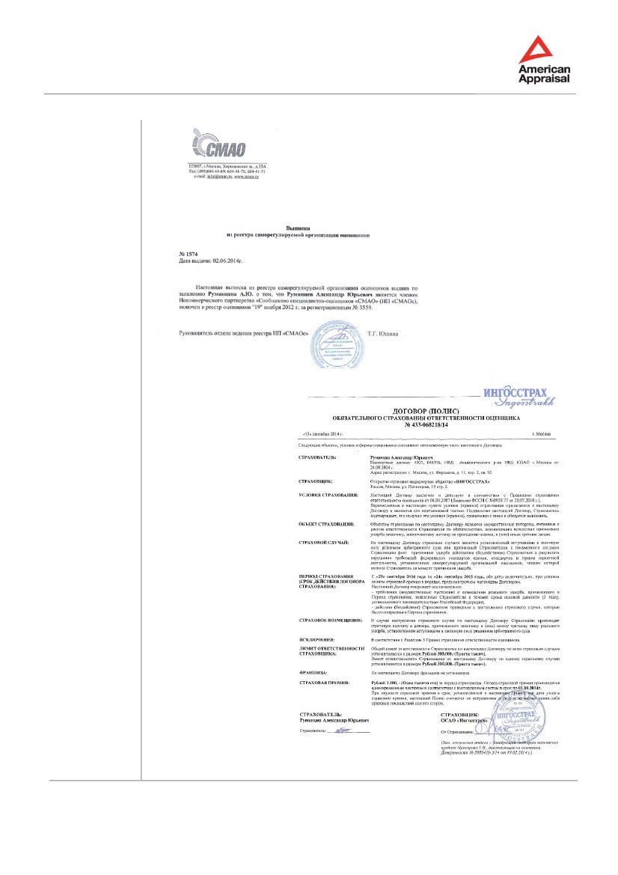
SELECTED INTANGIBLE AND TANGIBLE ASSETS VALUATION
Exhibit D4 – Appraiser Membership Details
LLC “Amercian Appraisal”
Leading \ Thinking \ Performing
Valuation Report # 4218
Page 66

SELECTED INTANGIBLE AND TANGIBLE ASSETS VALUATION
Exhibit E

Assumptions and Limiting Conditions
LLC “Amercian Appraisal”
Leading \ Thinking \ Performing
Valuation Report # 4218
Page 67

SELECTED INTANGIBLE AND TANGIBLE ASSETS VALUATION
Exhibit E – Assumptions and Limiting Conditions
This valuation consulting service was performed with the following general assumptions and
limiting conditions:
1.
To the best of our knowledge, all data, including historical financial data if any, relied upon
in reaching opinions and conclusions or set forth in this Report are true and accurate.
Although gathered from reliable sources, no guarantee is made nor liability assumed for
the truth or accuracy of any data, opinions, or estimates furnished by others that have
been used in this analysis.
No responsibility is assumed for matters legal in nature. No investigation has been made
of the title to or any liabilities against the property appraised. We have assumed that the
owner’s claim is valid, the property rights are good and marketable, and there are no
encumbrances that cannot be cleared through normal processes, unless otherwise stated
in the Report.
The value or values presented in this Report are based upon the premises outlined herein.
The date of value to which the conclusions and opinions expressed apply is set forth in
the Report. The value opinion herein rendered is based on the status of the economy and
on the purchasing power of the currency stated in the Report as of the date of value.
This Report has been made only for the use or uses stated, and it is neither intended nor
valid for any other use.
Possession of this Report or any copy thereof does not carry with it the right of publication.
No portion of this Report (especially any conclusion, the identity of any individuals signing
or associated with this Report or the firms with which they are connected, or any reference
to the professional associations or organizations with which they are affiliated or the
designations awarded by those organizations) shall be disseminated to third parties
through prospectus, advertising, public relations, news, or any other means of
communication without the written consent and approval of LLC “American Appraisal”.
Areas, dimensions, and descriptions of property, if any, used in this analysis have not
been verified, unless stated to the contrary in the Report. Any areas, dimensions, and
descriptions of property included in the Report are provided for identification purposes
only and should not be used in a conveyance or other legal document without proper
verification by an attorney.
Plans and maps, if any, presented in the Report are intended only as aids in visualizing
the property and its environment. Although the material was prepared using the best
available data, it should not be considered as a survey or scaled for size.
8.
Unless stated to the contrary in the Report, no environmental impact study has been
ordered or made. Full compliance with all applicable federal, state, and local
environmental regulations and laws is assumed unless otherwise stated, defined, and
considered in the Report. We have also assumed responsible ownership and that all
required licenses, consents, or other legislative or administrative authority from any local,
state, or national government or private entity organization either have been or can be
obtained or renewed for any use that is relevant to this analysis
The value estimate contained within the Report specifically excludes the impact of
substances such as asbestos, urea-formaldehyde foam insulation, other chemicals, toxic
wastes, or other potentially hazardous materials or of structural damage or environmental
contamination resulting from earthquakes or other causes, unless stated to the contrary
in the Report. It is recommended that the reader of the Report consult
a qualified structural engineer and/or industrial hygienist for the evaluation of possible
structural/environmental defects, the existence of which could have a material impact on
value.
2.
3.
4.
5.
6.
7.
9.
LLC “Amercian Appraisal”
Leading \ Thinking \ Performing
Valuation Report # 4218
Page 68

SELECTED INTANGIBLE AND TANGIBLE ASSETS VALUATION
Exhibit E – Assumptions and Limiting Conditions
10.
No soil analysis or geological studies were ordered or made in conjunction with the Report,
nor were any water, oil, gas, or other subsurface mineral and use rights or conditions
investigated, unless stated to the contrary in the Report.
It is assumed that all applicable zoning and use regulations and restrictions have been
complied with unless nonconformity has been stated, defined, and considered in the
Report. Further, it is assumed that the utilization of the land and improvements is within
the boundaries of the property described and that no encroachment or trespass exists
unless noted in the Report.
If we have made a physical inspection of the property, the inspection was made by
individuals generally familiar with real estate and building construction. However, we do
not opine on, nor are we responsible for, the structural integrity of the property including
its conformity to specific governmental code requirements, such as fire, building and
safety, earthquake, and occupancy, or any physical defects that were not readily apparent
to the appraisers during their inspection.
11.
12.
LLC “Amercian Appraisal”
Leading \ Thinking \ Performing
Valuation Report # 4218
Page 69

