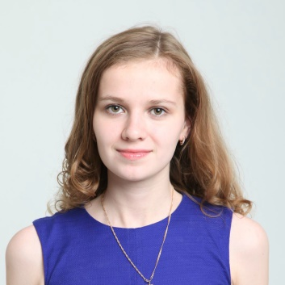
Kasintseva Anastasia
Tel: 89160364249
E-mail: kasintsevaa@yahoo.com

Profile:
A fourth-year linguistics student. Reliable, trustworthy, numerate and meticulous. An interpreter, a monitor of the group, a professor’s assistant, children’s English and German tutor.
Education:
2013 - … Higher School of Economics; Theoretical and computational linguistics; 4 year of studying;
Scholarships and international exchange programs:
April 2016 – September 2016 – Erasmus + student in Jena, Thüringen, Germany;
June 2015 – September 2015 – Work and Travel participant in the US;

Experience:
2016 - … interpreter
September 2016 – interpreter at “Textile EXPO”
2013 - … personal English and German tutor
July 2015 – August 2015 shop-assistant in Calzedonia (a lot of customers from all over the world)
January 2014 – May 2014 an assistant of Academic Writing Course
2013 – 2014 the University of children’s volunteer
January 2013 – a volunteer at Linguistic Competition (checking), at HSE competition ( an organisator)
2010 - 2013 Promoter

Computer skills:
Microsoft Windows 7 / 8, Linux, MAC OS X
Microsoft Office 2010 / 2013 (Word, Excel, PowerPoint, Access),
Programming (Python, HTML, CSS, JavaScript).

Hobbies and interests:
A good tennis-player and swimmer;
Like studying, reading, travelling, languages, other countries and their cultures.

