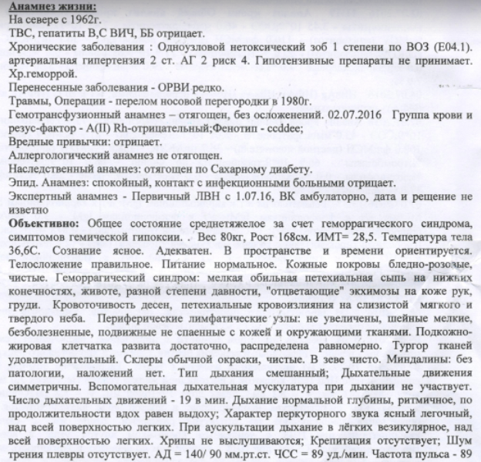
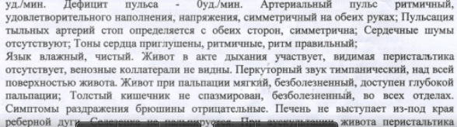
Present Medical history:
Lives in the North since 1962.
Denies having TB, Hepatitis B, C, HIV or BD
Chronic illnesses: one-sided non-toxic goiter of 1st degree as defined by WHO.
2nd degree arterial hypertension with risk factor 4. Does not take hypotension medication. Chronic hemorrhoid.
Past medical history: ARI – rarely
Trauma, Surgical history: nasal septum fracture in 1980.
Had incompatible blood transfusion without complications. 2.7.2016. Blood type and Rh factor: A(II), Rh negative; phenotype: ccddee
Social history: denies drinking or smoking.
Allergies: none.
Family history: diabetes.
History of infectious illnesses: denies contact with infected people.
Expert history: initial temporary disability permit since 01.07.2016, by medical board, outpatient, date and decision unknown.
Objective: moderate to severe condition in view of hemorrhagic syndrome, symptoms of blood hypoxia. Weight - 80 kg, height -168 cm, BMI=28.5 Body temperature 36,6 C. Awake and alert. Oriented to time and place. Of normal build. Eating habits: normal. Skin is of pale-pink color, clear. Hemorrhagic syndrome: small abundant petechiasis of lower limbs and abdomen, different in age, discolored skin ecchymosis of hands, chest. Bleeding of gums, petechial hemorrhage of mucous membrane in soft and hard palate. Peripheral lymphatic nodes: not enlarged, small, painless, mobile, not attached to skin or surrounding tissue. Fatty tissue is well-developed, distributed evenly. Tissue turgor is satisfactory. Sclera is clear, of usual coloring. Pharynx is without obstruction. Tonsils without pathology, no abscess. Respiration is orinasal. Breathing movements are symmetrical. Accessory muscles are not in use during breathing process. Breathing movements rate – 19 per minute. Breathing is normal, rhythmic; inhale and exhale are equal in length. Resonance is clear, pulmonary throughout lungs. Auscultation reveals breathing is vesicular throughout. No wheezing. No crepitation. No pleural fremitus. BP = 140/90, CCR= 89 beats per minute. Pulse rate – 89 beats per minute. Pulse deficit – 0 beats per minute. Arterial pulse is rhythmic, with satisfactory inflation and tension, and symmetric in both arms. Pulsation of dorsalis pedis artery can be measured on both sides, symmetric. No cardiac murmur. Heart sound is muted, rhythmic, rhythm is normal.
Tongue is moist, clear. Abdomen participates in breathing act, no visible peristalsis, venous collaterals are not noted. Resonance is tympanic throughout abdomen. Abdomen palpation reveals softness, no pain, available for deep palpation. Large intestine has no spasms, no pain, in all compartments. Irritation symptoms in abdomen are negative. Liver does not emerge from below the edge of costal arch. Spleen is not palpated.

