  - Removal of the chuck

    - Removal cycle

The chuck needs to be removed and cleaned at least for one time when it is operated for more than 1000 hours. If the chuck cuts the castings, then the chuck needs to be cleaned for one time at least when it operates for 300 hours.

    - Procedures

Remove the upper soft jaw.

Remove the cover case of the chuck end face.

Loosen the internal tightening nut with the rod wrench, and uncouple the slide trombone. Loosen the tightening bolts of the chuck, and remove the chuck.
Remove the sliding block.

Pull the main jaw from inside and take it out at the back of the chuck.

Remove the piston nut inside the sliding block, and remove the tightening nut as well. After the removal, clean the chuck components with oil or benzene and dry them.
Clear up the cuttings inside the chuck body or the damaged parts, and coat the tracks of the sliding block and the main jaw with grease containing molybdenum disulfide.

Inferior grease will affect the clamping force of the chuck and damage the chuck in turn.

Reinstall the chuck in the reverse order of the removal.

In the proper order, install the main jaw and sliding block into the chuck body.

  - Fault handling

When the chuck emerges any fault, the followings should be checked and correct measures need to be taken before contacting the service provider of Haitian Precision Machinery Co. Ltd.

    - Chuck can not move

If the chuck components are damaged, dismantle the chuck and replace the components.

If the operation component is pressed or stuck, dismantle the chuck and correct the pressed or stuck component.

If the hydraulic cylinder is not working, check the hydraulic circuit and see whether the hydraulic pipe has hydraulic oil or not.

    - The main jaw does not move according to the specified travel If there is foreign matter inside the chuck, remove the chuck and clean it. If it is due to the loose rod, screw it tightly.

    - The work piece falls off the chuck during the cutting

If the travel of the jaw is improper, adjust it until that the main jaw is in the middle of the travel when the work piece is clamped tightly.

When the diameters of the work piece and the soft jaw are different, the soft jaw is processed. When the cutting force is big, calculate the cutting force and change the cutting conditions. When the rotating speed is high, reduce the speed till it reaches the needed clamping force.
Check whether the oil viscosity meets the specified requirements or not, and when the viscosity is low, change the oil.

    - The work piece can not reach the required machining precision

The chuck has periphery run-out, which needs to be reinstalled.

If there is some foreign matter or iron filings in the connecting gears between the main jaw and the soft jaw, remove the top jaw and clean the gears.

If the coupling bolt of the top jaw is not fastened tightly, lock the bolt tightly according to the specified torque.

If the machining condition of the top jaw is not so good, correct and modify the top jaw.

If the height of the top jaw is excessive and makes the top jaw deform or makes the bolt expand, reduce the height of the top jaw as much as possible.

If the excessive clamping force deforms the work piece, reduce the clamping force within the allowable range.

5.8 Lubrication

5.8.1 Routine lubrication

It is very necessary to maintain the lubrication in order to reach the high precision of the chuck for a long time. However, the improper lubrication could lead to the following problems:

Abnormal operation under the low hydraulic pressure Insufficient clamping force
Low clamping precision Abnormal abrasion Damage
Thus the lubrication oil needs to be supplied on a daily basis.

5.8.2 Routine cleaning

The chuck body and the track need to be cleaned everyday after the work.

6. Machine Tool Structure

6.1 spindle

6.1.1 spindle box

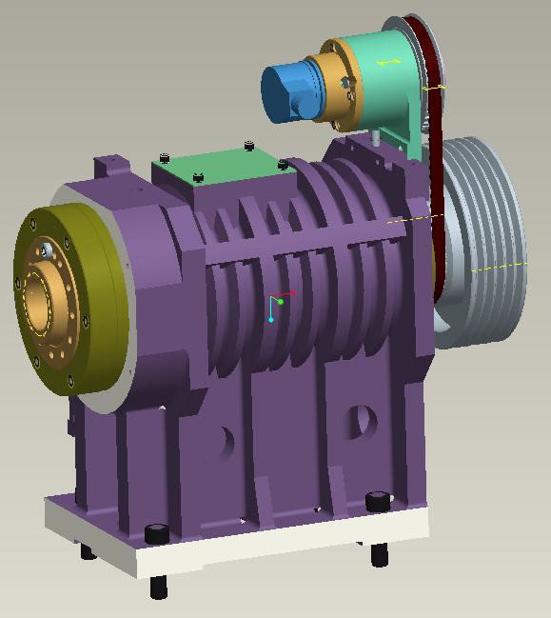

6.1.2 spindle torque-power

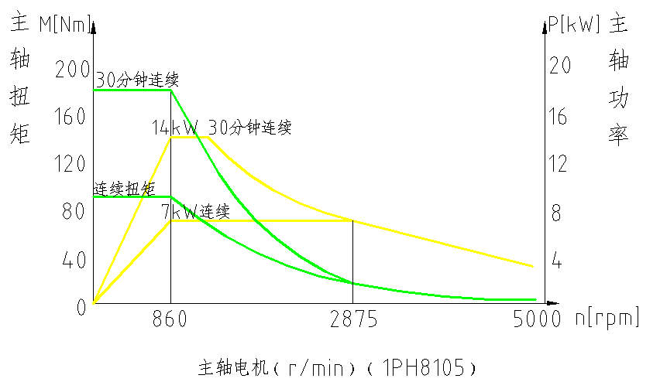

Rated Output Description
7kW of continuous output power and 14kW of 15-minute output power referred to in the above characteristic diagram for the speed output of the spindle are simply explicated as follows:
Continuous Output Power

Under the condition of 7 kW of output power, even though the machine tool works continuously, all the temperature rises of the insulating layers and other restrictions would not exceed. At the same time, in the case that the maintenance of the machine tool is in
normal condition, no matter how long the machine tool works with such continuous output power, the motor will not burn out.

1) Short-term Output Power

In the case that the maximum ambient temperature is 40℃, if the machine tool work for a short time (15 minutes) with the set output power (14 kW), all the temperature rises of the insulating layers and other restrictions would not exceed.

In other words, the 15-minute output power means the following: if the power reaches 14 kW, the motor will reach the ultimate temperature rise only when the machine tool runs for 15 minutes. Of course, if the operation stops just for a short time, the temperature rise of the motor will still gradually reach the ultimate value.

It is about theoretical explanation of output power above. However, on the machine tools of our company, the value of 100% showed in the motor load table refers to the state of continuous output power.

  - Axial Feed Transmission

    - X-Axis Feed System

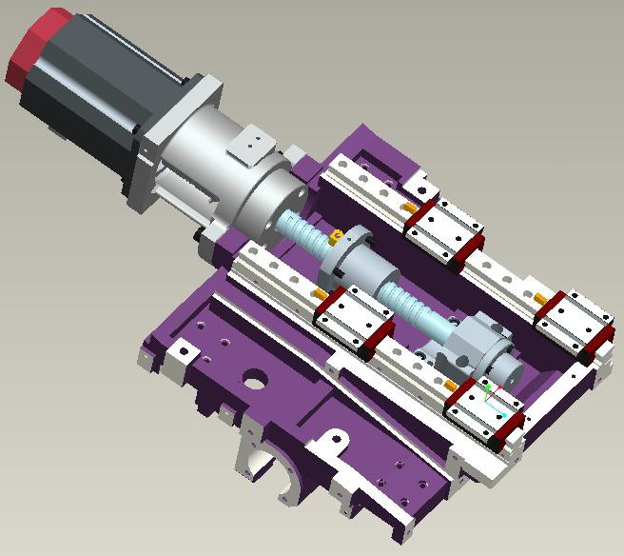
    - Z-Axis Feed System

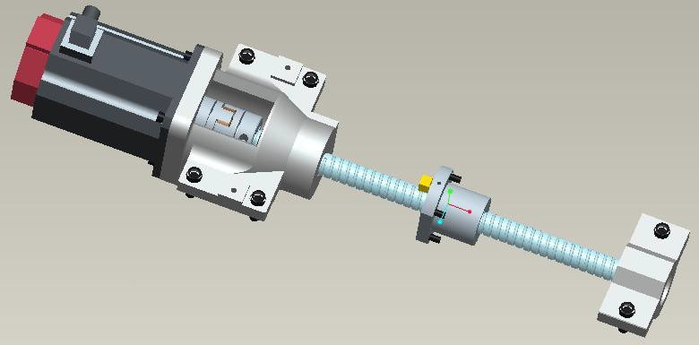

6.3. Turret

6.1.3 Parallel Adjustment with Turret

After unexpected cases such as car crashes happened, the cutter head will absorb the energy from car crashes, and displacement may be caused.
1） Install the tool disc onto turret, with bolt unscrewed.
2） Position the tool disc with pin, after the locating pins are knocked lightly in (other location pin holes), 8 mounting screws on the cutter head should be locked.

3) install dial indicator in the spindle box or other fixed position; after the X-axis is moved, a line of 45° on the cutter head surface is made.
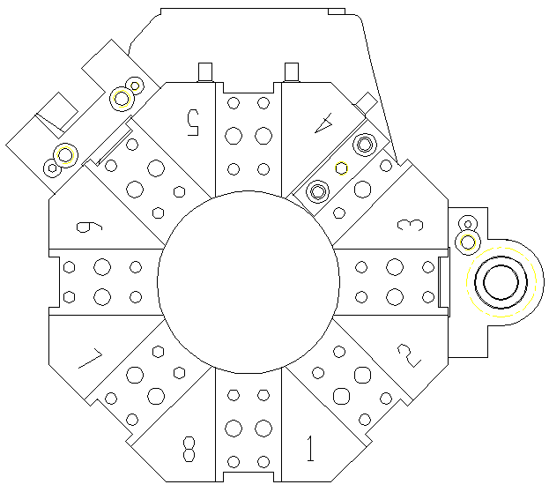

The allowable tolerance of the line should be within 0.02 mm; if it exceeds the tolerance, adjustment should be conducted according to the following steps:

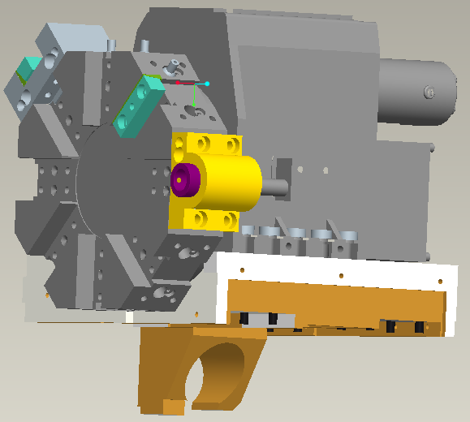

- Loosening the eight locking screws on the tool turret;
- Adjusting the location of the tool turret with the locating pin in the mounting seat of the tool turret as the ce nter of the circle, until the allowable tolerance of the indicator is within 0.02 mm;
- Locking the screws.

