Транзисторные ключи могут использоваться для включения или отключения низковольтного устройства постоянного тока (например, светодиодов) с использованием транзистора в насыщенном состоянии или отключенном.

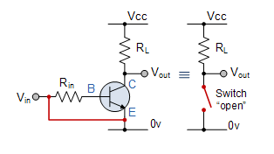

При использовании в качестве усилителя сигнала переменного тока напряжение смещения базы транзистора применяется таким образом, что оно всегда работает в своей «активной» области, то есть используется линейная часть кривых выходных характеристик.

Однако оба типа биполярных транзисторов типа NPN и PNP могут работать как полупроводниковый переключатель типа «ВКЛ / ВЫКЛ» путем смещения транзисторов. Базовый терминал по-разному соответствует сигнальному усилителю.

Твердотельные переключатели являются одним из основных приложений для использования транзистора для переключения постоянного тока «ВКЛ» или «ВЫКЛ». Некоторым выходным устройствам, таким как светодиоды, требуется только несколько миллиампер при напряжении постоянного тока на логическом уровне и поэтому может управляться напрямую выходом логического вентилятора. Однако устройства с высокой мощностью, такие как двигатели, соленоиды или лампы, часто требуют большей мощности, чем у обычных логических вентилей, поэтому используются транзисторные переключатели.

Если схема использует биполярный транзистор как коммутатор, то смещение транзистора, либо NPN, либо PNP, предназначено для работы транзистора с обеих сторон кривых характеристик «I-V», которые мы видели ранее.

Области работы транзисторного переключателя известны как область насыщения и область отсечения. Это означает, что мы можем игнорировать действующую схему смещения Q-точечной цепи и делителя напряжения, необходимую для усиления, и использовать транзистор в качестве переключателя, перемещая его назад и вперед между его «полностью выключенным» (отсечкой) и «полностью отключенным», ON "(насыщенность), как показано ниже.Operating Regions
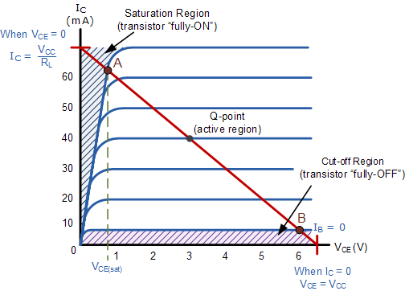

The pink shaded area at the bottom of the curves represents the “Cut-off” region while the blue area to the left represents the “Saturation” region of the transistor. Both these transistor regions are defined as:

1. Cut-off Region
Here the operating conditions of the transistor are zero input base current ( I_{B} ), zero output collector current ( I_{C} ) and maximum collector voltage ( V_{CE} ) which results in a large depletion layer and no current flowing through the device. Therefore the transistor is switched “Fully-OFF”.

Cut-off Characteristics
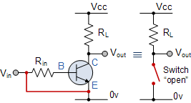 | - • The input and Base are grounded ( 0v )  - • Base-Emitter voltage V_{BE} < 0.7v  - • Base-Emitter junction is reverse biased  - • Base-Collector junction is reverse biased  - • Transistor is “fully-OFF” ( Cut-off region )  - • No Collector current flows ( I_{C} = 0 )  - • V_{OUT} = V_{CE} = V_{CC} = ”1″  - • Transistor operates as an “open switch”

Then we can define the “cut-off region” or “OFF mode” when using a bipolar transistor as a switch as being, both junctions reverse biased, V_{B} < 0.7v and I_{C} = 0. For a PNP transistor, the Emitter potential must be negative with respect to the Base.

2. Saturation Region
Here the transistor will be biased so that the maximum amount of base current is applied, resulting in maximum collector current resulting in the minimum collector emitter voltage drop which results in the depletion layer being as small as possible and maximum current flowing through the transistor. Therefore the transistor is switched “Fully-ON”.

Saturation Characteristics
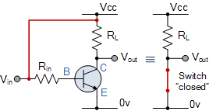 | - • The input and Base are connected to V_{CC}  - • Base-Emitter voltage V_{BE} > 0.7v  - • Base-Emitter junction is forward biased  - • Base-Collector junction is forward biased  - • Transistor is “fully-ON” ( saturation region )  - • Max Collector current flows ( I_{C} = Vcc/R_{L} )  - • V_{CE} = 0 ( ideal saturation )  - • V_{OUT} = V_{CE} = ”0″  - • Transistor operates as a “closed switch”

Then we can define the “saturation region” or “ON mode” when using a bipolar transistor as a switch as being, both junctions forward biased, V_{B} > 0.7v and I_{C} = Maximum. For a PNP transistor, the Emitter potential must be positive with respect to the Base.
Then the transistor operates as a “single-pole single-throw” (SPST) solid state switch. With a zero signal applied to the Base of the transistor it turns “OFF” acting like an open switch and zero collector current flows. With a positive signal applied to the Base of the transistor it turns “ON” acting like a closed switch and maximum circuit current flows through the device.
The simplest way to switch moderate to high amounts of power is to use the transistor with an open-collector output and the transistors Emitter terminal connected directly to ground. When used in this way, the transistors open collector output can thus “sink” an externally supplied voltage to ground thereby controlling any connected load.
An example of an NPN Transistor as a switch being used to operate a relay is given below. With inductive loads such as relays or solenoids a flywheel diode is placed across the load to dissipate the back EMF generated by the inductive load when the transistor switches “OFF” and so protect the transistor from damage. If the load is of a very high current or voltage nature, such as motors, heaters etc, then the load current can be controlled via a suitable relay as shown.

Basic NPN Transistor Switching Circuit
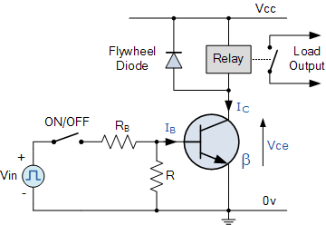

The circuit resembles that of the Common Emitter circuit we looked at in the previous tutorials. The difference this time is that to operate the transistor as a switch the transistor needs to be turned either fully “OFF” (cut-off) or fully “ON” (saturated). An ideal transistor switch would have infinite circuit resistance between the Collector and Emitter when turned “fully-OFF” resulting in zero current flowing through it and zero resistance between the Collector and Emitter when turned “fully-ON”, resulting in maximum current flow.
In practice when the transistor is turned “OFF”, small leakage currents flow through the transistor and when fully “ON” the device has a low resistance value causing a small saturation voltage ( V_{CE} ) across it. Even though the transistor is not a perfect switch, in both the cut-off and saturation regions the power dissipated by the transistor is at its minimum.
In order for the Base current to flow, the Base input terminal must be made more positive than the Emitter by increasing it above the 0.7 volts needed for a silicon device. By varying this Base-Emitter voltage V_{BE}, the Base current is also altered and which in turn controls the amount of Collector current flowing through the transistor as previously discussed.
When maximum Collector current flows the transistor is said to be Saturated. The value of the Base resistor determines how much input voltage is required and corresponding Base current to switch the transistor fully “ON”.

Transistor as a Switch Example No1
Using the transistor values from the previous tutorials of: β = 200, Ic = 4mA and Ib = 20uA, find the value of the Base resistor (Rb) required to switch the load fully “ON” when the input terminal voltage exceeds 2.5v.
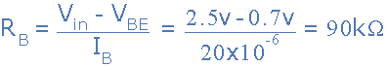

The next lowest preferred value is: 82kΩ, this guarantees the transistor switch is always saturated.

Transistor as a Switch Example No2
Again using the same values, find the minimum Base current required to turn the transistor “fully-ON” (saturated) for a load that requires 200mA of current when the input voltage is increased to 5.0V. Also calculate the new value of Rb.
Transistor Base current:
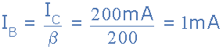

Transistor Base resistance:
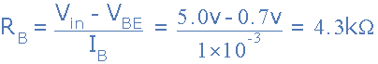

Transistor switches are used for a wide variety of applications such as interfacing large current or high voltage devices like motors, relays or lamps to low voltage digital IC’s or logic gates like AND gates or OR gates. Here, the output from a digital logic gate is only +5v but the device to be controlled may require a 12 or even 24 volts supply. Or the load such as a DC Motor may need to have its speed controlled using a series of pulses (Pulse Width Modulation). transistor switches will allow us to do this faster and more easily than with conventional mechanical switches.

Digital Logic Transistor Switch
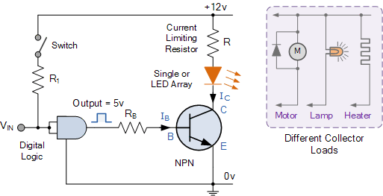

The base resistor, Rb is required to limit the output current from the logic gate.

PNP Transistor Switch
We can also use the PNP Transistors as a switch, the difference this time is that the load is connected to ground (0v) and the PNP transistor switches the power to it. To turn the PNP transistor operating as a switch “ON”, the Base terminal is connected to ground or zero volts (LOW) as shown.

PNP Transistor Switching Circuit
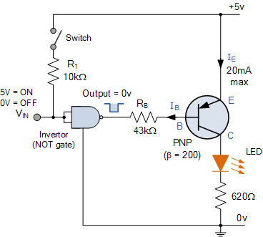

The equations for calculating the Base resistance, Collector current and voltages are exactly the same as for the previous NPN transistor switch. The difference this time is that we are switching power with a PNP transistor (sourcing current) instead of switching ground with an NPN transistor (sinking current).

