Employee Responsibilities

Personal Appearance
Your appearance has a big effect on your property's image. You can show guests you care about yourself and the property by keeping a clean, professional appearance.
Cleanliness comes from:
- Bathing or showering every day before work
- Using deodorant/antiperspirant every day before work
- Brushing your teeth every day before work
- Shampooing your hair often
- Changing your undergarments and wearing clean ones every day
A professional appearance comes from:
Cleanliness also comes from washing your hands or using hand sanitizer:
- Before going on duty
- After sneezing, coughing, or blowing your nose
- After touching something soiled
- After taking a break
- After smoking a cigarette
- After using the restroom
- Wearing your hair short, or tying it back so it is off your shoulders
- Having hair that is of no more than two naturally-occurring colors
- Being clean-shaven and following the property's guidelines for facial hair
- Keeping your fingernails clean and short, not wearing garish or brightly-colored nail polish, and using hand lotion to keep hands soft and presentable
- Applying makeup in a natural and conservative style
- Using little or no cologne or perfume
- Wearing little or no jewelry
Ask your manager or trainer for more information about the property's dress code and appearance standards.
Comply with your property's guidelines regarding body piercings or tattoos.
SKILLS, TASKS, AND RESULTS TRAINING

Uniforms
Your uniform is a vital part of your property's image. The uniform reflects positively on the property, and was chosen specifically to represent the property. You should appear in your full uniform whenever you are in a public area of the property.
Always be sure that your uniform is:
- Clean and pressed or ironed
- Worn as it was intended (no pantlegs or sleeves rolled up, vests or jackets buttoned)
- In good repair
- Free from holes, rips, tears, or stains
Always be sure that your shoes are:
- Clean
• Polished
• In good repair
Be clear on what kinds of shoes your property allows.
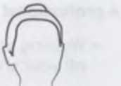
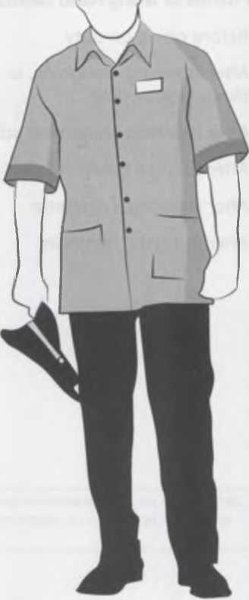
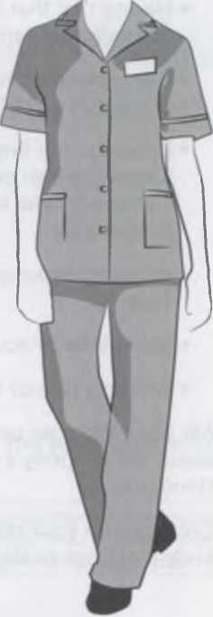
Some properties encourage employees to add accessories to their uniform to show additional personality, such as adding their place of origin to nametags, or wearing an item that indicates a personal interest. Be sure to check your property's guidelines for wearing any fashion accessories.

