UNEWS. Leather
Information Bulletin, Nº 20

TECHNICAL AND SALES MEETING

ÍNDEX

Index

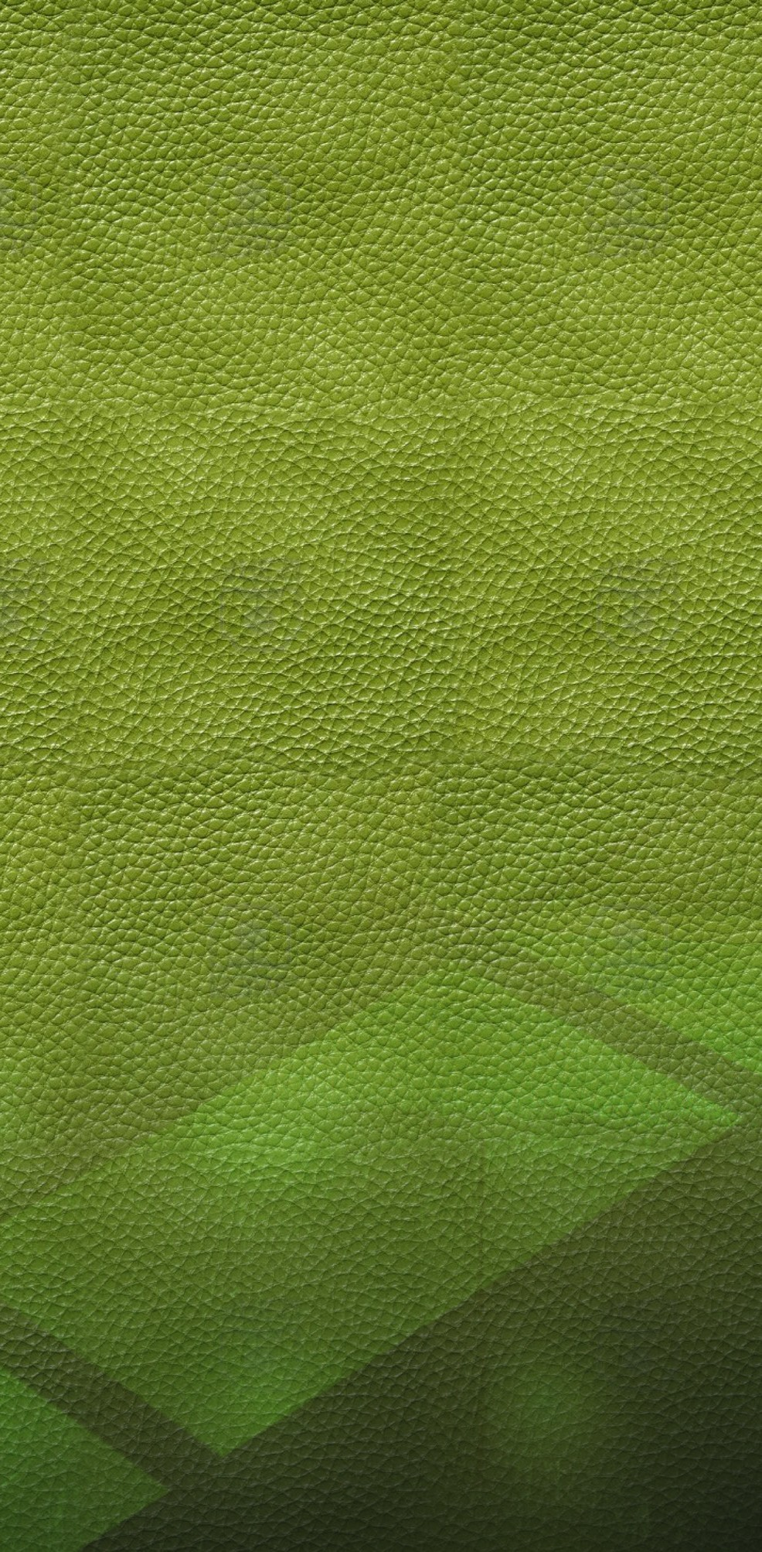Automotive Leather:
INTRODUCTION
The biannual technical and sales meetings held at our Application Laboratories are an important tool for technical information update, and involves both products and studies conducted at the lab and experiences and developments reported by our technical and sales representatives. Also, the technical & sales team is briefed on sales poli- cies, and objectives are set.
On the other hand, in-person contact and lively discussion of different points of view adds to the attendees’ general knowledge.
This issue contains structured pieces of work submitted at the meeting, as well as several for- mulas submitted by our commercial technicians.
- Fogging
- Requirements
- Drying Systems.

Neutralization-Anionization:
Physical Properties

Waterproofing Process with Retanal PSH-200
Influence of Retanning 1 Softness Degree
- Thickness
- Water Absorption
- Water Vapour Permeability

List of Formulas Submitted

Designed, Edited & Published by Cromogenia’s Leather Department
This bulletin is addressed to all Technicians, Representatives, Customers and Friends who wish to keep themselves updated about our new products and releases.
For further information or suggestions, please contact: unewsleather@cromogenia.com

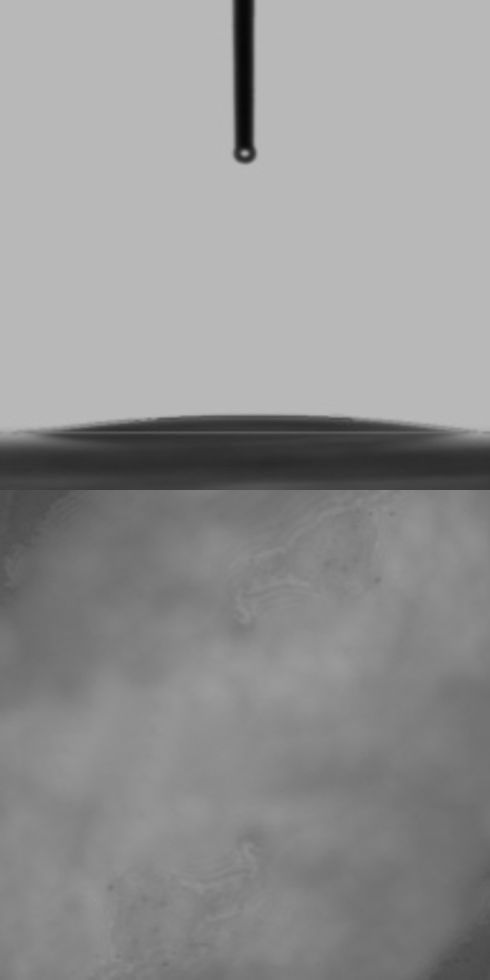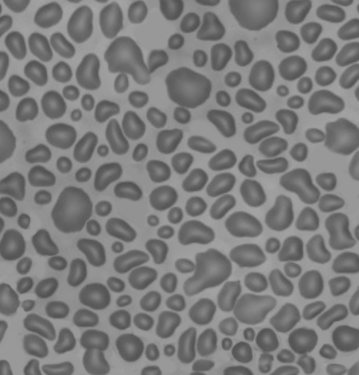Fogging
(a)
(b)
500μm
(c)
500μm

The HAZE Method uses the same principles as the Reflectometric Method, but uses the light that passes

The Fogging test in one of the most important tests per- formed in the automotive leather industry. Fogging results from the heat-induced evaporation of chemicals from the materials used in car interior accessories.
These chemicals are condensed in car windows and form a layer that reduces or even obstructs the driver’s view.
The purpose of this test is to simulate and quantify the eva- poration and condensation of the materials components used in car leather upholstery. This is performed by means of three different methods:

- The Gravimetric Method

- The Reflectometric Method

- The VOC Method

The Gravimetric Method allows determining the amount of evaporated and condensed substances on aluminum foil under specific time and temperature conditions. The result is expressed in mg ―the lower the value, the better the fogging.

The Reflectometric Method allows assessing the extent to which substances evaporated under specific time and temperature conditions induce window fogging. The degree of fogging is measured on a glass plate and the result is ex- pressed in % ―the higher the value, the better the fogging. Tiny, evenly distributed droplets on the glass plate must be obtained.

The VOC Method allows determining volatile organic compounds, mainly including:
- Compounds of carbon with mostly H, O, F, Cl, Br, S, and N.
- Solvents: benzene, toluene, nitrobenzene, xylene, etc.
- Evaporation of organic solvents and tobacco smoke.

The result is expressed in ppm―the lower the value, the better the fogging.
through the glass instead of the light reflected on it. Light is measured with a Hazemeter detector. The result is ex- pressed in % ―the lower the value, the better the fogging.

STANDARD | TITLE | METHOD
DIN 75201 A / B | Determination of the fogging characteristics of trim materials in the interior of automobiles. | Reflectometric Gravimetric
ISO 17071  IUP 46 | Leather – Physical and Mechanical Tests – Determination of fogging  characteristics. | Reflectometric Gravimetric
SAE J 1756 | Test method for determination of the fog- ging characteristics of trim materials in the interior of automobiles. | Reflectometric Gravimetric

The SAE J1756 method includes several temperature and time variables.

Examples: Reflectometric Fogging

STANDARD | SAMPLE DRYING | RESULTS
DIN 75201 A | 7 days | 50 -65 %
SAE J1756 | 7 days | 80-90 %
SAE J1756 | Without drying | 80-90 %
DIN 75201 A: 3h, 100ºC, cooling at 21ºC SAE J1756: 6h, 85ºC, cooling at 38ºC

Reflectometric fogging is quite unreliable because values can be considerably reduced by small variations in leather processing or product composition. The method’s reproducibility is poor and scattered results are obtained. What are the products that affect fogging?
All products used from beamhouse to finishing affect fogging to a greater or lesser extent.

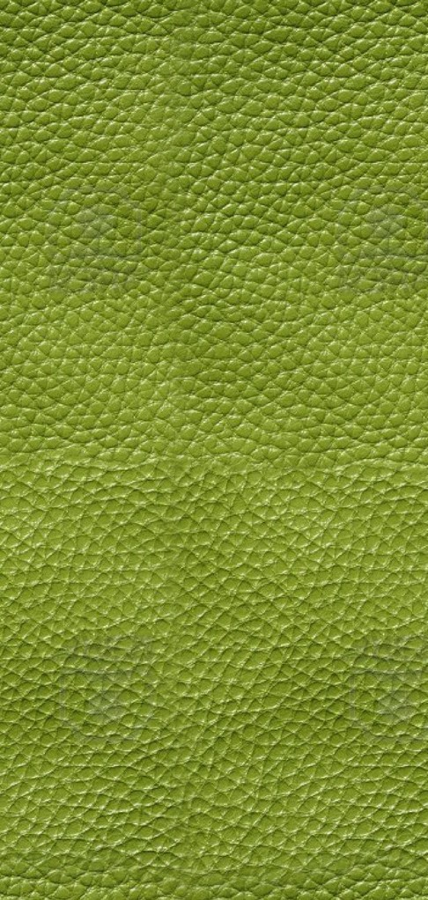
According to Starting Materials:
INFLUENCING FACTOR | REPERCUSSION | RECOMMENDATIONS
Natural fat | Influence on refl. fogging | Select a good degreasing agent
Biocidal products | Refl. and grav. fogging | Test / Select

According to Work Processes:
INFLUENCING FACTOR | REPERCUSSION | RECOMMENDATIONS
Washing | Refl. and grav. fogging | Wash thoroughly after each operation
Washing temperature | Refl. and grav. fogging | Wash at high temperatures
Drying | Refl. and grav. fogging | Dry at the end with temperature

According to Processes Used:
INFLUENCING FACTOR | REPERCUSSION | RECOMMENDATIONS
Ammonium salts | Refl. fogging | Do not use / Wash thoroughly
Degreasing / tensioactive agents | Refl. and grav. fogging | Test
Inorganic tanning agents | Generally without effect | Test
Synthetic and vegetal agents | Generally without effect | Test
Acrylic agents | Generally without effect | Test
Fatliquors | Refl. and grav. fogging | Test

Current fogging requirements by automobile manufacturers

In Europe:
Gravimetric fogging (more reliable and more reproducible results)
In North America:
Reflectometric fogging and, to a lesser extent, gravimetric fogging.
In Asia:
Haze and reflectometric fogging.

Requirements
Requirements vary greatly according to Country, manufacturer, etc. The fogging values that are valid in/ to most of them are shown in Table 1.
Regarding the steering wheel’s physical resistance,
a high TEAR RESISTANCE value ―greater than 40 N― and an ELONGATION percentage between 15 and 20%, are required. ELONGATION requirements are increased from 20 to 40% in seats.

Table nº 1 Drying Systems
METHOD | OPTIMAL VALUE | OBJECTIVE | RANGE
Gravimetric (mgr) | 0 | <3 | >3-5
Reflectometric (%) | 100 | 80 | <60
VOC (ppm) | 0 | 200 | >500

Different Drying Procedures
Each different drying procedure exerts great influence on the final product, particularly on its physical properties. Three basic drying procedures are used, namely:

Wet toggle drying:
Sammy-set Wet toggling Stake
Dry milling Dry toggling

Vacuum
Sammy-set
Vacuum (under temperature)
Stake
Dry milling
Dry toggling (optional)

TAIC system (The first four
operations are run serially)
Sammy-setr Wet stake TAIC
Dry stake
Milling
Dry toggling (optional) or vacuum

Recommended Products

Retanning
Retanal A-4 Retanal CAU Retanal RC-200 Retanal RCN-40 Retanal PNB Retanal PR-199/6 Retanal XD Retanal SUL Retanal RST

Neutralization
Retanal A-4 Neutragent NT

Fatliquoring
Unix P-48
Fosfol AUT C-3 Extra Fosfol AUT C-7 Extra Fosfol LC-80 Extra

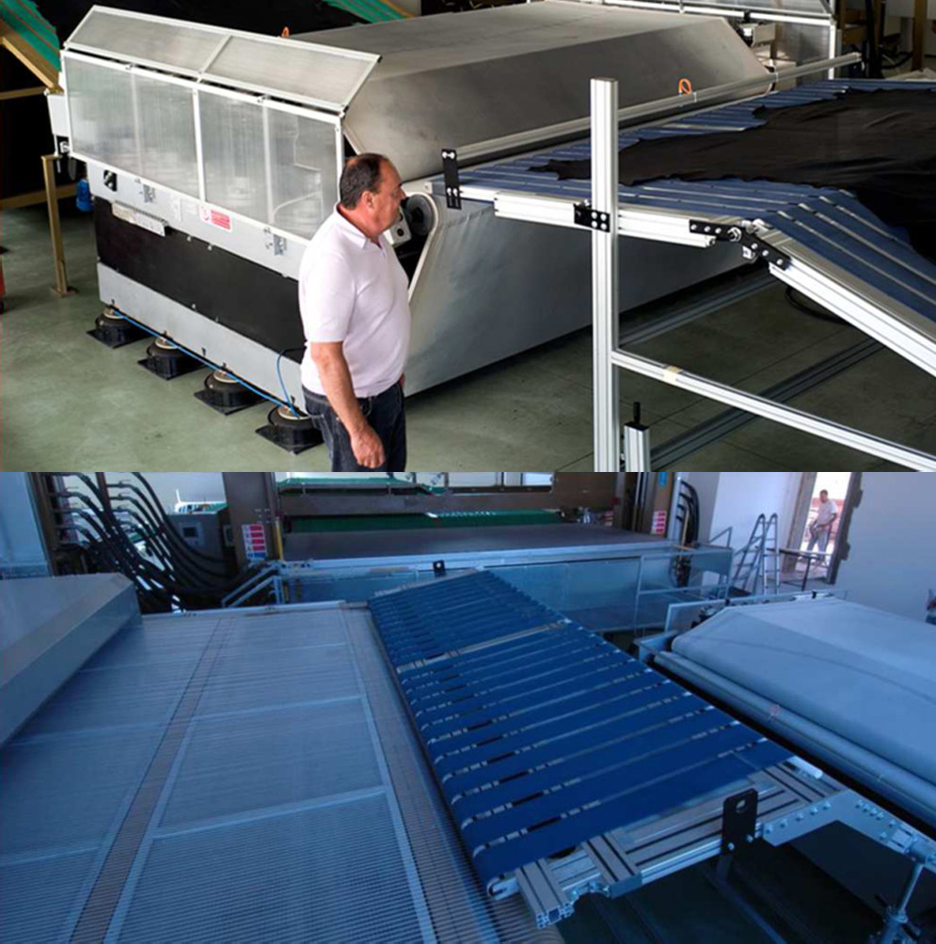
Sistema TAIC

Neutralization-Anionization

Physical Properties

Influence of Neutralization on Leather Properties
The present study addresses the influence of
neutralization – anionization on the following leather properties:

- Softness degree

- Physical resistance

An optimal neutralization process involves the following steps:
- Add 2% sodium formate to de-acidify the leather
surface while providing masking of chrome.
- Add 2-3% neutralizing agent sintan and run until uniform pH and anionization values are obtained (B.G. and/or U.I and methylene blue control), both in section and in surface.
As shown by the chemical mechanism, an initially chrome tanned hide previously de-acidified at pH=4.3 with sodium formate has a complex total load of 2+. The neutral salt of naphthalenesulfonic acid (RETANAL A-4) is introduced inside the complex by changing the load to 1-. This is how the
leather is neutralized and anionized.

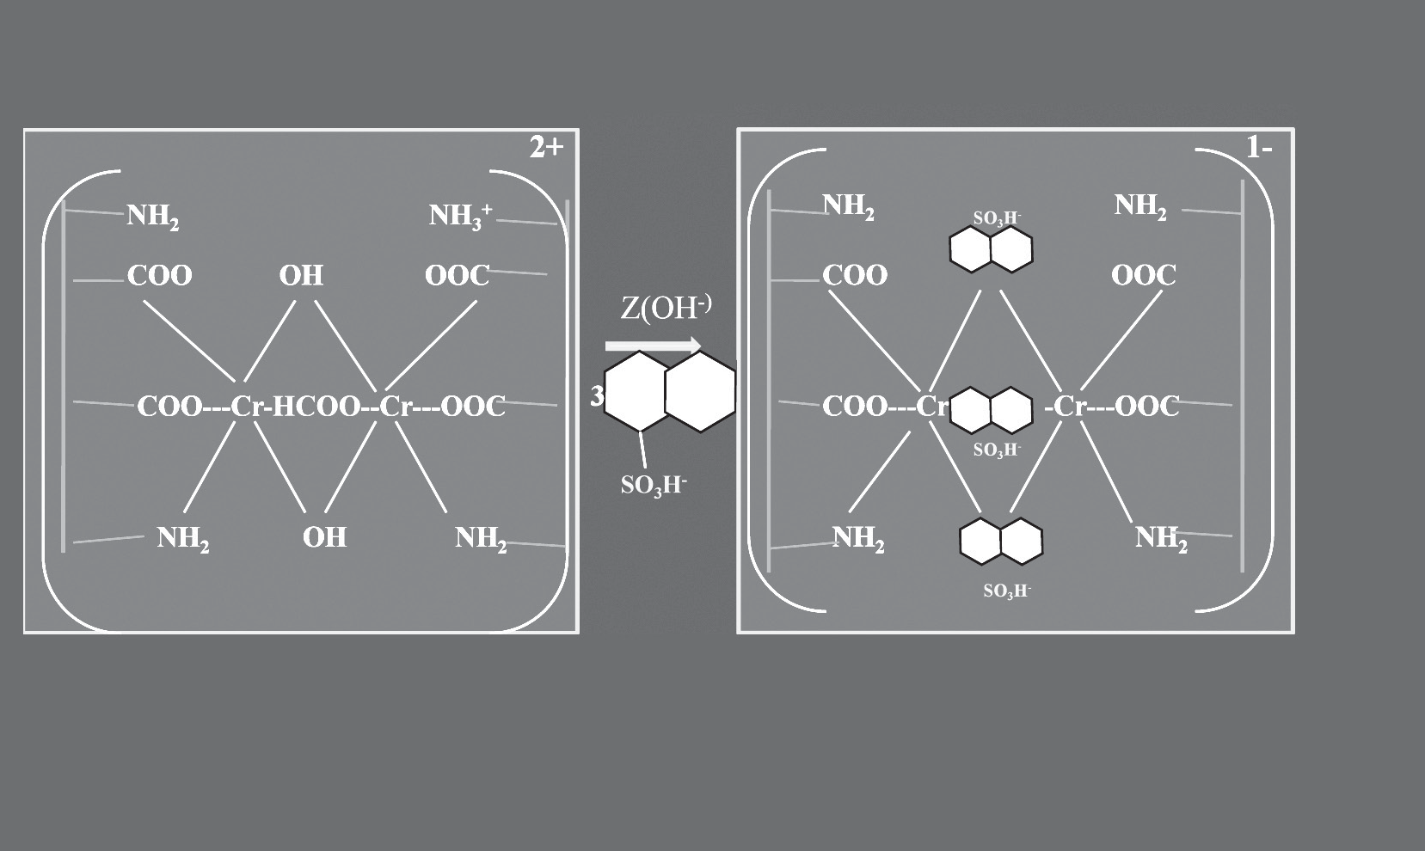A standard process was used to assess the influence of final pH, and final pH was adjusted to the values of 4.5- 5.5-6.5 for comparison with the same process but without the addition of RETANAL A-4.
Chemical Mechanism of Neutralization / Anionization
pH = 4,3
Leather treated with (cationic) sodium formate
+ H2O
pH = 5,0
Leather treated with sodium formate
+ naphthalenesulfonic acidsodium formate

NEUTRALI ZATION- ANIONIZATION

Neutralization-Anionization

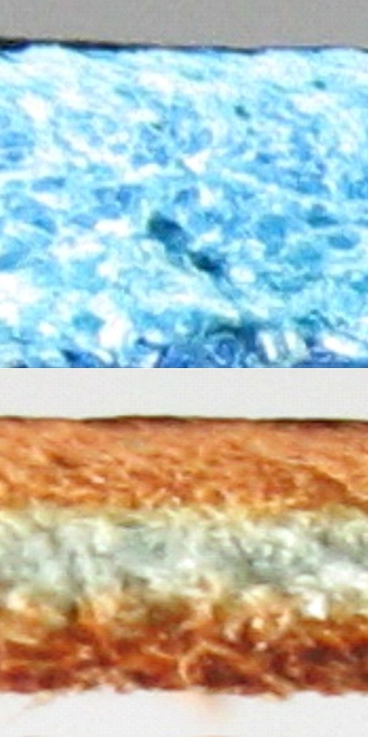As shown in the reference process (without RETANAL A-4), only neutralization is observed, with no anionization (colorless methylene blue section) and partial penetration of the dying agent.
PROCESS VARIABLES (LEFT HALVES - REFERENCES)
SOAKING
500% Water at 35º C 0.2% CELESAL DL
and wash 10 min
RETANNING
100% Water at 35º C
4% Chromium salt 33º Sch 2% Sodium formate
Wash 10 min
NEUTRALIZATION
100% Water at 30º C 2% Sodium formate
X% Sodium bicarbonate
Run 2 hours;pH=3.8; Drain
Run 60 min
Run 60 min; pH=3.7. Drain.

Run 30 min
Run 60 min (pH=adjust) drain
and wash 10 min (control with METHYLENE BLUE)
DYING / FAT-LIQUORING
60% water at 30º C
2% RETANAL HD
3% dying agent 100% water at 60º C
10% FOSFOL AUT C-3
1.5% formic acid
1.5% formic acid
pH = 3.9; Drain and wash 10 min
Run 45 min
Run 45 min
Run 60 min
Run 30 min
Run 30 min

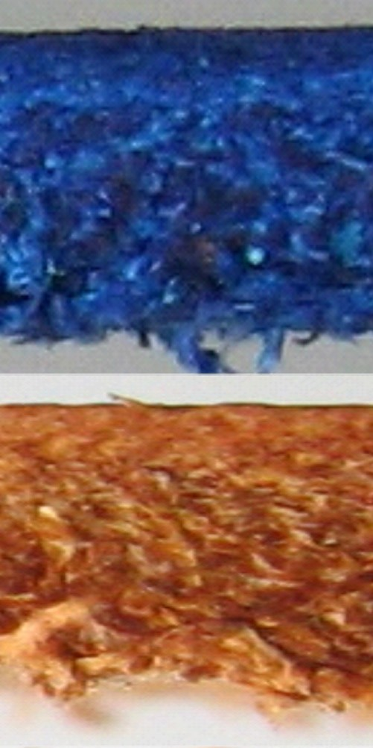In contrast, total anionization is obtained with the addition of RETANAL A-4, as shown with methylene blue, and complete dye penetration is achieved.
PROCESS VARIABLES (RIGHZT HALVES)
SOAKING
500% Water at 35º C 0.2% CELESAL DL
and wash 10 min
RETANNING
100% Water at 35º C
4% Chromium salt 33º Sch 2% Sodium formate
Wash 10 min
NEUTRALIZATION
100% Water at 30º C 2% Sodium formate
2% RETANAL A-4
X% Sodium bicarbonate preestablished values)
DYING / FAT-LIQUORING
60% water at 30º C 2% RETANAL HD
3% dying agent 100% water at 60º C
10% FOSFOL AUT C-3
1.5% formic acid
1.5% formic acid
pH = Empty bath and wash 10 min
Run 2 hours;pH=3.8; Drain
Run 60 min
Run 60 min; pH=3.7. Drain.

Run 30 min
Run 60 min
Run 60 min (Adjust pHs to

Run 45 min
Run 45 min

Run 60 min
Run 30 min
Run 30 min

Neutralization-Anionization
VARIATIONS IN LEATHER PROPERTIES
The assessment of SOFTNESS DEGREE and PHYSICAL RESISTANCE suggests that:
  - Increased values (▲) are obtained in the hides treated with RETANAL A-4, at the same pH values.
  - The maximum value is obtained at pH = 5.5.

10
 | SOFT | NESS

9
8
7
% SOFNESS
6
5
4
3
2
1
0
4,5

20
 | ELON | ATION

18
G
16
% ELONGATION
14
12
10
8
6
4
2
0
4,5

5,5
pH

5,5
pH

6,5

6,5
20
18
 | TEAR | LOAD

16
14
% TEAR LOAD
12
10
8
6
4
2
0
4,5

20
T | NSILE S | TRENGT | H

18
% TENSILE STRENGTH
16
14
12
E
10
8
6
4
2
0
4,5

5,5
pH

5,5
pH

6,5

6,5

These values can be interpreted from the fatliquoring fixation mechanism to the hide. Fatliquoring samples were obtained at different stages of the process, and thin layer chromatography (TLC) was performed. Neutralization conducted at pH=4.5 led to very fast fixation of sulfited fatliquoring and very superficial fatliquoring. Neutralization at 5.5 grants optimal penetration and fixation conditions, as evidenced by TLC with approximately 60-70% fatliquoring exhaustion before the addition of formic acid, and completion with such addition. Neutralization at pH=6.5 leads to fatliquoring fixation only after the addition of formic acid, and also involves superficial fatliquoring.

INFLUENCE OF THE NEUTRALIZATION-ANIONIZATION PH ON FATLIQUORING BATH EXHAUSTION
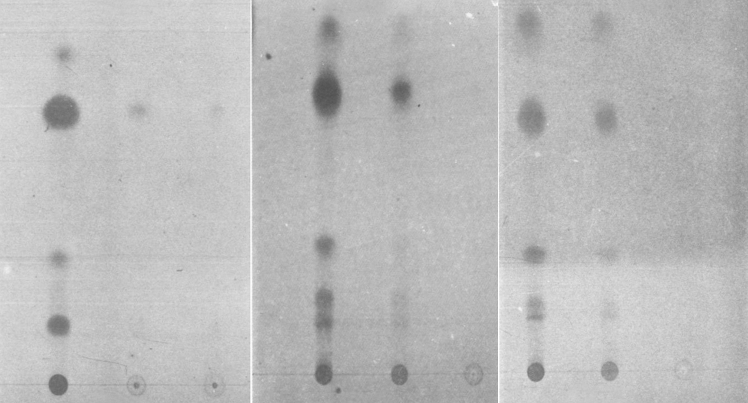
pH = 4,5
pH = 5,5
pH = 6,5
Antes
Antes
Antes
2min Formic Final 2min Formic Final 2min Formic Final
Neutralization at pH = 5.5 leads to total, uniform, deep fatliquoring penetration, thus allowing perfect lubrication of the leather and consequently one of the highest physical resistances.

1 Softness Degree
PSH-200
In order to ascertain the influence of several retanning agents on the water repellency values and the physical properties of several retanning products, a study was designed which consisted

in comparing the left half of a hide ―treated with a standard formula― with its right half ―treated similarly but adding 2.5% of retanning active matter (a.m).
E
Seven wet blue leathers shaved to 2-2.2 mm and with a mean weight of 11 kg/leather were used as raw material.

The retanning agents selected belong to several types of our range and also include a vegetal agent (acid chestnut) widely used in water repellency processes.

RETANAL SUL ACID CHESTNUT
RETANAL MV EXTRA RETANAL CLE RETANAL RCN-40 RETANAL RC-200 RETANAL RST
The standard process was conducted as follows:

On W.B. weight

WASHING
200% water at 35ºC
0.4% formic acid Run 20 min Drain

RETANNING
100% water at 35ºC
4% Chromium salt 33º Sch Run 45 min 2% Sodium formate Run 30 min pH=3.8
0.2% Sodium bicarbonate Run 60 min pH=4.0 Drain

WASHING
200% water at 35ºC Run 10 min Drain NEUTRALIZATION
100% water at 35ºC
2% Sodium formate Run 15 min
3% RETANAL A-4 Run º 90 min pH=4.8
0.2% Sodium bicarbonate Run 120min pH=5.2 Overnight bath

WASHING
200% water at 35ºC Run 15 min Drain

DYE / FAT-LIQUORING
50% water at 35ºC
2.5% a.m. RETANNING/ REFERENCE Run 15 min
6% REPELAN PSH-200 Run 10 min
1.5% RETANAL A-4
3.5% Acid Black 210 Run 30 min Penetration control 100% Water at 60ºC
0.7% Formic acid Run 20 min
1% Acid Black 210 Run 20 min
  - % Formic acid Run 20 min pH=4. Drain

TOP
100% Water at 60ºC
4% REPELAN PSH-200 Run 10 min
  - % Formic acid Run 20 min pH=3.8. Drain

WASHING
200% Water at 35ºC Run 15 min Drain FIXATION 150% Water at 35ºC
4% Chromium salt 33º Sch Run 60 min pH=3.1.. Drain

WASHING
200% Water at 30ºC Run 10 min Drain WASHING
200% Water at 30ºC Run 10 min Drain

DRAIN-VACUUM 3 min at 60ºC - AIR-DRY - STAKE

All data assessed until the submission of this study are shown in three graphs for each retanning agent.
All measurements exceeded 150.000 MAESER, and therefore the water repellency values shown in the graphs correspond to water absorption at 15.000 Maeser and to water vapor permeability.

4 Water Vapour PermeabilitPy
SH-200

2 Thickness, 3 Water Absorption,

RETANAL SUL
20
SOFTNESS THICKNESS FIRMNESS 14
 |  |  |  | 8
 |  | 6,4 |  |  |  |  |  | HEAD
 |  |  | 1,3 |  |  |  |  | BUTT
 |  |  |  |  | -2 | -1,5 BELLY
-4,9

15

10
INCREASE (%)
5

0
-5

-10

20 20
REFERENCE
6,8 6,4
SUL
-6
VARIATION
WATER VAPOR PERMEABILITY
(mg/cm2*h)
16
7,02 8,13
REFERENCE
SUL
VARIATION

15 15
ABSORTION (%)

10 10

5 5
0 0

-5 -5

-10

20
-10
Increased head thickness and firmness (8% and 14%, respectively). While no significant changes are observed in the absorption %, water vapor permeability is increased by 16%.

ACID CHESTNUT

15
SOFTNESS
THICKNESS
FIRMNESS
14,2
HEAD
1,5
0,7
BUTT
9
5,3
1
BELLY
-7,3

10
INCREASE (%)

5

0

-5

-10

15

10
ABSORTION (%)

5

0

-5

-10

-15

12
11
REFERENCE
ACID CHESTNUT
VARIATION
9,15
9,7
6
WATER VAPOR PERMEABILITY
(mg/cm2*h)
6,5 5,5
REFERENCE
ACID CHESTNUT
VARIATION

10
9
8
7
6
5
4
3
2
1
-15 0

Increased head thickness and firmness (9% and 14.2%, respectively). 15% decrease of water absorption. No other significant values obtained.

PSH18
-2SOFT0NESS
0THICKNESS

FIRMNESS

RETANAL MV EXTRA
BUTT
20

16
14
INCREASE (%)
12
10
8
6
4
2
0
- 2
- 4
5 5 4,9
REFERENCE
MV EXTRA
VARIATION

4 12
REFERENCE
MV EXTRA
VARIATION
9,15
9,7
6
WATER VAPOR PERMEABILITY
(mg/cm2*h)
11
3 10
ABSORTION (%)
9
2 8
7
1 6
5
0 4
3
-1 2
1
- 2 -2 0
Notably increased firmness and thickness.

RETANAL CLE
X
SOFTNESS
THICKNESS
FIRMNESS
HEAD
BUTT
BELLY

HEAD BELLY

X

X
INCREASE (%)

X

X

0

X 6
5,5 5,4
REFERENCE
CLE
VARIATION

5

4 12
CLE
VARIATION
11,83
10,06
10
REFERENCE
ABSORTION (%)
WATER VAPOR PERMEABILITY
(mg/cm2*h)

3 11,5

2 11

1 10,5
0 10

- 1
E
- 2 - 2
Increased firmness and thickness. Increased water vapor permeability (10%).
9,5

9

RETANAL RCN40 PSH-200
X
HEAD
BUTT
BELLY
SOFTNESS THICKNESS FIRMNESS

X
INCREASE (%)
X X X X X X 0
- X
- X 8
REFERENCE
RCN40
VARIATION
6,4
5,9
6 35 35
 |  | 11,83 |  | REFERENCE
 | 8,76 |  |  | RCN40
 |  |  |  | VARIATION

4 30
WATER VAPOR PERMEABILITY
(mg/cm2*h)

2 25
ABSORTION (%)

0 20

- 2 15

- 4 10

- 6 5

- 8 - 8 0

35
30
INCREASE (%)
25
20
15
10
5
0
- 5
- 10
- 20
4,5
Notably increased firmness (40%) and thickness, with no significant variations in softness. Decreased water absorption (8%) and strongly increased permeability (35%).

RETANAL RC-200
SOFTNESS
THICKNESS
30
HEAD
BUTT
BELLY
13
4,7
6,7
-11,4 -10,5 -11,3
FIRMNESS

4
 | 4,3 | 4,3
 |  |  | REFERENCE
 |  |  | RC-200
 |  |  | VARIATION

3,5

3 12
11
8,5
7,63
REFERENCE
RC-200 VARIATION
WATER VAPOR PERMEABILITY
(mg/cm2*h)

2,5 10
ABSORTION (%)

2 8

1,5 6
1 4

0,5 2
0 0 0
Evenly decreased softness in the different parts of the hide. Significantly increased thickness and strongly increased firmness (30%). No variations in water absorption, and increased water vapor permeability (11%).

PSH-200
E

RETANAL RST
X
SOFTNESS
THICKNESS
FIRMNESS
XX
HEAD
XX XX
BUTT
BELLY
XX
XX
XX
XX

X X
X
INCREASE (%)

X X
0

X X X

5 20
15
8,18 8,3
REFERENCE
RST VARIATION
4,5 4,3
REFERENCE
RST
VARIATION

4 18

3 16
WATER VAPOR PERMEABILITY
(mg/cm2*h)

2 14
ABSORTION (%)

1 12

0 10

-1 8
- 2 4

- 3 2
- 4 - 4 0

Decreased degree of softness in head (9.8%) and significantly increased thickness in head, butt and belly; thickness is increased in the entire leather ―more in head and less in butt and belly. Strongly increased firmness (25%).
In respect of water repellency value, slightly decreased water absorption (4%), and increased water vapor permeability (15%).

LIST OF FORMULAS
SUBMITTED

List of Formulas Submitted

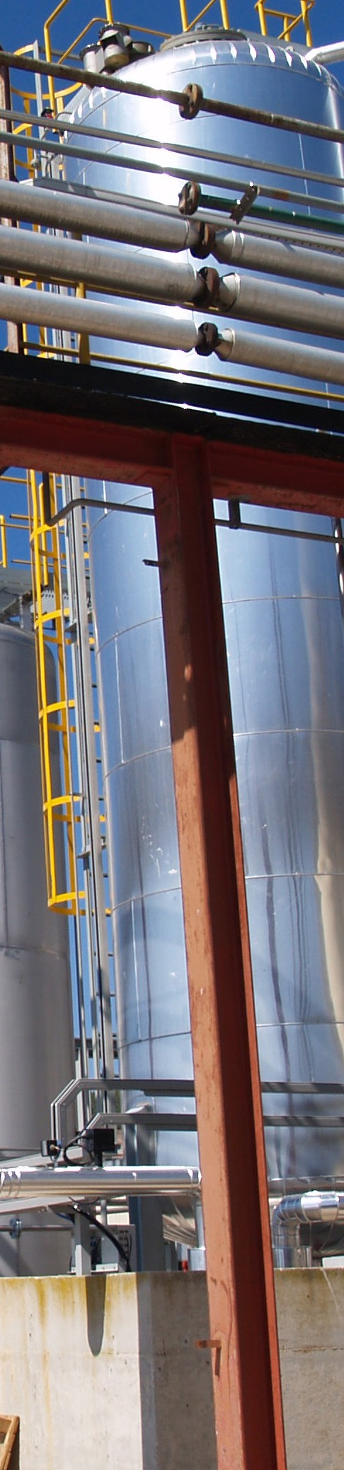
Sheepskin

Goat Suede-1 Goat Suede-2
Goat Vegetable pickle-1 Goat Vegetable tanned-2
Goat Vegetable dye/fat-liquoring-3 Goat Vegetable-4
Goat crust for nubuck Goat and cow shrunken
Goat black vegetable nubuck Lamb dry White
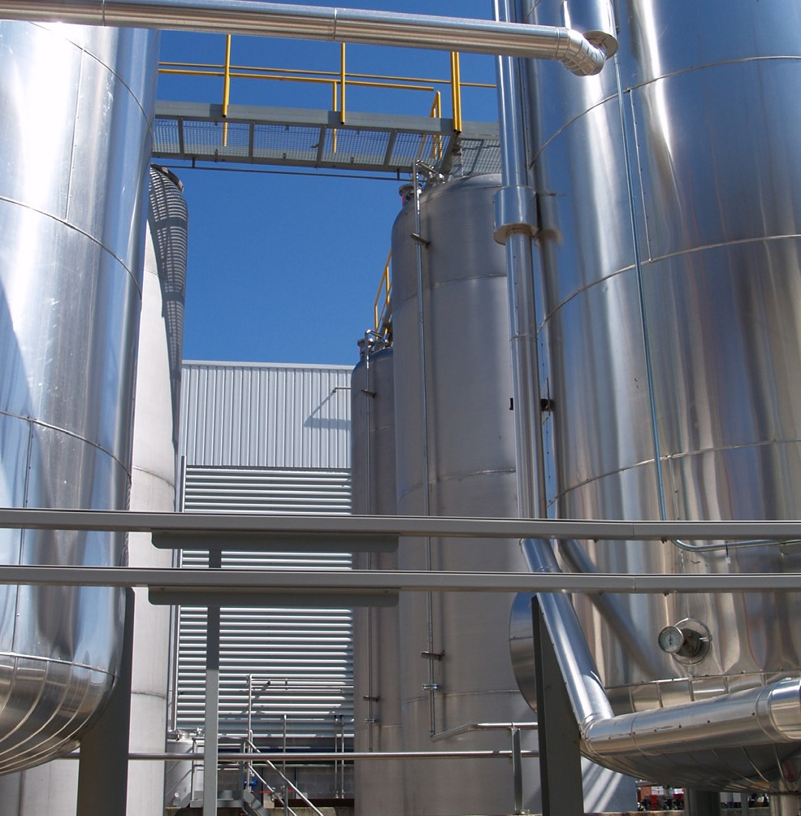
Lamb Nappa dry White footwear Lamb Nappa dry White garment Lamb Nappa finishing garment Lamb Nappa scoured footwear White Double Face
Cow

Soaking-unhairing for wet white Deliming-bating-tanning for wet white
Automotive leather w.b. 1,2 m.m. (AV-4512-3) Automotive leather w.b. 1,2 m.m. (AV-6512) Upholstery 1,2 m.m. (AV-6412)
Upholstery 1,2 m.m. (AV-6412-2)

High-Resistance Urethane Tops

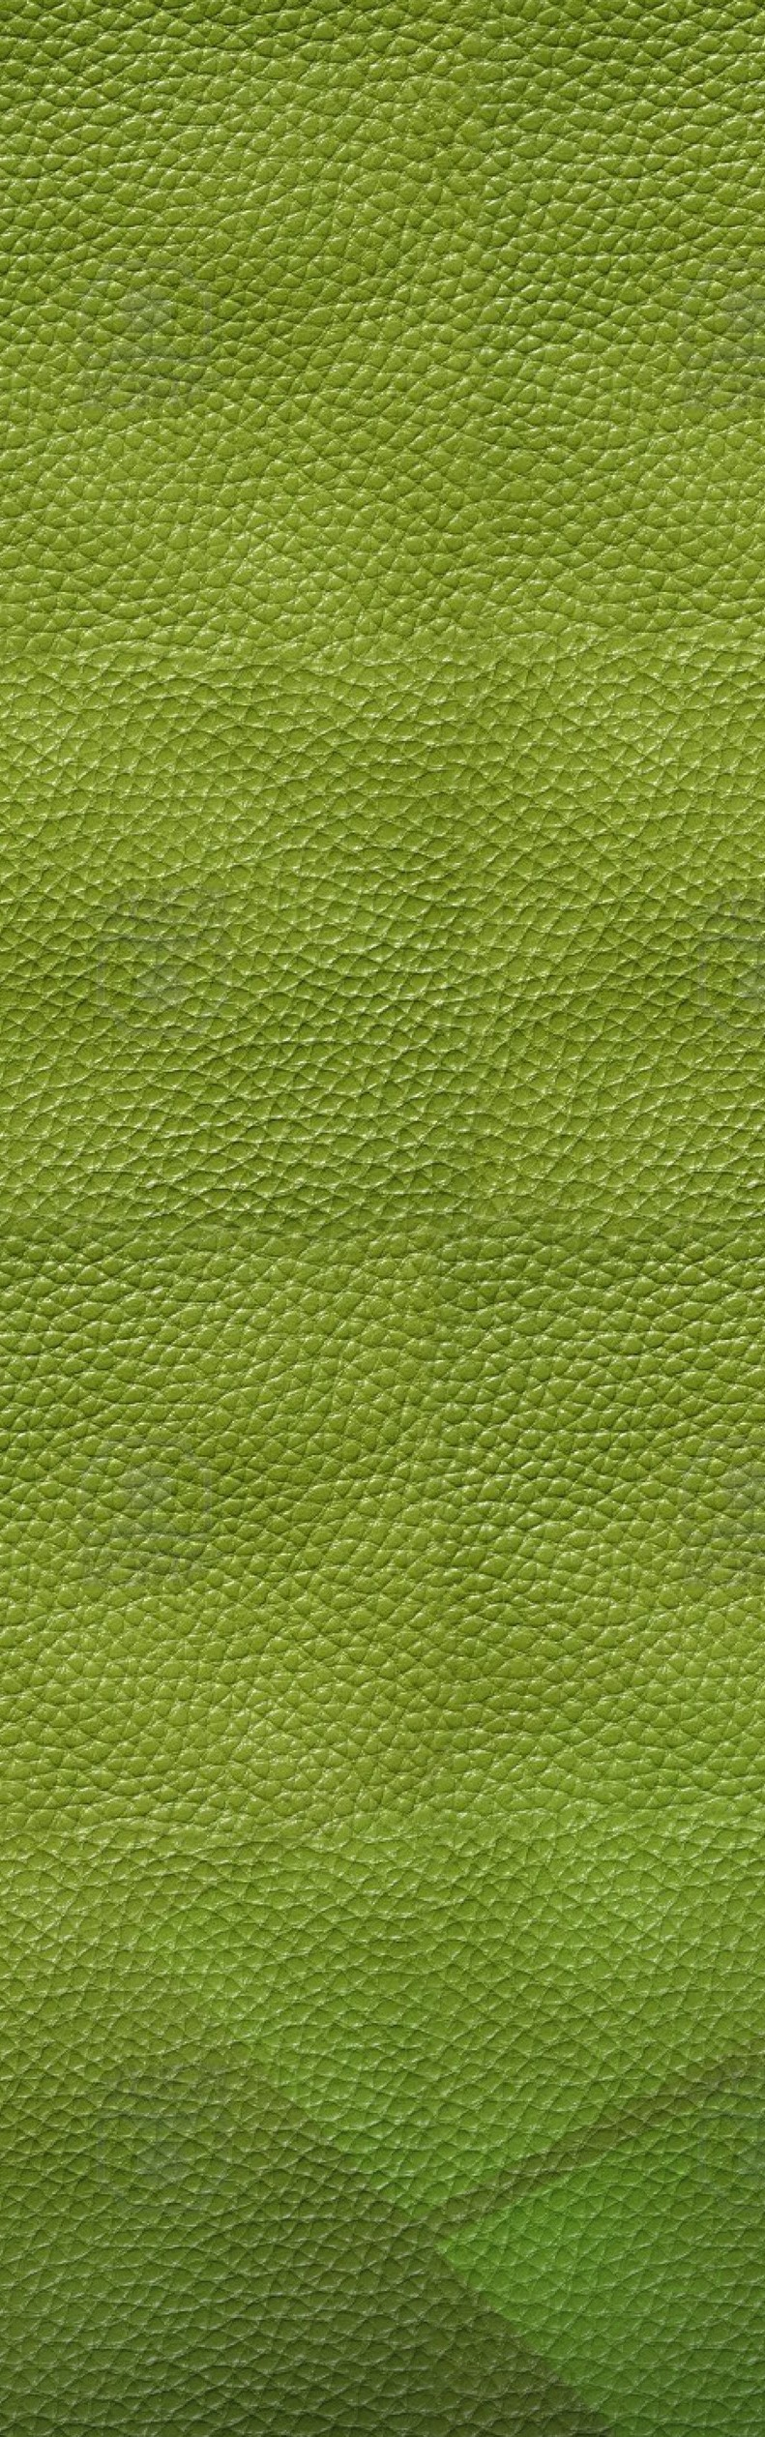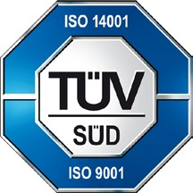
C0002

C./ 40, Nº 14-16
08040 BARCELONA SPAIN
Tel. +34 93 432 94 00
Fax +34 93 422 60 14
cromogenia@cromogenia.com www.cromogenia.com

