Original Contribution

Journal of Cosmetic Dermatology, 13, 307--314

A new dermal filler made of cross-linked and auto-cross-linked hyaluronic acid in the correction of facial aging defects
Adele Sparavigna, MD,1 Pasquale Fino, MD,2 Beatrice Tenconi, Sc.D,1 Nicola Giordan, PharmD,3 Vittoria Amorosi, MD,2 & Nicolo` Scuderi, MD2
1Derming Clinical Research and Bioengineering Institute, Monza, MB, Italy
2Department of Plastic, Reconstructive and Aesthetic Surgery, University of Rome ’Sapienza’, Policlinico ’Umberto I’, Rome, Italy
3Clinical Research Department, Fidia Farmaceutici, Abano Terme, Padua, Italy

Summary Background A novel Hyaluronic Acid (HA) derivative dermal filler has been developed with characteristics especially suited for nasolabial folds (NLF) and facial defects due to volume loss.
Aims An open-label prospective study was carried out to evaluate this HA filler’s performance in correcting facial defects due to volume loss.
Methods A single Italian site treated subjects aged 30–65 for facial defects due to volume loss with a new dermal filler injectable gel; subjects returned to the clinic at
7 and 14 days, and 1, 3, 6, 9, and 12 months for follow-up. The primary effectiveness endpoint was improvement in wrinkle severity (measured using the Wrinkle Severity Rating Scale) (WSRS) and facial volume (measured using the Facial Volume Loss Scale) (FVLS) at 6 and 12 months from baseline. Secondary endpoints were safety evaluation, performance duration, product handling, subjects’ and investigator’s treatment evaluation. Assessment of aesthetic results included the skin hydration, image analysis of nasolabial folds (3D), and photographic documentation. Results The reduction in nasolabial wrinkles was statistically significant at 6 months after the first implant. The aesthetic improvement of 1 grade on WSRS was evident in 95% of subjects up to 3 months, in 84% of subjects up to 6 months and in 27% up to 12 months. A clinically (> 1 point improvement) and statistically significant improvement in the FVLS was observed at each study visit; in 100% of treated cases, up to 3 months and in 61% up to 9 months. Good results were obtained during the study in skin hydration. There were no severe adverse events related to treatment.
Conclusion This injectable gel is well tolerated and has been demonstrated to provide a smooth and natural improvement in facial defects due to volume loss in nasolabial folds and the malar region that lasts for up to 1 year.
Keywords: dermal filler, hyaluronic acid, facial defects, volume loss, patient satisfaction

Correspondence: Pasquale Fino, MD, Department of Plastic, Reconstructive and Aesthetic Surgery, University of Rome “Sapienza”, Policlinico Umberto I, Via dei Quinzi, 5, Interno 21, 00175, Roma, Italy.
E-mail: pasquale.fino@gmail.com, pasquale.fino@uniroma1.it

Accepted for publication September 5, 2014

Introduction
Nonsurgical rejuvenation procedures such as botulinum toxin (BTX) and dermal filler injections are now the most common aesthetic treatments performed world-

wide.1,2 In 2008, the American Society of Aesthetic Plastic Surgeons (ASAPS) published projected nation- wide statistics of US dermal filler practice, in which hyaluronic acid-based fillers were the most commonly performed with over 1.26 million treatments.3 The pur- suit of the ideal filler dates back centuries. As early as 1893, autologous fat injection to correct facial defects was reported by Neuber and only a few years later par- affin was injected for cosmetic treatment.4,5 This tech- nique enjoyed much popularity until many patients began to develop severe foreign-body and granuloma- tous reactions.6 Later, in the 1940s, the use of liquid sil- icon become very popular first in the US and subsequently in Germany, Switzerland, and Japan, until many patients demonstrated numerous complica- tions that prevented approval for cosmetic purposes by the United States Food and Drug Administration (FDA).7,8 Modern soft tissue augmentation began in 1982 with the approval of bovine collagen. Since then, soft tissue augmentation and injection of materials for cosmetic enhancement have increased considerably and became the second most common cosmetic nonsurgical procedure in 2009. To date hyaluronic acids account for the majority of the soft tissue augmentation market.9 Hyaluronic acid (HA) is a biological glycosaminoglycan distributed in the extracellular matrix of most tissues, and particularly concentrated wherever rapid tissue pro- liferation, regeneration, and repair occur.10 It was first isolated in 1934 from bovine vitreous humor.11–13
HA is a polysaccharide composed of repeating units of D-glucuronic acid and N-acetyl-glucosamine. It is found in all tissues of vertebrates and is very prevalent in human skin. It has been demonstrated to be decreased in intrinsically aged skin and to be altered in photoaged skin. It is highly hydrophilic, binding much more than its weight in water. In a filler, the cross-link of the poly- saccharide chains serves to slow HA degradation and to increase tissue residence time. Hyaluronic acid fillers are mainly used in nasolabial folds, which was the site of original FDA approval. They are also used in many areas including the lips and marionette folds.14–17
A new dermal filler, HA derivative and classified as a medical device, has recently been developed. The product is based on highly viscous and absorbable gel formulation, which thanks to its properties can ensure a long-lasting volumizing effect. Chemically, it is a combination of two components: an auto-cross-linked hyaluronic acid (ACP) and a hyaluronic acid cross- linking through BDDE (butanediol-diglycidyl-ether). The combination of the two products forms a gel that degrades over a long period of time and ensures a volumizing effect.
Aim of this open-label, prospective study, here pre- sented, was to evaluate the long-term effectiveness and safety of this novel HA filler in correcting facial defects due to volume loss.

Methods

Study design
This was a prospective, open-label study in which a highly cohesive and viscous HA volumizing filler was evaluated for its indicated use of restoring facial vol- ume. The trial was carried out in compliance with the Declaration of Helsinki and the Guidelines for Good Clinical Practice. Independent ethics committee approval was obtained from the Independent Multidis- ciplinary Ethical Committee (Monza, IT) and all sub- jects provided written informed consent.
In this clinical trial 20 adult subjects were enrolled from November 2011 to December 2012, at an Italian site to evaluate the efficacy and tolerability of a new dermal filler in correcting facial defects due to volume loss.

Subjects
20 subjects fulfilling the following inclusion criteria were considered eligible: healthy subjects of both sexes,
aged 30–65, score ≥2 on the Facial Volume Loss Scale (FVLS), score ≥3 on the Wrinkle Severity Rating Scale
(WSRS), subjects willing to come back to the clinic for follow-up visits, subjects willing to abstain from other cosmetic procedures (e.g., further augmentation ther- apy, botulinum toxin injections, facelift procedures, laser chemical peeling etc.) during the entire duration of the study, subjects providing signed informed con- sent form.
Subjects were excluded if they were participants in any ongoing clinical trial or had any conditions con- traindicating the use of HA fillers such as skin disease, (infections, dermatitis, active eczema, psoriasis, acne, rosacea, herpes etc.), subjects in therapy with antico- agulant drugs, subjects with facial volume loss caused by traumas or genetic defects, subjects with hypersen- sitivity to hyaluronic acid and/or its ingredients, aller- gies, autoimmune disease (LES, sclerodermia etc.), cancer, in therapy with immunosuppressive drugs, in pregnancy or lactation.
Subjects were removed from the trial if they with- drew from the study for personal reasons, developed any of the conditions specified in the original exclusion criteria or contracted a serious illness preventing con-

tinuation of the study. Subjects removed from the study were not replaced.

Study procedures
Participants received Ial-System Duo® (Fidia Farmaceu- tici S.p.A., Via Ponte della Fabbrica 3/A, 35031, Abano Terme (PD)-Italy), a class III, EC market medical device, provided in a disposable prefilled syringe of 1 mL vol- ume. Allowable treatment sites were the nasolabial folds or malar region, with a maximum volume of 4 mL. Intradermal and/or subcutaneous injection was per- formed by needle (30G, 13 mm, linear retrograde tech- nique) at the level of nasolabial folds or blunt cannula (27G, 40 mm, fan technique) for the malar region. The injection volume selected for the first implant was between 2 mL and 4 mL.
Following treatment with this hyaluronic acid inject- able gel, subjects returned to the clinic for follow-up visits at 7 days (V2), 2 weeks (V3), 1 (V4), 3 (V5), 6 (V6), 9 (V7), and 12 (V8) months after initial treat- ment. An optional top-up treatment was allowed at 1 week with an injection volume between 0.5 and 1 mL.

Data collection and study endpoints
The primary effectiveness endpoint was improvement in wrinkle severity (measured using the Wrinkle Sever- ity Rating Scale) and facial volume (measured using the Facial Volume Loss Scale) at 6 and 12 months from baseline.
Investigators recorded each subject’s age, sex, base-
line volume loss according to the FVLS and severity of wrinkles according to the WSRS. Clinical evaluation by WSRS (score from 1 to 5) and FVLS (from 1 to 5) was used to assess the efficacy of the product. Investigator and subject satisfaction was evaluated by a numerical
generate a 3D profile of the measured skin surface. The Investigator’s judgment on product handling, after the first implant and the top-up, was recorded as a score from 1 to 5. Finally, patient’s global assessment was evaluated asking patients to complete a self-assessment questionnaire.
Assessment of safety was performed by direct obser- vation of local expected events/reactions induced by the injection (pain, erythema, edema, bruise), and any other adverse event/reaction, also of systemic source, occurring during the study.

Data analyses
The data was summarized with descriptive statistics (e.g., adjusted means, standard deviation, minimum and maximum value). The statistical analysis of clini- cal data was performed using nonparametric tests (Friedman test followed, in the event of statistically significant results, by Dunnett test), while parametric tests were used for instrumental data (ANOVA test fol- lowed, in the event of statistically significant results, by Dunnett test). The results obtained at each study time point were compared with baseline conditions. Safety and tolerability were evaluated at any follow- up visit.

Results

Study participants

Twenty female were included in the study, age range 49–65 years (mean = 56), with a score ≥2 on the FVLS and a score ≥3 on the WSRS, from whom
informed consent had been obtained (Table 1).

Table 1 Subject baseline and demographic data

rating scale from 0 to 10, where 0 was no improve-

ment and l0 was maximum improvement. Duration time of the volumizing and filler effect was evaluated by image analysis results on nasolabial folds, obtained 14 days after the first intradermal implant and com- pared to the ones obtained after 1, 3, 6, 9, and 12 months. Skin hydration was measured using the Corneometer CM825 (Caurage–Khazaka, K6ln, Ger- many). Two-dimensional frontal face pictures were taken with standardized methods. 3D nasolabial folds pictures, were taken using the PRIMOS® (GFMesstech- nik GmbH, Teltow, Germany) which provides a high-resolution profilometry of skin surfaces using
Female (no) 20/20

Age (years)
Mean | 56
Min | 49
Max | 65

Facial Volume Loss Scale
Score 2 | 2/20 (10%)
Score 3 | 3/20 (15%)
Score 4 | 8/20 (40%)
Score 5 | 7/20 (35%)
Wrinkles Severity Rating Scale

phase-shifted light stripes projected by micro mirrors to
Score 3 | 4/20 (20%)
Score 4 | 10/20 (50%)
Score 5 | 6/20 (30%)

Treatment and practice characteristics
All subjects received injections of the same hyaluronic acid filler in NLFs and the malar area on both sides of their face at the baseline visit. Seventeen subjects received a top-up treatment at 1 week in NLFs, while top-up was performed in the malar region and nasola- bial chin folds on 3 and 6 subjects, respectively. The mean injection volume was 0.5–1 mL. Two subjects, due to the presence of bruises after the first implant, refused the top-up treatment. One subject did not per-

100
90
80
70
60
50
40
30
20
10
0

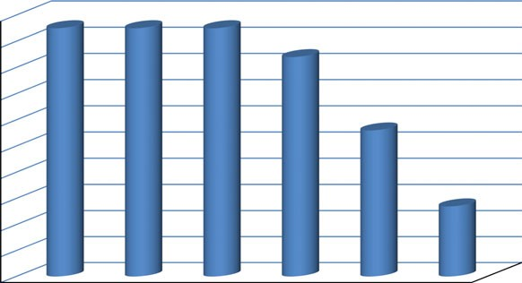95 95 95
84

56

27

form V3 because of personal problems. No other signif- icant event, which may have interfered with the test results occurred during the study period. Five subjects dropped out of the study due to personal problems not related to the tested product or the aesthetic treatment; therefore, at V6, the statistical analysis was performed on a total of 19 subjects, and at V7 and V8 the statis- tical analysis was performed, respectively, on a total of 18 and 15 subjects who completed the trial.

Aesthetic outcomes
Effectiveness
Before treatment, nasolabial folds were rated by the investigators as being extreme in 30% of subjects, severe in 50%, and moderate in 20% of subjects. The mean WSRS at baseline was 4.1, the treatment resulted in a significant improvement, after 3 months the scores decreased by 1.3 points and after 12 months from first implant the reduction of WSRS was still clinically evident.
Treatment with hyaluronic acid filler induced a clini- cally and statistically significant improvement from baseline condition, the reduction in WSRS being,

5
*p< 0.05 vs V1

4.1
V3 V4 V5 V6 V7 V8

Figure 2 Proportion of subjects with ≥1 grade improvement from baseline in Wrinkles Severity Rating Scale (WSRS).

Facial Volume Loss Scale (FVLS)

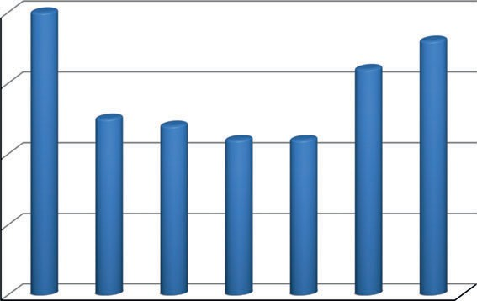4

3
FVLS (mean score)

2

1

0
V1 V3 V4 V5 V6 V7 V8

Figure 3 Mean score of the Facial Volume Loss Scale (FVLS) evaluated at baseline, after 14 days, 1, 3, 6, 9, 12 months after injection.

respectively, of 32% at V3 and V4, of 34% at V5, of 24% at V6, of 15% at V7, and 10% at V8, correspond- ing to a visual score reduction of at least one grade in 95% of treated cases up to V5, in 84% at V6, in 56% and 27%, respectively, at V7 and V8 (Figs 1 and 2).

4
Mean WSRS Score

3 2,8* 2,8*

2

1

2,7*

3,1*

3.5
3.7
At baseline the FVLS score of all subjects ranged from 2 to 5, the mean score declined significantly (P < 0.05 vs. baseline condition), from 4.0 at baseline visit to 2.2 at visits 5 and 6 (3 and 6 months after treatment). The reduction in FVLS visual score vs. baseline (V1) was 38% at V3, 40% at V4, 45% at V5 and V6, 20% at V7, and 10% at V8, corresponding to a visual score reduction of at least one grade in 100% of treated cases up to V5 and in 61% after 9 months (Fig. 3).

V1 V3 V4 V5 V6 V7 V8

Figure 1 Mean score of the Wrinkles Severity Rating Scale (WSRS) evaluated at baseline, after 14 days, 1, 3, 6, 9,
12 months after injection.
These measures may be more interesting considering
that at V4 and more consistently at V5 and V6, the percentage of subjects who showed a reduction in the FVLS visual score of 2 and 3 grades was higher in

100

90

80

70

60

50

40

30

20

10

0
100 100 100
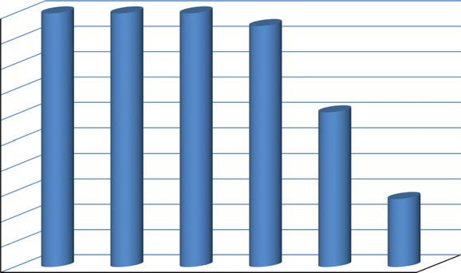95

61

27
the ability of ACP (auto-cross-linked hyaluronic acid) to bind with the water molecule causing a rapid increase in deep moisture and a progressive improvement in superficial skin hydration, detectable up to 9 months after the treatment.
The skin profilometry of wrinkles (PRIMOS®) at the level of nasolabial folds showed from V3 onwards a statistically and clinically significant reduction (Dun- nett test P < 0.05 V3, V4, V5, and V6 vs. baseline condition) in the roughness parameter (RA) (Table 2). Hyaluronic acid treatment achieved a reduction in the

V3 V4 V5 V6 V7 V8

Figure 4 Proportion of subjects with ≥1 grade improvement from baseline in Facial Volume Loss Scale (FVLS).

SKIN ELECTRICAL CAPACITANCE (SKIN HYDRATION)

65
mean depth of the RA parameter from 120.8 lm to
55.4 lm at 2 weeks (V3) after the first implant, indi- cating an excellent filling product activity which was still marked for up to 6 months; in particular the per- centage reduction in RA corresponded to 51.7% at V3, 46.9% at V4, 42.9% at V5, 35.2% at V6, 16.5% at V7 and 6.5% at V8.
The clinical and instrumental assessments, as well as

60

55
50.32 49.74
50
44.68 46.54

52.98 54.12

47.98 47.22
59.79 60.27

53.48 55.27

50.27

49.41
the patient and investigator global assessment, con-
firmed that the filling and re-densifying activity of the study product was still marked and clinically signifi- cant 12 months after the first implant (Fig. 6a–g

45

40
39.04
35

30

25

20

43.33 42.98

40.31
47.18
43.59

37.77
photographic documentation 3D and 2D).

Safety
No adverse events/reactions related to the study prod- uct occurred during the study. Local post-treatment events such as erythema resolved in the majority of

V1 V3 V4 V5 V6 V7 V8
MEAN mean+1/2 Std. Dev. mean-1/2 Std. Dev.

Figure 5 Skin hydration (*P < 0.05 Dunnett test vs. V1).

comparison with V3 (60% at V4, 70% at V5, and 69% at V6 vs. 42% at V3). These results may be explained by the stimulating activity of hyaluronic acid on cellu- lar functionality and by the long-lasting performance (re-densifying activity) and bio-revolumetric effect of the study product (Fig. 4).
The mean value of skin electrical capacitance (skin hydration) (Fig. 5), measured with the Corneometer CM825 instrument, was 44.7 A.U. at baseline. One (V4), six (V6) and nine (V7) months after treatment, results confirmed a clinically and statistically significant hydration improvement respectively to 7.4%, 19.7% and 23.7% in comparison with baseline condition (V1) (Dunnett test P < 0.05). Regarding the other study time points although no statistically significant varia- tion vs. V1 was found, it is important to note a trend towards increase in skin electrical capacitance (+4.2% at V3, +5.7% at V5). These results may be explained by
treated subjects within 2–3 h, while the resolution
time for edema, was on average of 3–4 h. Bruising was more marked in the malar region and the resolu- tion time, dependant on the extent and severity of the lesion, was 10-15 days. Pain, more prominent at the level of the nasolabial folds and less intense in the malar region, was perceived by subjects during injec- tion procedure (resolution time generally 1–2 min). Final tolerance of study product was rated by the investigator as good to very good in 100% of treated patients. No serious adverse events were occured in the study and no patients withdrew from the study due to safety reasons.

Discussion
Minimally invasive or non-invasive procedures cur- rently represent about 80% of cosmetic interventions. According to the statistics of the American Society of Plastic Surgeons (ASPS) from 2009, the top five mini- mally invasive procedures performed in 2009 were BOTOX injections (4.8 million), soft tissue fillers (1.7 million), chemical peel (1.1 million), microderm-

Table 2 Mean change in PRIMOS® measurements from baseline

 | 2 weeks | 1 month | 3 months | 6 months | 9 months | 12 months
Baseline | V3 | V4 | V5 | V6 | V7 | V8
measurement (SD) 120.8 lm (55.2) 55.4 lm (34.2) 68.4 lm (54.0) 72.0 lm (52.7) 77.6 lm (45.0) 97.9 lm (52.6) 105.7 lm (52.0)
Variation % vs. baseline (SD) —51.7 (20.2) —46.9 (20.8) —42.9 (19.3) —35.2 (19.4) —16.5 (14.2) —6.5 (11.1)

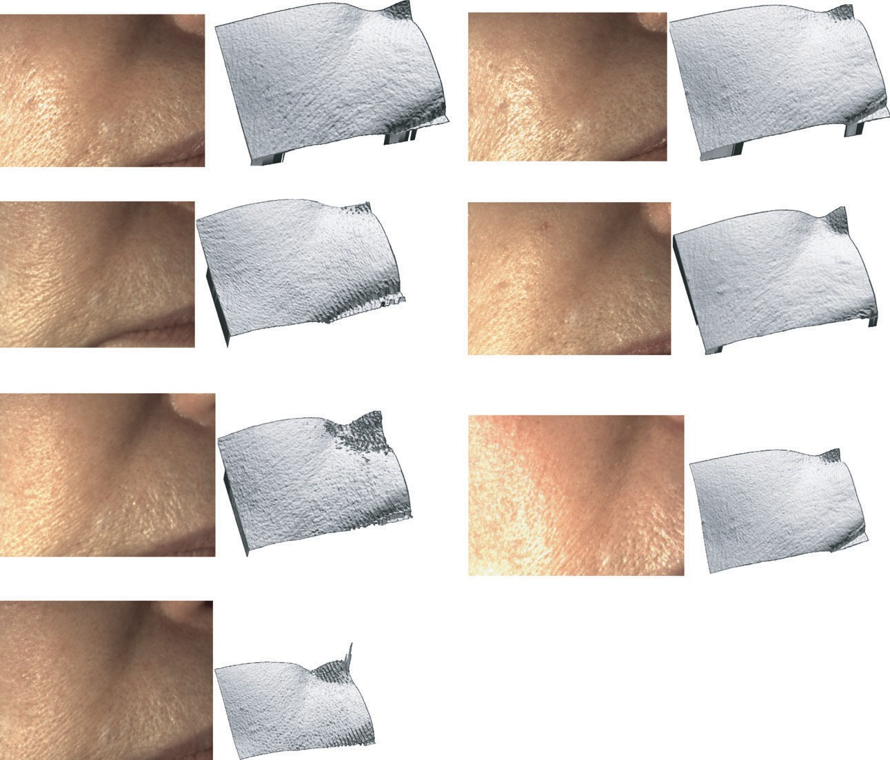(a)

V1 (Baseline visit)
- Post-treatment view at V3 14 days after treatment

- Post-treatment view at V4 1 month after treatment
- Post-treatment view at V5 3 months after treatment

- Post-treatment view at V6 6 months after treatment

- Post-treatment view at V7 9 months after treatment

- Post-treatment view at V8 12 months after treatment

Figure 6 (a–g) Pre and post treatment views of a 49-years-old caucasian woman: Figures 2D and 3D show the nasolabial fold from V1 (baseline) to V8 (12 months after treatment).

abrasion, (910 000) and laser hair removal (893 000).18 Many patients see surgical operations as high-risk procedures, but do not perceive any risk related to minimally invasive treatments.9,19 Requests for these types of treatment are increasing in popularity
worldwide and are associated with a high level of patient satisfaction.20–23
Among the nonsurgical approaches for facial rejuve- nation, after treatment with botulinum toxin, dermal filler procedures, and in particular with hyaluronic

acids, are the most frequently performed.3,24 Over 150 injectable fillers are available on the world market, but only around a dozen have had the approval of the FDA. Fillers can be divided into permanent and tempo- rary and enter into four main categories: autologous fat, collagen, hyaluronic acid and biosynthetic poly- mers. Hyaluronic acids account for the majority part of the soft tissue increase market. HA fillers are com- monly used for the treatment of wrinkles, filling of folds, and regional volumizers.9
The success of hyaluronic acids is especially due to their properties, such as an excellent risk-benefit ratio, simplicity of use, long-lasting effects, versatility, and reversibility.25 Various controlled randomized trials (RCTs) have compared the efficacy and safety of HA fill- ers with other non-HA injectable substances. Studies comparing HA fillers with bovine collagen have found that HA supplies a much longer-lasting correction in the nasolabial fold according to the 5-point Wrinkle Assess- ment Scale with similar safety profiles.26–28

Conclusions
This trial was designed to evaluate the safety and effi- cacy of a novel, highly cohesive, viscous HA volumiz- ing filler in restoring facial volume in nasolabial folds and the malar region. In our clinical and instrumental study, using this new dermal filler, a clinically and sta- tistically significant improvement in the FVLS was observed at each study visit. In 100% of treated cases, the reduction of visual score grade was at least one grade up to V5 (3 months after the first implant). The percentage of subjects who presented a reduction in FVLS visual score of 2 and 3 grades was higher at V4, V5, V6 than at V3 (60% at V4, 70% at V5, 69% at V6 vs. 42% at V3). The reduction in nasolabial wrin- kles was statistically significant 6 months after the first implant and was still clinically evident in most of trea- ted cases up to 9 months. An aesthetic improvement of at least 1 grade in the WSRS was still evident in 95% of subjects until V5, in 84% of subjects at V6 and 56% at V7. The clinically and statistically significant increase in skin hydration (P < 0.05 at V4, V6 and V7 vs. V1) confirmed the good results obtained during the study. Investigator and subject satisfaction with the aesthetic results was very high.
Currently, the FDA has approved several HA filler agents for mid-to-deep dermal implantation (i.e., Resty- lane, Juvederm, Hylaform) for the correction of facial wrinkles and folds,29–32 where HA is subjected to chemical cross-linking processes, which improve its vis- coelastic properties and increase its half-life.
The possibility of obtaining cross-linked hyaluronan gels by chemical derivatization has been well known since 1964;33 in recent years, a wide variety of chemi- cal modifications and subsequent cross-linking have been proposed to achieve chemical and mechanical HA robustness.34
In hyaluronic acid object of this study the chemical network plays a protective role decreasing the rate of HA hydrolysis and improving long term efficacy. Favoured by its prolonged residence time in the appli- cation site, the product slowly releases natural hyal- uronic acid by the auto-cross-linked HA (ACP), which thanks to its natural hydrating properties and visco- elasticity, improves the turgidity and the elasticity of the skin.
This new dermal filler seems to combine line efface- ment and volume restoration by BDDE-based cross- linked HA to a short-term bio-stimulating effect due to the release of native hyaluronic acid by the auto-cross- linked HA.

References
- Bray D, Hopkins C, Roberts DN. A review of dermal fillers in facial plastic surgery. Current Opinion in Otolaryngology
& Head and Neck Surgery 2010; 18: 295–302.
- American Society of Plastic Surgeons. National Clearing-
house of Plastic Surgery Statistics. 2010 plastic surgery pro- cedural statistics. Available at: http://www.plasticsurgery.
- American Society of Aesthetic Plastic Surgery Practice Survey 2008. Available at: http://www.surgery.org/sites/ default/files/2008stats.pdf (accessed 19th February 2010).
- Neuber F. Fett transplantation. Chir Kongr Verhandl Dtsc Gesellch Chir 1893; 22: 66.
- Gersuny R. Uebereinesubcutyane prosthese. Z Heilk 1900;
30: 1–5.
- Glicenstein J. The First ‘Fillers’, vaseline and paraffin.
From miracle to disaster. Ann Chir Plast Esthet 2007; 52: 157e61.
- Narins RS, Beer K. Liquid injectable silicone: a review of its history, immunology, technical considerations, compli- cations, and potential. Plast Reconstr Surg 2006; 118: 77Se84S.
- Rapaport MJ, Vinnik C, Zarem H. Injectable silicone: cause of facial nodules, cellulites, ulceration and migra- tion. Cosmetic Plast Surg 1996; 20: 267e76.
- Markarian MK, Hovsepian RV. The Interface of Cosmetic Medicine and Surgery: working from the inside and the outside. Clin Plastic Surg 2011; 38: 335–45.
- Meyer JM, Stern R. Age-dependent changes of hyaluro- nan in human skin. J Invest Dermatol 1994; 102: 385–9.
- Manuskiatti W, Maibach HI. Hyaluronic acid and skin: wound healing and aging. Int J Dermatol 1996; 35: 539–44.

- Monheit GD, Coleman KM. Hyaluronic acid fillers. Derma- tol Ther 2006; 19: 141e50.
- Hanke CW, Rohrich RJ, Busso M et al. Facial soft tissue fill- ers: assessing the state of the science conference: proceedings report. J Am Acad Dermatol 2011; 64: S53–65.
- Rohrich RJ, Hanke CW, Busso M et al. Facial soft tissue fillers conference: assessing the state of the science. Plast Reconstr Surg 2011; 127(Suppl 4): 22S–122e-S.
- Carruthers A, Carruthers J. Non-animal-based hyaluronic
acid fillers: scientific and technical considerations. Plast Reconstr Surg 2007; 120 (Suppl 4): 33S–40S.
- Andr´e P. Evaluation of the safety of a non-animal stabi- lized hyaluronic acid (NASHA—Q-Medical, Sweden) in European countries: a retrospective study from 1997 to 2001. J Eur Acad Dermatol Venereol 2004; 18: 422–5.
- Larsen NE, Pollak CT, Reiner K et al. Hylan gel biomate-
rial: dermal and immunologic compatibility. J Biomed Mater Res 1993; 27: 1129–34.
- D’Amico RA, Saltz R, Rohrich RJ et al. Risks and opportu- nities for plastic surgeons in a widening cosmetic medi- cine market: future demand, consumer preferences, and trends in practitioners’ services. Plast Reconstr Surg 2008; 121: 1787–92.
- Ogden S, Griffiths TW. A review of minimally invasive
cosmetic procedures. Br J Dermatol 2008; 159: 1036–50.
- Kim JE, Sykes JM. Hyaluronic acid fillers: history and
overview. Facial Plast Surg 2011; 27: 523–8.
- Coleman KR, Carruthers J. Combination therapy with
BOTOXTM and fillers: the new rejuvenation paradigm.
Dermatol Ther 2006; 19: 177–88.
- Dayan SH, Arkins JP, Patel AB et al. A double-blind, ran-
domized, placebo-controlled health- outcomes survey of the effect of botulinum toxin type A injections on quality of life and self-esteem. Dermatol Surg 2010; 36: 2088–97.
- Sepehr A, Chauhan N, Alexander AJ et al. Botulinum toxin
type A for facial rejuvenation: treatment evolution and patient satisfaction. Aesth Plast Surg 2010; 34: 583–6.
- Fagien S, Stuzin J. Injectable soft-tissue augmentation: the present and the future. Plast Reconstr Surg 2007; 120: 5S–7S.
- Gold M. The science and art of hyaluronic acid dermal
filler use in esthetic applications. Journal of Cosmetic Der- matology 2009; 8: 301–7.
- Baumann LS, Shamban AT, Lupo MP et al. JUVEDERM vs ZYPLAST Nasolabial Fold Study Group. Comparison of smooth-gel hyaluronic acid dermal fillers with cross- linked bovine collagen: a multicenter, double-masked, randomized, within-subject study. Dermatol Surg 2007; 33(Suppl 2): S128–35.
- Lupo MP, Smith SR, Thomas JA et al. Effectiveness of
Juv´ederm Ultra Plus dermal filler in the treatment of severe nasolabial folds. Plast Reconstr Surg 2008; 121: 289–97.
- Narins RS, Brandt F, Leyden J et al. A randomized, double-blind, multicenter comparison of the efficacy and tolerability of Restylane versus Zyplast for the correc-
tion of nasolabial folds. Dermatol Surg 2003; 29: 588–95.
- Arron ST, Neuhaus IM. Persistent delayed-type hypersen-
sitivity reaction to injectable non-animal-stabilized hyal- uronic acid. J Cosmet Dermatol 2007; 6: 167–71.
- Falcone SJ, Berg RA. Temporary polysaccharide dermal
fillers: a model for persistence based on physical proper- ties. Dermatol Surg 2009; 35: 1238–43.
- Gold MH. Use of hyaluronic acid fillers for the treatment
of the aging face. Clin Interv Aging 2007; 2: 369–76.
- Gold MH. What’s new with hyaluronic acid fillers. J Drugs
Dermatol 2007; 6: 1050–3.
- Laurent TC, Hellising K, Gelotte B. Crosslinked gels of
hyaluronic acid. Acta Chem Scand 1964; 18: 374–5.
- Serban MA, Yang G, Prestwich GD. Synthesis, character-
ization and chondroprotective properties of a hyaluronan thioethyl ether derivative. Biomaterials 2008; 29:
1388–99.

