Formability of all-metal sandwich sheets
by
Aleksandra Pylaeva

Table of contents
Formula symbols and abbreviations v
1. Introduction 1
2. Structure of facings and a core 1
3. Forming of a sandwich panel 3
3.1 Joining of face sheets with a core 4
3.2 Deep drawing of a sandwich panel 5
4. Analytical and numerical models of a sandwich panel 6
5. Conclusion 7
Bibliography 8

Formula symbols and abbreviations

Formula Symbols
Symbol | Unit | Description
P | MPa | Pressure
E | MPa | Young’s modulus
t | mm | Facing sheet thickness
σ | MPa | Stress
b | mm | Width of a supporting plate
L | mm | Length of a supporting plate
D | mm | Depth of a core
k | N/m | Stiffness of a supporting plate
B | N/m | Stiffness of a facing sheet

Abbreviations
Abbreviation |  | Description
FEM |  | Finite-Element-Method

- Introduction
Sandwich sheets are special three-ply structures, generally consisting of two metallic skins and a core with a low density (as shown in Figure 1). The purpose of the thick and soft core is to allow the uniform behavior as well as the stability of two outer layers by means of keeping the defined distance between them. Required results can be achieved by appropriate bonding of metallic sheets with the core, which transfers forces from one surface layer to another. This design allows to reduce the thickness of a whole panel simultaneously increasing its bending stiffness.
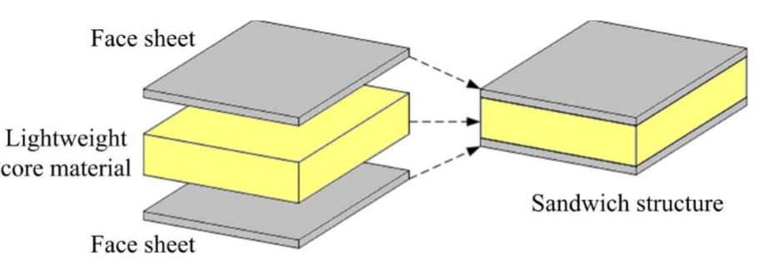
Figure 1: Sandwich panel. [1]
Due to high strength and at the same time to the light weight, compared to the monolithic sheet of the same face material, sandwich panels are nowadays rapidly spreading in such industry sectors as construction, shipbuilding, aeronautics and vehicle manufacturing. These sheets are being successfully investigated and applied mainly in automotive production. However, according to the research of Mohr and Straza [2] at this field, joining and forming problems of such kind of sheets are indisputable obstacles, that are needed to be eliminated.
- Structure of facings and a core
Sandwich panels show high reliability and stability in dimensions under loads. However, their mechanical properties depend on the proper selection of core and face materials. An outer layer needs to be rigid and strong enough at tension-compression loads to resist wrinkling and bending [3]. So, applicable materials are steel, aluminium, wood, fiber-reinforced plastic and sometimes concrete. At the same time the low density of the inner layer is the main purpose why the whole sandwich structure is so light, consequently, such materials as cork, balsa wood, rubber, conventional thermoplastics (polyethylene), foamed polymer (polyurethane, polystyrene, phenolic foam) or mineral wool slabs are utilized [4].
Different core structures are presented in Figure 2. As Besse [1] has shown, a good engineering solution for increasing the stability of the sandwich panel is to set a system of rib stiffeners as a core. It can be done with the use of corrugated core or cellular implies. Cellular categories can be divided into eggbox-structure (when endothermic properties of the part are needed); truss-structure (shows good properties at shearing, compression and bending, however, at high loads the properties are lost because of buckling) and honeycomb-structure (shows perfect behavior at shearing and bending load).
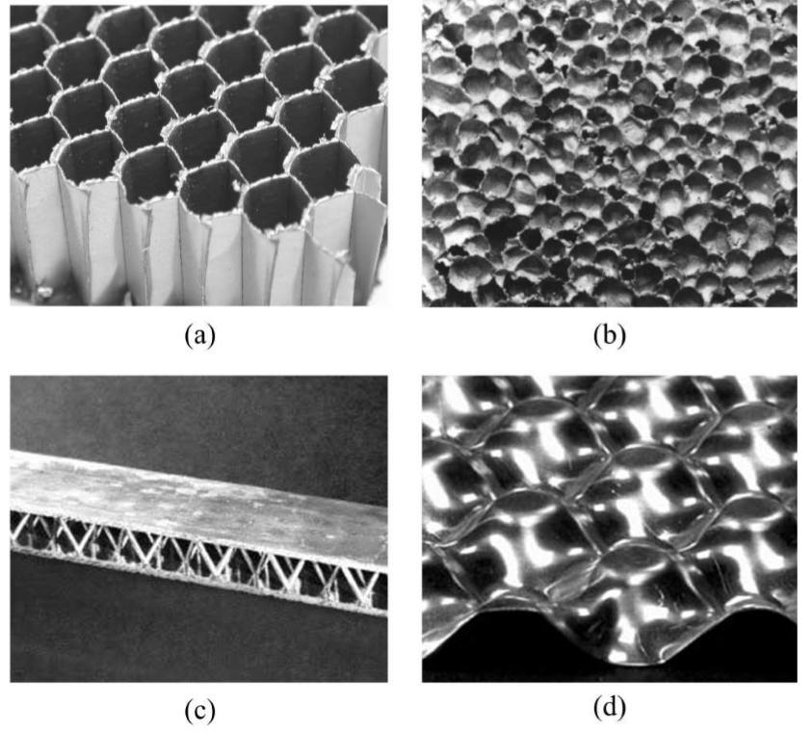
Figure 2: sandwich structure with: a) hexagonal honeycomb core; b) foam core; c) alloy truss core; d) eggbox core. [1]
Honeycomb and corrugated structures are being used more frequent than foam cores since they show the best mechanical properties. Current investigations are mainly being done on these two structures.
- Forming of a sandwich panel
The forming process of a sandwich sheet into a three dimensional structure is still a topic under research. Finding the suitable method is complicated because of the material differences of face sheets and a core. For example, Behrens et. al [6] have offered the solution, which allows to combine forming and joining of steel /fiber-reinforced plastics/steel sandwich sheet to a sandwich part only in one process step. The special tool for stacking a core with sheet metals and further processes of heating a panel, forming, joining, consolidating it and cooling the final part is developed. However, the cycle time is too big because of the special requirements for cooling of thermoplastic.
Galdos et. al. [9] have shown the advantages of incremental sheet metal forming of sandwich panels. They have investigated laminate vibration damping steels as facings and a considerably thin layer of resin as a core, proving that such sandwich construction shows very good vibration and noise damping properties. Nevertheless, these suitable research results are observed only with use of exact materials as well as special geometry of the part and become unacceptable with any change. Furthermore, incremental sheet metal forming is a very time consuming process itself, consequently this kind of forming a sandwich panel has to be improved to be applied for a mass production.
Thus, forming of the sandwich part is principally done in two steps: 1) combining two metal facings together with a core into a sandwich sheet 2) making the required sandwich panel from sandwich sheets with conventional forming methods such as deep drawing. [7]

  - Joining of face sheets with a core
The connection of metallic skins and a core is done in two steps. Firstly, outer layers are produced. Secondly, manufacturing of a core along with its bond to two outer layers is done (gluing of facings and a core with special synthetic substances is also used, but more modern methods are introduced nowadays).
Face sheets, according to the required geometry, are produced by conventional cold-forming operations (folding, press-braking, roll-forming or deep drawing). A core is mainly formed from the pre-formed slabs. [4]
According to Khan [5] a core and outer layers can be bonded with the use of adhesive film, that is situated on the top and the bottom surfaces of the core, upon which pre-impregnated composite fibers («preprags») are placed.
It is a big issue to provide the proper joining of a core and face sheets during adhesion because of the instability of chemical reactions and possible defects of very thin film and preprags. Effective meshing of a core and face sheets is extremely important, because it is in the direct correlation with bearing capacity of the whole sandwich panel. Due to the difference of stiffness of a core and facings, shear stress is generated at the boundary «core-facing». As shown in Figure 3, cracks, initiated in a zone of the insufficient connection of layers, grow fast and lead to the failure of the whole sandwich panel.
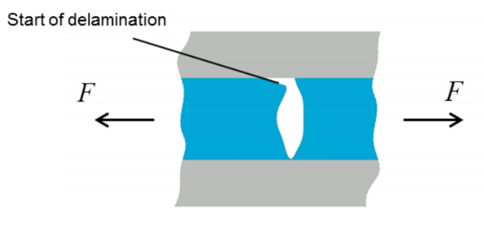
Figure 3: Crack propagation because of delamination. [11]
Sokolova et. al. [8] have mentioned roll-bonding as the method of manufacturing the initial sandwich sheet. In this process the first cleaned metal facing is coated with epoxy resin, then heated up, covered with a polymer foil (also heated) and placed between the rolls. After that this product is cleaned again, heated up and joined with the second metal facing in the same way. This method requires more production time than the one, offered by Khan [5].
  - Deep drawing of a sandwich panel
Sokolova et. al. [8] have shown the forming behavior of steel/polymer/steel sandwich cup as well as its dependency on the core thickness and the geometry of the punch.
Low stainless carbon steel is chosen as the facing material (with thickness of each sheet being 0.5 mm). Polypropylene (combined with polyethylene, rutile and barite) is chosen as core material (thickness of a core is different in each experiment: 0.2 mm, 0.6 mm, 1.0 mm and 2.0 mm).
Deep drawing with a circular and with a square punches has been investigated. Photogrammetrical analysis of the parts has shown, that for circular geometry of a punch main deformations are distributed at the punch radius and the edge area of the part. For the square punch corners of the part are concentrators of tangential and radial stresses.
Failure analysis of the part, produced by circular punch, has shown that the thinner the core - the higher the tension in stress concentrated area (thus the risk of the failure is enhanced). Cracks can be avoided with increasing the core thickness up to 2.0 mm. Fractures appear in parts with 0.2-0.6 mm core thickness. The resistance of a facing sheet to the punch loading is higher with increasing the thickness of the core. Strain values fluctuate at flanges of a metallic skin with changing in thickness of a polymer core. Failure analysis of the part, produced by square punch, has shown, that a core reacts different in diagonal and perpendicular direction to the punch (tension is 14% higher in the diagonal direction). Wrinkling defect has appeared at flanges with no dependence on the changing in thickness of the parts.
- Analytical and numerical models of a sandwich panel
Błaszczuk and Pozorski [10] have analyzed bending behavior of a sandwich panel, taking wrinkling into account, since wrinkling problem occurs during forming in any case and is proven to be serious. According to their research, the depth of a sandwich sheet (steel/polymer/steel), a thickness of a facing and core stiffness influence wrinkling.
For analytical analyses is assumed that a sandwich panel shows elastic, homogenous and isotropic behavior. Shear stresses are distributed uniformly in a core due to the low stiffness of a core.
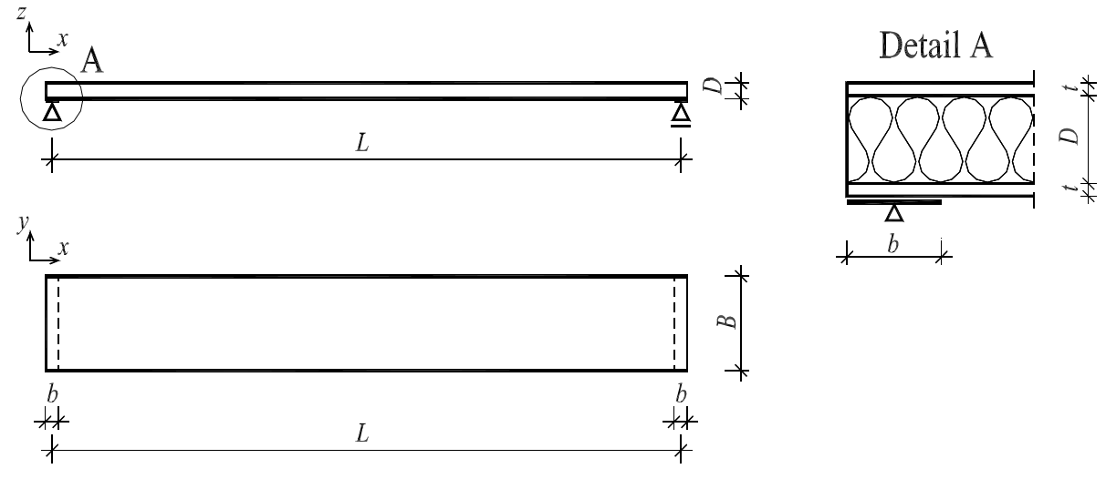
Figure 4: Geometry of a sandwich panel under investigation. [10]
As it is shown in Figure 4, a rigid sandwich panel of a simple rectangular geometry with length L and width B is fixed at both sides. It is analyzed as a beam. A core represents corrugated structure. Width of a supporter is b, depth of a core is D and thickness of both facings is t.
It is derived, that wrinkling stress $σ$ depends on the thickness t of outer layers and the compressive pressure P (Eq.1.1).
$$σ= \frac{P}{t} = \frac{3\sqrt{2 }}{2}\frac{f_{2}}{t}\sqrt{\frac{BE}{D}} (1.1)$$
Pressure P depends on the stiffness of facings $B$, Young’s modulus of facings E and a special function $f_{2}$, which describes Young’s modulus of the core, depth of the core D and stiffness of supporters k (Eq. 1.2).
$$f_{2}= \sqrt{\frac{kD}{E_{c}}} (1.2)$$
For a numerical investigation ABAQUS software is used. FEM analysis has shown that the smaller D and bigger the values of bending stiffness of a core and outer layers - the more wrinkling affects appear. Different mesh sizes are used as well, the bigger their values - the higher the possibility of wrinkling. Numerical and analytical methods correspond enough to apply them for practice.
- Conclusion
Sandwich panels show high load-bearing capacity being lightweight materials, good behavior under thermal loads and excellent damping properties. Different core structures are used to increase the stiffness of a sandwich sheet. They should be properly connected with facings with glue, adhesive films or roll-bonding processes to avoid crack propagation. Delamination and wrinkling of final parts as well as shear stresses between different layers tend to be the main problems that have to be solved. Formability of sandwich panels increases with increasing the thickness of the polymer core. Geometry of a punch also affects formability.
Manufacturers try to produce sandwich panels in one step, combining deep drawing and stretching with joining or applying new forming methods. Current investigations show that it is possible, however, more research work has to be done.

Bibliography
[1] Besse, C., 2012. Development and optimization of a formable sandwich sheet.
[2] Mohr, D., Straza, G. 2005. Development of formable all-metal sandwich sheets for automotive applications. Advanced Engineering Materials.
[3] Carlsson, L.A., Kardomateas, G.A., 2011. Structural and failure mechanics of sandwich composites, pp. 1 - 37.
[4] Davies, J. M., 2011. Lightweight sandwich construction.
[5] Khan, S., 2007. Bonding of sandwich structures - the facesheet/honeycomb interface - a phenomenological study.
[6] Behrens, B., Hübner, S., Grbic, N., Micke-Camuz, M., Wehrhane, T., Neumann, A., Forming and joining of carbon-fiber-reinforced thermoplastics and sheet metal in one step. Procedia Engineering 183 (2017) , pp. 227 - 232.
[7] Besse, C., Mohr, D., Plasticity of formable all-metal sandwich sheets: Virtual experimentsand constitutive modeling. International journal of solids and structures 49 (2012), pp. 2863 - 2880.

[8] Sokolova, O.A., Kühn, M., Palkowski, H. Deep drawing properties of lightweight steel/polymer/steel sandwich composites. Archives of civil and mechanical engineering 12 (2012), pp. 105 - 112.

[9] Galdos, L., Sáenz de Argandoña, E., Otegi, N., Ortubay, R., 2012. Incremental forming of sandwich materials.
[10] Błaszczuk, J., Pozorski, Z., Analytical and numerical models of sandwich panel taking into account wrinkling phenomenon. Revista Română de Statistică – Supliment Trim IV (2012), pp. 238 – 244.
[11] Behrens, B-A., Bouguecha, A., Bonk, C., Schulze, H. Finite element analysis regarding the forming behavior of symmetric hybrid structures consisting of two sheet metal outer layers and a thermoplastic core. 4th International Conference Recent Trends in Structural Materials. IOP Publishing. Materials Science and Engineering 179 (2017).

