Victoria Usanova
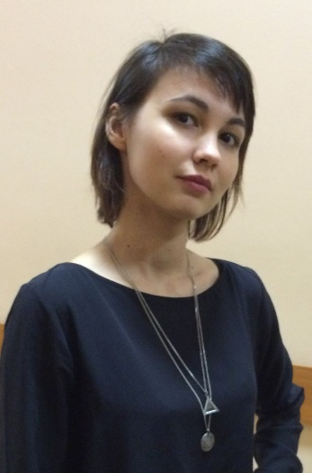
+7(911)257-58-44
mrnwing@gmail,com
Saint-Peretsburg, Russia
Employment History
- Translator and interpreter
OMZ Special Steels LLC
March 2016
Translated technical specifications, interpreted inspection for nuclear reactor components (bottom and shell rings)
- Part-time resume translator
Kelly Services
September 2015
Translated resumes and cover letters for company.
- Translator from English into Russian
International Maritime & Adventure film festival "The Sea Calls"
March 2013, March 2014, March 2015
Translated scripts for films from English into Russian. Films were connected with nature, biology and marine themes.
- Interpreter
ICIEP
October 2013, February 2014, October 2014
Worked as volunteer interpreter at the International Education Fair in Russia, Saint-Petersburg. Translated conversation between students and exhibitors from English into Russian and vice versa.
Education
• Bachelor of Arts (B.A.), Contemporary Linguistics and Intercultural Communication; Translation | Herzen State Pedagogical University of Russia
2011 - 2017
Study aspects of intra- and interlingual translation, intercultural communication, adaptation, localization, special terminology.

