Choosing a way to go on with Russia’s railway restructuring at the 3rd stage
Petrakov V. V.
Ph.D., associate professor
Department of management, School of economics and management,
Far-Eastern federal university, Vladivostok, Russian Federation
Phone: +79147255350, e-mail: vavan_99@mail.ru

Abstract. Russian railway has been under restructuring since 2001. Currently we see the third (and the last, as per Governmental Program for railway restructuring) stage. To determine further direction of restructuring it is required to briefly specify all the three stages, analyze their results and make conceptual proposals for further restructuring method. We offer to study one of the two basic models for railway operation, namely North American (vertically integrated competing companies) instead of European (vertical separation of infrastructure and freight). The scientific novelty is in applying the North American model in the whole territory of Russia, not only in the European Russia as offered by various authors. The conclusions are supported by systematic comparative analysis.
Keywords: reform; restructuring; Russian Railways; railway transport; vertical integration; parallel competition.

- Introduction
The Governmental Program for railway restructuring provided for the following three stages of restructuring.
- Transformation of Ministry of communication lines into OAO “Russian Railways” (joint-stock entity), the infrastructure monopoly engaged in transportation services, actually being the infrastructure owner and monopolistic freight operator. It was planned to complete the 1st stage by 2002, but in fact it was finished in October 2003 with the incorporation of OAO “Russian Railways” due to difficulties with the assessment of new company’s assets [1].
- Restructuring of OAO “Russian Railways” by separation of structural entities which could be open for competition regulated by government, engaged in suburban passenger traffic, long-distance passenger traffic, railway repair works as well as noncore activities and further could be restructured into subsidiaries of OAO Russian Railways” or independent commercial entities with shares sold and traded on stock exchange. The 2nd stage was planned to be completed in 2003 – 2005, although the basic restructuring was completed in 2007 upon the incorporation of OAO “First freight company” which was assigned 40% of wagons owned by OAO “Russian Railways”.
- At the 3rd stage of restructuring it is provided for the assessment of feasibility and methods of full organizational separation of infrastructure from freight business (if conditions allowing for such separation have been reached at that stage), development of private locomotives, ownership of over 60% of wagons by private operators. We stress that is was provided for “feasibility assessment of establishment of several vertically integrated railway companies” and “steps in connection with competition growth on freight market on infrastructure’s areas allowing for parallel routes (possible, in the European Russia)”.
Thus, the choice of further strategy of restructuring remains free and is not exactly specified in Program. Meantime, as pointed above, vertical integration and parallel competition are suggested as alternatives for discussion and consideration, according to Program.

- Russian rail’s performance results and trends
Before analyzing the restructuring results and further alternatives we will have a look at key trends in Russian railway transport as shown in Annual report-2013 by OAO “Russian Railways” [2].
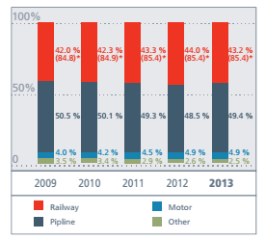

Pic. 1 – Cargo turnover by kinds of transport in 2009-2013 including pipelines (in brackets – stake of railways without considering pipelines).

As seen from Pic. 1, the stake of railways remains stable at 42-44%, which is acknowledged by more detailed data from Table 1.

Table 1 – Cargo turnover by kinds of transport in Russia in 2013 [2].
 | 2013 |  | Stake of transport kinds in total cargo turnover, % | Stake of transport kinds in total cargo turnover not accounting for pipelines, %
 | Billion tkm | % to 2012
Cargo turnover in transport | 5083.0 | 100.5% | 100.0% | 100.0%
including:
Railway | 2195.8 | 98.8% | 43.2% | 85.4%
Highway (motor) | 250.0 | 100.4% | 4.9% | 9.7%
Ocean | 39.4 | 86.9% | 0.8% | 1.5%
Inland water | 80.1 | 99.1% | 1.6% | 3.1%
Air | 5.0 | 98.9% | 0.1% | 0.2%
Pipeline | 2512.7 | 102.4% | 49.4% | -

The structure of goods carried by rail has not changed recently.

Pic. 2 – Structure of goods carried by Russian railways in 2013 [2].

Coal and oil/oil products are the core cargoes shipped by rail, jointly making for almost half of goods carried.
Now it is feasible to assess the main achievements of Russian railway transport restructuring. Among undoubted results of the reform, there is the advent of private companies owning and operating wagons and private wagon stock ultimate growth trend in goods carried, total number of wagons and cargo turnover. That led to competition growth between private operators and finally was of benefit for most shippers and gave a push for wagons building sector.

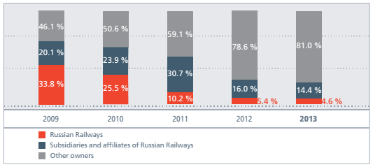
Pic. 3 – Structure of wagons operation by volume of goods carried, % [2].

However in infrastructure and locomotive sector still uncovered by the reform are showing lack of investments and stagnation, as stated by F. Khusainov [3].

Table 2 – Wear of fixed assets of Russian railways in 2000 – 2012 [2; 4].
Fixed assets | Wear, %
 | 2000 | 2004 | 2006 | 2008 | 2012
Electric locomotives | 63 | 65 | 74 | 76 | 70
Diesel locomotives | 71,3 | 73 | 75 | 77 | 80
Freight wagons | 58,8 | 70 | 84 | 85,5 | 65
Passenger wagons | 49,4 | 56 | 65 | 70 | 72

As seen from Table 2, the wear decreased only by freight wagons which is explained by deregulation of freight traffic and large-scale purchase of rolling stock by freight wagon operators.
Besides the fixed assets wear, infrastructure’s capacity also has had a decline since 1993, decreasing in quantity by 2008 as follows:
- by 18% - total number of railway stations;
- by 9% - total length of station tracks;
- by 20% - length of receiving and departure tracks;
- by 20% - length of marshalling tracks;
- 3 times – total number of marshalling depots (from over 200 sown to 60) [5].
Thus, the matter of choosing a concept or alternatives for further running of the restructuring at the third stage remains open.

- Strategies for restructuring infrastructure monopolies
In practice there are three core strategies of restructuring vertically integrated infrastructure monopolies.

Table 3 – Advantages and disadvantages of core strategies for restructuring infrastructure monopolies.
Model | Description | Advantages | Disadvantages
Monolithic | Horizontally and vertically integrated monopoly, traditional from the historical point of view. | - economy of scale;  - economy of scope;  - no problem with schedules coordination | - combined commercial tasks and regulation functions;  - non-transparent tariff and cost structure;  - complex and old management structure;  - costs on social infrastructure being the direct tax on end users
Vertical integration | Horizontally separated monopoly with competition between several vertically integrated companies. Thus, monolithic monopoly of the first model is divided horizontally into a few segment and each segment company both owns the infrastructure and is engaged in core activities (subject that management is separated) | - tariff setting as per market principles and ultimate tariff decrease;  - no governmental funding of infrastructure;  - investments growth | - need for parallel routes;  - cartel risks;  - complexity of new companies incorporation and selection of their infrastructure network
Vertical separation | Along with vertical separation of infrastructure and several core activities, a separate infrastructure company exists covering repair, maintenance and development of infrastructure, operational control, access of independent operators to the network. Separate independent operator companies at the same time are engaged in core activities paying infrastructure access tariff to the infrastructure company. | - growth of production parameters;  - several competing operators;  - transparency inside sector;  - specialization | - loss of economy of scale and scope;  - requires complex agreements between infrastructure owner/operator and independent operators;  - high costs on separation;  - conflicts between railway authorities and operators;  - difficulties in connection with mutual schedules;  - lack of investments and need for governmental subsidies

- Two basic variants to go on with Russian rail restructuring
To bring investments it is required to determine and choose further concept of the reform. In general, two alternatives are proposed: variant by “McKinsey & Со” supported by OAO “Russian Railways” with competition for the route only for dead-end sections [6]; and variant offered by S. Guriev et al on establishment of 3-4 vertically integrated companies in the European Russia (so-called North-American model) [7].
The arguments for the second variant are rather logical and will be considered below.
The first argument moved by supporters of parallel competition of vertically integrated companies is the notion of similar conditions of operation and performance figures of the North-American model’s countries and Russia. The research of Institute of natural monopolies’ problems summarizes the above conditions and figures [8].

Table 4 – Comparing railway operational parameters in countries of various models.
Parameter | Germany | France | UK | Sweden | Austria | Italy | Poland | Australia | Canada | USA | RF
Average weight of freight train, mt* | 500 | 380 | 800 | 480 | 460 | 450 | 640 | 4250 | 2900 | 2850 | 2255
Average number of wagons in freight train | 13 | 10 | 20 | 13 | 12 | 12 | 17 | 89 | 72 | 69 | 61
Average freight distance, km | 320 | 375 | 215 | 345 | 205 | 300 | 245 | 320 | 1100 | 915 | 1700
Traffic density of network, million tkm | 2,97 | 1,16 | 1,32 | 2,05 | 3,19 | 0,89 | 2,53 | 7,55 | 7,05 | 11,05 | 24,6
Traffic load (freight and passenger wagons), thousand wagon/km | 200 | 175 | 185 | 115 | 180 | 180 | 135 | 240 | 225 | 310 | 730
Productivity of freight locomotives, million tkm/year | 63 | 45 | н/д | 104 | 43 | 39 | 35 | 236 | 185 | 107 | 186
Productivity of freight wagons, thousand tkm/year | 993 | 430 | н/д | 1520 | 886 | 511 | 576 | 6610 | 5015 | 2080 | 1963
*Average net weight of freight train including empty freight trains equals cargo turnover (net) / train-km (including empty) of freight trains.
In the EU the stake of railway transport in cargo turnover is up to 37%, in passenger turnover up to 10%; in Russia – 43.5 and 31.5%, respectively. Thus, railway transport in European countries does not have the framework and social role like in Russia. The stake of freight traffic in the EU cargo turnover is 25 – 75%; in the RF – 95% [8]. Railways in Europe are mainly oriented for passenger carrying while in Russia and North America they are aimed at freight. Therefore restructuring approaches which had positive results in Europe may bring different results in Russia.
Average weight of freight train in the EU is below 800 mt, number of wagons under 20, freight distance under 400 km; in Russia those parameters are: over 2,500 mt, 60 wagons and 1,700 km respectively, increasing European parameters by 3 times and North-American parameters by 1.7 times (which evidences one more common feature between the conditions of railway operation in North America and Russia).
The second argument concerns the specifics of freight flows – very similar in North America and Russia, allowing for parallel competition between vertically integrated companies (owners of infrastructure and rolling stock).

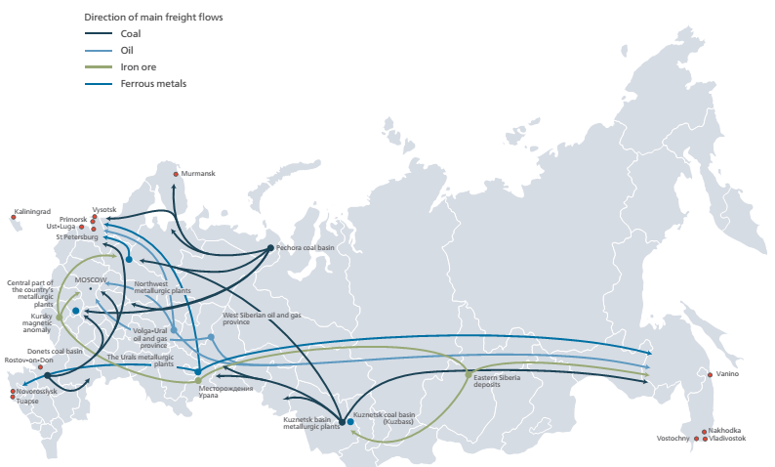
Pic. 4 – Direction of main freight flows of the Russian railways [2].

The analysis of main freight flow directions shows that there are four largest massive loading centers: coal deposits and foundries of Kuznetsk coal basin, ore mining fields and foundries of Urals, West-Siberian oil and gas province and East Siberian deposits. The destination points are mainly ports of western and eastern parts of Russia. In 2013, 44.5% of 352 million mt of coal produced (5,064,000 gondola wagons) were exported [9]. This is acknowledged by the average transportation distance making up some 4,377 km for export coal [10].
Thus, the shippers from the two largest freight loading centers (shippers of Kuznetsk basin, metallurgic pants from the Urals and oil producers from West Siberian oil and gas province) are shipping to western and eastern Russian ports handling their cargoes to end-users. To western ports their cargoes may be delivered at least via three parallel (not in geometric sense) routes, to eastern – via two (Baikal-Amur railway and Transsiberian railway), accounting for the fact that the eastern parallel route begins only in Taishet and the rail to Taishet will be the only infrastructure, with regulated access.

- Preliminary findings in connection with the use of North American model
We drafted a set of five findings which as we opine need to be considered in the coming year in connection with the use of vertical integration and parallel competition concept in the territory of the whole country, but not only in the European part, which is the principal difference from the second variant of restructuring.
First, infrastructure should be assigned to vertically integrated companies on long-term lease conditions (sale of concessions). Parallel competing companies will be established by sale of long-term (30 years’ at least) concessions for management of vertically integrated companies may become a tool for the attraction of investments. Meantime the infrastructure will be state owned and concession contracts may provide for the terms and conditions the execution of which are opined necessary due to social or strategic reasons (for example, transportation for Ministry of Defense). Besides, the terms and conditions of concessions must include investment programs. Assumingly in the event of the sale of four vertically integrated concessions the price of each of the two 30-years’ concessions in the western Russia covering some 25,000 km network may cost some 0.6 – 4 billion USD making 2.3 billion in the average per concession in the European part. In the eastern part of Russia, the network of each of the two remaining concessions will make about 15,000 km 0.45 – 2.5 billion USD worth. Accounting for the climate of the eastern Russia, costs for buying the eastern concessions may grow. If there are 5 or 6 concessions, the network size and the cost of each concession will be decreasing. Therefore it is quite real to bring Russian capital.
Second, it is required to set the right of access to the infrastructure of competing railway. It is obvious that in many cases in particular during bulk cargoes transportation across the whole country shippers will have to use at least two railways on the non-parallel part of the route. To ensure that, mutual cooperation of railways will be needed by granting each other the right to infrastructure access. Most agreements on mutual use of infrastructure will be voluntary and mutually beneficial. Mandatory access providing by orders of governmental authorities should take place only in exclusive cases.
Third, it is required to protect dependent or captive shippers (R. Pittman’s terminology) from the only railway in their area in a way similar to Canadian system. Thus, shippers dependent on one railway may either insist on providing services by the second railway through the first railway’s tracks or demand cooperation between the first and the second railways. In both cases, tariffs should be regulated. It is also necessary to develop the settlement procedure for claims received from shippers in connection with the abuse of monopolistic power by railways.
Fourth, switching areas need to be created. In some areas, close to large stations or ports we offer to create so called stitching areas – tracks, stations and terminals jointly owned or operated by two or more competing railways or independent players. Main switching areas – contact points of competing railway lines – are freight stations of Moscow, Saint-Petersburg, Kirov, Yekaterinburg, Ufa, Chelyabinsk, Omsk and ports of Vladivostok, Nakhodka, Vostochny, Vanino, Murmansk, Saint-Petersburg.
Fifth, we offer to divide the railways into 5 vertically integrated companies (3 in the European part and 2 in the eastern part). Concerning the detailed determination of lots of infrastructure to be assigned into concession to those 5 companies we opine that it will require additional research regarding the European part and is very obvious for the eastern part. In the eastern Russia we plan to use Baikal-Amur railway and Transsiberian railway (route 1 – Taishet – Lena – Komsomolsk-on-Amur, route 2 – Taishet – Irkutsk – Volochaevka). Meantime, Volochaevka – Komsomolsk-on-Amur – Sovetskaya Gavan and Volochaevka – Pacific ports will be regulated as per the first offer above.
The Russian government prolonged the third stage of structural reform for 2015. We see some reasons to state that the above offers will be considered by respective governmental authorities and OAO “Russian Railways”.

References:
1. D. Simakov, Ministry of communication lines more expensive than “Gazprom”, Vedomosti. 149 (2002) 2.
2. Annual report of OAO “Russian Railways” for 2013 [http://ir.rzd.ru/dbmm/download?vp=58&load=y&col_id=121&id=314].
3. F.I. Khusainov, Rail reform: achievements and problems, Vestnik transporta. 4 (2011) 8-14.
4. V. G. Larionov, Problems of transport in Russia in the view of present industrial logistics, Rossiyskoye predprinimatelstvo. 24 (2013) 145-152.
5. F.I. Khusainov, Rolling stock management: revolution coming, RZhD-Partner. 20 (2010) 34-38.
6. M. Dmitrieva, M. Kuzminov,. Transport services market for five years’ term: state contract and competition with economy of scale, RZhD-Partner. 20 (2009) 37-40.
7. S. Guriev, R. Pittman, E. Shevyakhova, Competition against regulation : offers on rail restructuring at the third stage of reform, Moscow, CEFIR, 2003.
8. Yu. Saakyan, V. Savchuk, I. Tereshko, Analysis of foreign research of
separation of railway transport infrastructure and freight business, Economics of railways. 7 (2013) 12-20.
9. L. Plakitina, Key challenges and threats for coal mining and export in world’s main countries, the CIS and Russia till 2030. [www.eriras.ru/files/pls_in-t_a_smita_vyzovy_i_ugrozy_may_2014_g_nov.pdf+&cd=2&hl=ru&ct=clnk&gl=ru].
10. O. Trudov, Two sides of transport problem, Nezavisimaya gazeta, 15.10 (2013) 3 [http://www.ng.ru/energy/2013-10-15/13_transport.html].

