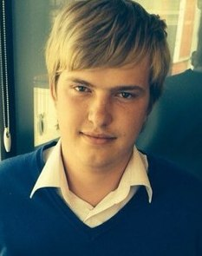
Serhiy Stepanets
Date and place of birth: 25/10/1992, Korostyshiv
Home address: Zhytomyr region, Korostyshiv, Gvardiyska 41, 12500
Phone numbers: 0630170020, (04130) 5-73-10.
E-mail: stepanets20@mail.ru
Skype: serhiy_stepanets
Objective: Seek the Position of a Translator.
Education:
1999- 2010. – Korostyshiv secondary school №3.
2010- 2014. – Incomplete higher education: Bachelor’s degree. Ivan Franko​​Zhytomyr State University; "Philology. Translation"; full-time education.
2014-2015 - Complete higher education: Specialist’s degree. Ivan Franko​​Zhytomyr State University; "7.02030304. Translation"; full-time education.
SUMMARY OF CHARACTERISTICS AND SKILLS
- Fluent Ukrainian, Russian, English (upper-intermediate level);
- Sufficient experience of written translations;
- German language at the intermediate level (oral speech, written, reading);
- Sociable, quick learner, and able to work much and intensively;
- Considerable and responsible, willing to cooperate.
PROFESSIONAL EXPERIENCE
2012-2014 - Freelancer. Worked in the Internet, providing translations on different topics (politics, medicine, law);
2014- present – translations of documents in official and publicistic styles, different agreements and contracts.
ADDITIONAL INFORMATION
- Experienced user of the Internet (search, analysis, structuring of the information);
- A good user of the operating system Windows: Microsoft Office (Word, Excel, PowerPoint), Internet Explorer, Opera, Mozilla Firefox, Chrome.

