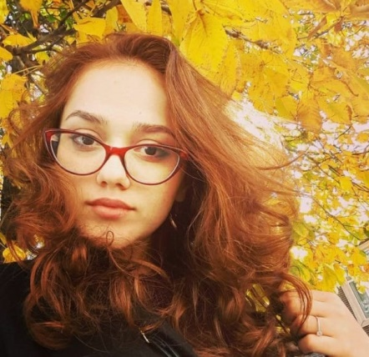 |  | EDUCATION
School №2 (Secondary Education), Qusar, Azerbaijan
Azerbaijan Cooperation University English translator

Izabella xanaxmedova  CONTACT  PHONE:  +994 50 303 17 05  EMAIL:  bellaxanova64@gmail.com  ADDRESS:  Azerbaijan Baku city  DATE OF BIRTH:  05.02.1994 |  | WORK EXPERIENCE
Shahdag Pik Palace Hotel Housekeeping Coordinator-07.10.15-31.03.16

Shahdag Pik Palace Hotel Housekeeping Coordinator-07.11.16-31.03.17

Jumeirah Bilgah Beach Hotel Housekeeping Coordinator-15.05.17-31.08.17

Shahdag Pik Palace Hotel Housekeeping Coordinator-20.11.17-31.03.18

Bilgah Beach Hotel Housekeeping Coordinator-01.06.18-31.09.18

Pik Palace and Park Chalet Hotels Housekeeping Coordinator-01.11.18-31.03.19

Bilgah Beach Hotel Housekeeping Coordinator-01.05.19-31.09.19

Pik Palace and Park Chalet Hotels Housekeeping Coordinator-01.11.19-31.03.20

Bilgah Beach Hotel Housekeeping Coordinator-01.05.20-31.09.20

Pik Palace and Park Chalet Hotels-Housekeeping Coordinator-01.10.20-18.03.21

 |  | SKILLS
Language Skills:

Azeri (fluent)
English (fluent)
Russian (fluent)
Lezghi (fluent)
Turkish (good)

Computer Skills:

Microsoft Office (Word, Power Point, Excel, Outlook)
Opera PMS
Internet Browsers
Printer
Scanner.

Other Skills:

Highly responsible,Creative, Sociable, Co-operation abilities, Organization abilities, Ability to work individually as well as a part of a team, Leadership,Highly disciplined, Ability to work under pressure, willingness to learn and grow in carreer.

Hobby:

Reading
Fitness

